

**Honours Project Final Report**

**2019-2020**

**Submitted for the Degree of:**

**BSc SDfB**

**Project Title:** An Investigation into Improving the Energy-efficiency of Real-Time Scheduling Policies within the Linux Kernel for use with MAV technology

**Name: James Devenport**

**Programme : Software Development for Business**

**Matriculation Number: S1423789**

**Project Supervisor: Mike Mannion**

**Second Marker: Mark Jenkins**

**Word Count: 10974**(***excluding contents pages, figures, tables, references and Appendices***)

**“Except where explicitly stated, all work in this report, is my own original work and has not been submitted elsewhere in fulfilment of the requirement of this or any other award”**

**Signed by Student:___________________ Date: ____________**

# Abstract

The Linux OS is a modular, open source operating environment which can be used on a plethora of hardware configurations. Recently, its usage has extended to real-time systems with the advent of kernel patches, such as the PREEMPT-RT patch. There exist many communities in various real-time domains now harnessing Linux as their environment. One such community is the ArduPilot community; their focus is rooted in unmanned vehicles and drones. This may be one of the first things one thinks of when the term ‘real-time system’ is mentioned.

However, for all the benefits of utilising Linux in an RT context, it does come with some drawbacks. Particularly when using Linux with RT systems which are battery-powered. The current default scheduling policies Linux uses for prioritising RT tasks are extremely unoptimized when it comes to conserving power and overall system energy-efficiency. Even the scheduling policy used in the PREEMPT-RT patched version of Linux does not prioritise energy-efficiency. The purpose of this project was to investigate how modifying a Linux RT scheduling policy with a dynamic voltage frequency scaling algorithm could help to mitigate this problem.

This experimental project involved designing and building a Micro-Aerial-Vehicle, implementing an energy-efficient scheduling policy into the kernel which the MAV used, defining and setting up a test case to compare this new policy with an unmodified control policy, and finally analysing both the resource utilisation and MAV performance results from the tests.

These results showed that the implementation method of the new policy did not positively affect the energy-efficiency of the MAV system as it was configured for this project. However, it did open the door for future study into how this method of energy-efficiency optimisation could be improved. It also provided a real-world context in which this field of research would be applicable, which – according to the available research – is something which has been previously unexplored in this field.

**Abstract Word Count: 314**

# Acknowledgements

I wish to warmly thank my supervisor, Mike Mannion, for providing such wonderful encouragement, reassurance, humour and motivation to me during the course of this project. I would also like to thank my good friends Alexander McKenzie (we did it, man!), James Brightley and Stig Rasmus Renvall, Caleb Bergquist, and of course my Mother for her invaluable assistance in rescuing the MAV from the largest tree you’ve ever seen!

This project would not have been possible without these people, so from the bottom of my heart, thank you all.

Table of Contents

Abstract 2

Acknowledgements 3

List of Abbreviations 7

Table of Figures 8

Table of Tables 11

Table of Formulae 11

1. Introduction 12

1.1 Project Background 12

1.1.1 The Importance of Energy-Efficiency in Computer Systems 12

1.1.2 Real-Time Processing In Linux 12

1.1.3 Problems with Energy-efficiency in Linux 12

1.1.4 Battery Life as a Limiting Factor in Portable Systems 13

Appendix 1 – Examples of MAVs in the Military: 13

Appendix 2 – Market for Energy-Efficiency in MAVs Within the Military: 14

Appendix 3 – Examples of MAV Interest Outside of the Military: 14

Appendix 4 – Linux Runqueue Explanation: 14

1.2 Project Outline 15

1.2.1 Project Aim 15

1.2.2 Project Objectives 15

1.2.2.1 Secondary Research Phase Objectives 15

1.2.2.2 Primary Research Phase Objectives 16

1.2.3 Hypothesis 16

2. Literature and Technological Review 17

2.1 Examining methods of measuring power consumption 17

Appendix 5 – Definition of ‘Power’ in a Computing Science Context: 17

Appendix 6 – The Observer Effect in Computing Science: 17

Appendix 7 – Power Consumption Matrices 17

2.1.1 Relevant Hardware/software for measuring and analysing power consumption 18

2.1.2 Conclusions 20

2.2 Understanding current RT scheduling policies and investigating other scheduling policy implementations 21

2.2.1 Investigating differences between PREEMPT-RT patched Linux and vanilla Linux 21

Appendix 8 – Why PREEMPT-RT? 21

2.2.2 Investigating new scheduling policy implementations 22

Appendix 9 - Current Linux Scheduling Policies 23

Appendix 10 – SCHED_FIFO and SCHED_RR shortcomings 24

2.2.3 Conclusions 25

2.3 Investigating previous attempts to improve RT system energy-efficiency using energy-efficient algorithms 26

2.3.1 Dynamic Voltage Frequency Scaling (DVFS) Algorithm definition 26

2.3.2 Investigating previous studies into energy-efficient policies for RT systems 27

2.3.3 Conclusions 28

2.4 Investigate the components required to build an MAV and record the MAV performance metrics 29

Appendix 11 – Multirotor MAV justification 29

2.4.1 Investigating relevant MAV performance metrics and how they are measured 30

2.4.2 Investigating MAV components and ground-control software 31

2.4.3 Conclusions 32

3. Execution 33

3.1 Project Methodology and Design 33

3.1.1 System Architecture Overview 33

3.1.2 Current Design and Implementation of the EDF Scheduling Policy in Linux 36

3.1.3 Speed Controllers, Motors and the Battery 38

3.1.4 Raspberry Pi 3b+, Navio2 Shield, Telemetry and GPS Module 40

3.2 Linux Process Scheduler Modifications 43

Appendix 12 – Actual sched.h modifications in detail 49

4. Test Cases and Results 52

4.1 Social and Legal Considerations 52

4.2 Test Case Metric Definitions 53

4.2.1 CollectD Metrics and Front-end RRD GUI 53

Appendix 13 – Notes on CollectD in practice, the observer effect in practice and daemons 53

4.2.2 ArduCopter Flight Data Logs and Performance Metrics 56

Appendix 14 – Measuring Throttle Using Pulse-Width Modulation Frequencies 58

4.2.3 Automated Flight Script 59

4.3 EDF Test Results 62

4.3.1 Resource Utilisation Results 62

4.3.2 MAV Performance Results 67

4.4 LA-EDF Test Results 80

4.4.1 Resource Utilisation Results 80

4.4.2 MAV Performance Results 88

5. Conclusions and Future Work 100

5.1 Project Resume 100

5.2 Conclusions and Critiques 101

References 103

# List of Abbreviations

**DVFS –** Dynamic Voltage Frequency Scaling

**EDF –** Earliest Deadline First (Scheduling Policy)

**ESC –** Electronic Speed Controllers

**FIFO –** First-in-first-out

**LA-EDF** – Look Ahead Earliest Deadline First (Scheduling Policy)

**MAV –** Micro Aerial Vehicle

**OS** – Operating System

**PDB** – Power Distribution Board

**POSIX –** Portable Operating System Interface

**PWM –** Pulse-Width Modulation

**RR –** Round Robin

**RT –** Real-Time

**SYS_EDF** – System-Wide Earliest Deadline First (Scheduling Policy)

**U –** Utilisation

**UAV –** Unmanned Aerial Vehicle

**WCET –** Worst-Case Execution Time

# Table of Figures

|  |  |
| --- | --- |
| **Chapter 2** | Figure 2.1 PowerTop Example **(p 18)** |
|  | Figure 2.2 CollectD Battery Plugin Example **(p 19)** |
|  | Figure 2.3 CollectD CPU State Plugin Example **(p 20)** |
|  | Figure 2.4 CollectD CPU Frequency Plugin Example **(p 20)** |
|  | Figure 2.5 Spinlocks vs. Mutexes **(p 22)** |
|  | Figure 2.6 POSIX Compliant Scheduling Classes **(p 24)** |
|  | Figure 2.7 SYS_EDF Policy Explanation **(p 27)** |
|  | Figure 2.8 Roll, Pitch and Yaw Visualisation **(p 31)** |
|  |  |
| **Chapter 3** | Figure 3.1 MAV Software Architecture Overview **(p 34)** |
|  | Figure 3.2 Linux Scheduler as Event-Driven Architecture **(p 45)** |
|  | Figure 3.3 Linux EDF Scheduling Policy Example **(p 37)** |
|  | Figure 3.4 MAV ESC Example **(p 38)** |
|  | Figure 3.5 MAV Front + Rear Motor Example **(p 39)** |
|  | Figure 3.6 MAV Battery Example **(p 39)** |
|  | Figure 3.7 Raspberry Pi + Navio2 Shield Example **(p 41)** |
|  | Figure 3.8 Raspberry Pi + Telemetry Transmitter Example **(p 42)** |
|  | Figure 3.9 Raspberry Pi + GPS Module Example **(p 42)** |
|  | Figure 3.10 LA-EDF Algorithm Design in Pseudocode **(p 45)** |
|  | Figure 3.11a-c LA-EDF Algorithm Exemplified and Visualised **(p 46-48)** |
|  |  |
| **Chapter 4** | Figure 4.1 Automated Flight Functions **(p 59)** |
|  | Figure 4.2 Automated Flight Script **(p 60)** |
|  | Figure 4.3 Automated Flight Landing Sequence **(p 61)** |
|  | Figure 4.4 CPU State for EDF Tests 1-2 **(p 63)** |
|  | Figure 4.5 CPU State for EDF Test 3 **(p 64)** |
|  | Figure 4.6 CPU Frequency for EDF Tests 1-3 **(p 67)** |
|  | Figure 4.7 MAV Pitch for EDF Test 1 **(p 68)** |
|  | Figure 4.8 MAV Pitch for EDF Test 2 **(p 68)** |
|  | Figure 4.9 MAV Pitch for EDF Test 3 **(p 69)** |
|  | Figure 4.10 MAV Roll for EDF Test 1 **(p 69)** |
|  | Figure 4.11 MAV Roll for EDF Test 2 **(p 70)** |
|  | Figure 4.12 MAV Roll for EDF Test 3 **(p 70)** |
|  | Figure 4.13 MAV Yaw for EDF Test 1 **(p 71)** |
|  | Figure 4.14 MAV Yaw for EDF Test 2 **(p 71)** |
|  | Figure 4.15 MAV Yaw for EDF Test 3 **(p 72)** |
|  | Figure 4.16 MAV Altitude for EDF Test 1 **(p 75)** |
|  | Figure 4.17 MAV Altitude for EDF Test 2 **(p 75)** |
|  | Figure 4.18 MAV Altitude for EDF Test 3 **(p 76)** |
|  | Figure 4.19 MAV Throttle for EDF Test 1 **(p 77)** |
|  | Figure 4.20 MAV Throttle for EDF Test 2 **(p 77)** |
|  | Figure 4.21 MAV Throttle for EDF Test 3 **(p 78)** |
|  | Figure 4.22 CPU State for LA-EDF Test 1 **(p 81)** |
|  | Figure 4.23 CPU State for LA-EDF Test 2 **(p 82)** |
|  | Figure 4.24 CPU State for LA-EDF Test 3 **(p 83)** |
|  | Figure 4.25 CPU Frequency for LA-EDF Test 1 **(p 86)** |
|  | Figure 4.26 CPU Frequency for LA-EDF Test 2 **(p 86)** |
|  | Figure 4.27 CPU Frequency for LA-EDF Test 3 **(p 87)** |
|  | Figure 4.28 MAV Pitch for LA-EDF Test 1 **(p 88)** |
|  | Figure 4.29 MAV Pitch for LA-EDF Test 2 **(p 89)** |
|  | Figure 4.30 MAV Pitch for LA-EDF Test 3 **(p 89)** |
|  | Figure 4.31 MAV Roll for LA-EDF Test 1 **(p 90)** |
|  | Figure 4.32 MAV Roll for LA-EDF Test 2 **(p 90)** |
|  | Figure 4.33 MAV Roll for LA-EDF Test 3 **(p 91)** |
|  | Figure 4.34 MAV Yaw for LA-EDF Test 1 **(p 91)** |
|  | Figure 4.35 MAV Yaw for LA-EDF Test 2 **(p 92)** |
|  | Figure 4.36 MAV Yaw for LA-EDF Test 3 **(p 92)** |
|  | Figure 4.37 MAV Altitude for LA-EDF Test 1 **(p 95)** |
|  | Figure 4.38 MAV Altitude for LA-EDF Test 2 **(p 96)** |
|  | Figure 4.39 MAV Altitude for LA-EDF Test 3 **(p 96)** |
|  | Figure 4.40 MAV Throttle for LA-EDF Test 1 **(p 97)** |
|  | Figure 4.41 MAV Throttle for LA-EDF Test 2 **(p 98)** |
|  | Figure 4.42 MAV Throttle for LA-EDF Test 3 **(p 98)** |
| **Appendices** | Figure 1. RT Linux Architecture Visualisation **(p 21)** |
|  | Figure 2. SCHED_FIFO Explanation **(p 23)** |
|  | Figure 3. SCHED_RR Explanation **(p 23)** |
|  | Figure 4. Fixed-Wing MAV Example **(p 29)** |
|  | Figure 5. Multirotor MAV Example **(p 30)** |
|  | Figure 6. LA-EDF implementation code – determines which function to call on task **(p 49)** |
|  | Figure 7. LA-EDF implementation code – finds task WCET **(p 50)** |
|  | Figure 8-9. LA-EDF implementation code – defers work until past earliest deadline **(p 51)** |
|  | Figure 10. LA-EDF implementation code – selects new minimum CPU frequency to operate at **(p 52)** |

# Table of Tables

|  |
| --- |
| **Chapter 4** |
| Table 4.1 Resource Utilisation Metrics Explanation **(p 55)** |
| Table 4.2 MAV Attitude Metrics Explanation **(p 57)** |
| Table 4.3 MAV Altitude + Throttle Metrics Explanation **(p 58)** |
| Table 4.4 MAV System Resource Utilisation Metrics for EDF Tests 1-3 **(p 65)** |
| Table 4.5 Cumulative MAV System Resource Utilisation Averages for EDF Tests **(p 66)** |
| Table 4.6 MAV Attitude Metrics for EDF Tests 1-3 **(p 73)** |
| Table 4.7 MAV Attitude Variances for EDF Tests 1-3 **(p 73)** |
| Table 4.8 MAV Altitude + Throttle Metrics and Variances for EDF Tests 1-3 **(p 78)** |
| Table 4.9 MAV System Resource Utilisation Metrics for LA-EDF Tests 1-3 **(p 84)** |
| Table 4.10 Cumulative MAV System Resource Utilisation Averages for LA-EDF Tests Compared to EDF Tests **(p 85)** |
| Table 4.11 MAV Attitude Metrics for LA-EDF Tests 1-3 Compared to EDF Tests **(p 93)** |
| Table 4.12 MAV Attitude Variances for LA-EDF Tests 1-3 Compared to EDF Tests **(p 94)** |
| Table 4.13 MAV Altitude + Throttle Metrics and Variances for LA-EDF Tests 1-3 Compared to EDF Tests **(p 99)** |

# Table of Formulae

|  |  |
| --- | --- |
| **Chapter 2** | Formula 2.1 Task Schedulability Explanation **(p 26)** |
| **Chapter 3** | Formula 3.1 EDF Schedulability Conditions **(p 36)** |
|  | Formula 3.2 LA-EDF Policy Algorithmic Steps **(p 43-44)** |

# Introduction

## Project Background

### 1.1.1 The Importance of Energy-Efficiency in Computer Systems

Increasing capabilities of technology comes with a trade-off of increased data storage and computational power requirements. As such, this results in greater volumes of energy consumption. Given the current global climate – increasing CO2 emissions, the melting of ice caps and increasing energy shortages, it is imperative that these new requirements be met whilst ensuring minimum energy wastage [48].

Beyond planetary value, increasing energy efficiency reduces energy costs both for consumers and businesses. An area in which this will be particularly relevant is battery-powered embedded systems. One such environment many embedded systems may operate is within Linux.

A processor task is either real-time or non-real-time. The difference is that non-real-time tasks do not have a deadline, whereas real-time tasks do [1]. Saving energy in non-real time systems is something which has been put into practice in systems such as mobile phones through methods such as Dynamic Voltage Frequency Scaling (DVFS) [49]. However, real-time systems, e.g. Micro Aerial Vehicles (MAV), have yet to make the move from theoretical energy savings to practical ones [32].

### 1.1.2 Real-Time Processing In Linux

Hard real-time tasks must execute within deadline, otherwise system failure could occur. Soft real-time tasks should meet deadlines, but system processes will continue as normal if they fail to [12]. Hard real-time tasks can be serviced in a Linux environment using a kernel patched with PREEMPT-RT[13].

The Linux process scheduler implements policies for RT and non-RT tasks [2]. It is possible to add policies due to the modularity of Linux [13, 14, 15]. One such policy is Earliest Deadline First (EDF) which assigns the highest priority to a RT task with the shortest deadline [4].

### 1.1.3 Problems with Energy-efficiency in Linux

EDF is one of the most common policies for addressing RT tasks, but it is not optimal in terms of energy-efficiency; it does not focus on the energy cost of peripherals and devices with rapidly switching power states [6]. This causes unnecessary power consumption within the system which in turn causes energy to be lost. This is a problem when battery life is a limiting factor within a system.

The modularity of Linux means that implementing a scheduling policy which focuses on minimising power consumption is plausible. This could help to manage the limited continuous usage which battery-powered systems face by improving the energy-efficiency of such systems.

### 1.1.4 Battery Life as a Limiting Factor in Portable Systems

MAV on-board controllers not only have to expend energy keeping the vehicle in the air, but also computing flight data and communicating with ground control systems. This means that the MAVs already poor battery life (approximately thirty minutes) is affected even more due to these additional operations [19].

In the military, a high level of security is necessary to prevent malicious code being injected into the aircraft [18]. This is another potential area of computation the on-board controller will have to spend time and battery life on. Some examples of MAV related missions include crop dusting [10], commerce [17] and military operations [21]. For this reason, maximising battery life and power consumption efficiency is crucial to a MAV, and indeed any portable system.

## Appendix 1 – Examples of MAVs in the Military:

MAVs are being used on the battlefield with monumental success. So much success in fact, that Christof Heyns, the UN Special Rapporteur on extrajudicial, summary, or arbitrary executions has argued that it is…

*"Essential for the international community to take stock*

*of the current state of affairs, and to establish a responsible*

*process to address the situation and where necessary*

*regulate the technology as it develops.”*[20]

Drones can have uses from bombarding and sieging a building, to dropping off hardware and resources to soldiers on the battlefield [21]. It is estimated that the market value of MAVs will grow up to $15.2 billion by 2027 [8].

## Appendix 2 – Market for Energy-Efficiency in MAVs Within the Military:

Interest in improving energy-efficiency in MAVs is present within the military industry: in 2016, the Civil Military Technology Cooperation Centre contributed funding towards research to test a regenerative fuel cell for use in UAVs. The intention being that it be used for long endurance-based missions [9].

## Appendix 3 – Examples of MAV Interest Outside of the Military:

Amazon experimented with air drones in 2013, and now the UK government has given the go-ahead to begin drone testing in public places [17]. A major difference between the drones that military companies and courier/e-commerce such as Amazon companies will be looking at, aside from intent, would be the class and designation of the drones. Commerce companies would likely consider MAV drones up to 2kg, whereas military organisations and companies would be working with Class II MAVs (150-600kg) and Class III (>600kg) UAV drones [22].

## Appendix 4 – Linux Runqueue Explanation:

According to [3], the runqueue is the tool used to hold all RT tasks which are ready to be served. Each kernel thread, i.e. each processor core, gets one runqueue. In Linux, the runqueue is defined by the struct_rq structure, which is declared in *“/kernel_source_code/kernel/sched.c*”. Load balancing between runqueues is achieved through a push-pull strategy:

* 1. When the RT module is inquired, it first tries to pull the highest priority non-executing task from another runqueue IF AND ONLY IF it is not already in the runqueue of the current processor.
  2. After this, it then checks to see if it can push the latest RT task to another processor which is currently executing a lower priority task than the latest pre-empted RT task.

## 1.2 Project Outline

### 1.2.1 Project Aim

Since battery life is a limiting factor in mobile real-time systems and process scheduling policies within Linux do not prioritise hardware energy-efficiency, the aims for this project become justified:

To decide on an energy-efficient RT scheduling policy compatible with Linux, to build an MAV, to implement the chosen policy into the process scheduler of the on-board computer, and finally to design and carry out a test case as a means of observing any changes in energy-efficiency and MAV performance. Conclusions regarding the suitability of modifying scheduling policies to improve the energy-efficiency of battery-powered systems shall then be made.

The problem statement is as follows:

**Investigating how modifying Linux RT scheduling policies may affect the energy-efficiency of real-time systems in the context of operating an MAV.**

### 1.2.2 Project Objectives

### 1.2.2.1 Secondary Research Phase Objectives

* 1: Examining methods of measuring power consumption
  + It is important to understand relevant and feasible ways of measuring power consumption for this project. Methods of gathering and analysing this data shall also be researched.
* 2: Understanding current Linux RT scheduling policies and investigating other scheduling policy implementations
  + Research shall be made into how RT tasks are scheduled within the Linux kernel. Then, research into implementing other policies shall also be made.
* 3: Investigating previous attempts to improve RT system energy-efficiency using energy-efficient algorithms
  + Research into what makes a scheduling policy energy-efficient shall be done and examples of Linux-friendly policies shall be found.
* 4: Investigating the components required to build an MAV and record MAV performance metrics
  + Research will be made to understand which components are required to build the MAV. The necessary hardware/software for measuring and analysing MAV performance metrics shall be researched.

### 1.2.2.2 Primary Research Phase Objectives

* 1: Design, Build and Test a Micro-Aerial-Vehicle configuration
  + Once appropriate components have been acquired, an MAV design shall be set out and built according to this design. Then, the MAV functionality shall be tested.
* 2: Modify the Linux Process Scheduler to prioritise energy-efficiency
  + Understand which pieces of the scheduler need to be modified and how they should be modified, then implement said modification in an effort to improve system energy-efficiency.
* 3. Construct a test case to compare the unmodified and modified versions of the scheduler in terms of energy-efficiency
  + Define a set of constants and variables which shall be monitored in a test scenario to observe if the scheduler modification has successfully improved system energy-efficiency
* 4. Evaluate the results of the test case and draw conclusions
  + Critically discuss and analyse the results from the test case to determine whether the scheduler modification has improved overall system energy-efficiency.

### 1.2.3 Hypothesis

The following hypothesis will be justified by the literature review:

Replacing the Linux EDF scheduling policy with a Linux-friendly energy-efficient scheduling policy shall reduce the total power consumption of the system and may be a basis of optimising battery life in systems where this is a limiting factor. Ensuring that the selected policy is schedulable will mean that the successful functioning of the system – in this case an MAV – will not be impeded.

# Literature and Technological Review

## 2.1 Examining methods of measuring power consumption

This section details methods of measuring power consumption both in terms of total power drawn by the system, and resources utilised by RT processes. The observer effect must be considered when choosing a method of monitoring resource utilisation. The energy usage of a system is defined as the power used to complete a deterministic set of tasks over a period of time [7].

## Appendix 5 – Definition of ‘Power’ in a Computing Science Context:

Power is the rate at which resources are allocated to complete tasks, and the number of watts consumed to do so. Reducing the amount of power consumed can increase the time it takes to complete the tasks, and vice versa [7]. If power consumption becomes too high for a number of tasks over a period, then the scheduling policy would be deemed energy inefficient. If time taken to complete a task becomes too great and deadlines are missed, then the policy would be deemed un-schedulable, or lacking in schedulability at the very least.

## Appendix 6 – The Observer Effect in Computing Science:

When choosing a method of power consumption measurement, the observer effect must be considered. The observer effect is a Physics phenomenon where the act of monitoring an event inadvertently changes the overall outcome of said event [24]. In computer science it is relevant because methods of power consumption monitoring can have a knock-on effect on the process being monitored; the process may slow down or use more processing power.

## Appendix 7 – Power Consumption Matrices

As a rule of thumb, it is a good idea to have two matrices of power measurement; one which looks at resource utilisation, e.g. the number of system calls a process makes in given period of time, and one which measures total power consumption in Watts [25].

### 2.1.1 Relevant Hardware/software for measuring and analysing power consumption

For the most accurate measurement of power consumption it makes sense to have a means of directly measuring battery charge/discharge. A means of directly measuring power consumption in this way would be to monitor the overall wattage the vehicle consumes. Measuring wattage using a laser power meter seems to be a good choice of hardware because it uses light as a measuring method which is un-intrusive [25]. Although, it may have limited relevancy within this project: measuring wattage output of a system may be the most accurate way to obtain power consumption readings, but it fails to specify where any power loss comes from. The cost of power meters in general is also dear; upwards of £90.

There do exist alternatives; SoftWatt is an example. It models and simulates power-consuming devices, e.g. graphics cards, and quantifies total power used within a virtual environment [23]. However, there is an issue with using SoftWatt too. If this project was focused on improving energy-efficiency for individual devices in a virtual test environment, it would be the ideal choice. But this project will focus on a real-world scenario, not a virtualised one.

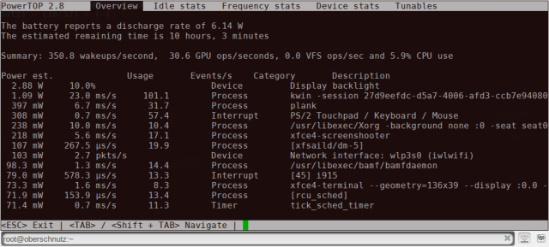As well as methods of direct power consumption measurement, there are also indirect ones; this would be the monitoring of resource utilisation within the system. E.g. measuring CPU operations over time. Regarding resource utilisation monitoring there is PowerTop which is software used by Intel; it reports on processes or devices being changed from idle to active states. It also provides estimations on the wattage these processes use. PowerTop is unfortunately only available for Intel processors which means that using it would severely limit the hardware spec. of the MAV.

*Figure 2.1: PowerTop showing power consuming events and their wattage estimates [40]*

A piece of open-source software acts similarly to PowerTop without reducing the spec. range called CollectD. It comes with over one-hundred plugins which allows for test cases to be fine-tuned [25]. Plugins of interest to this project would be Battery, CPU and CPUFreq plugins [27]. The Battery plugin measures charge, current and voltage over time as seen in Figure 1. This could be a useful alternative to a power meter; it could be seen more precisely how an energy efficient policy directly affected battery charge.

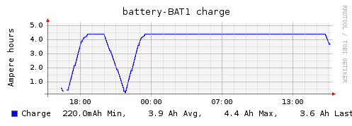

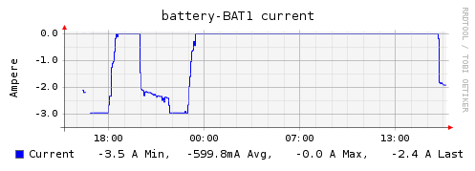

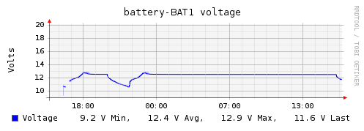

*Figure 2.2: Examples of battery charge (ampere hours), current (amperes) and voltage measured over hours [41]*

CPU measures the CPU state (wait, user, system, idle, etc.) in ‘jiffies’ – single scheduling units - over time. A goal here could be to maximise the wait and idle states.

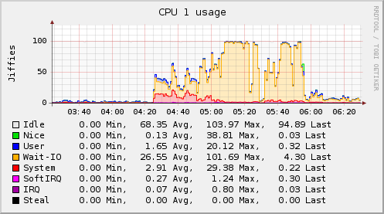

*Figure 2.3: A Linux system CPU usage measured by CollectD. RT tasks are denoted by SoftIRQ and IRQ*

CPUFreq measures the CPUs frequency (speed) over time. For energy-efficiency in mobile systems, in very general terms, the CPU frequency should be as low as possible [33].

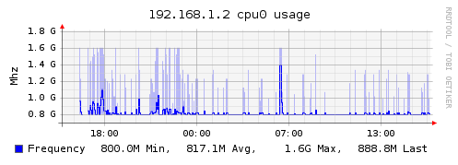

*Figure 2.4: CPU Frequency measured in GHz over hours*

### 2.1.2 Conclusions

For this project, direct measures of power consumption shall not be measured due to a lack of specificity in terms of energy-inefficient areas and due to costs. Only resource utilisation shall be measured as a power consumption metric for this project. Since RT scheduling policies prioritise tasks in a fine-grained way, it makes sense to analyse power consumption in an equally fine-grained way. CPU states, CPU frequency and battery data shall be the metrics used to do this. The technology to measure resource utilisation shall be CollectD because it does not limit the hardware specifications, it is modular, lightweight and can be fine-tuned for the project.

## 2.2 Understanding current RT scheduling policies and investigating other scheduling policy implementations

### 2.2.1 Investigating differences between PREEMPT-RT patched Linux and vanilla Linux

The vanilla kernel needs patched because it is not fully pre-emptible [28]. Being non-preemptible means that in some cases, a high priority task may be kept waiting by a lower priority task [13]. This is because spinlocks are used on kernel threads: if a task on a kernel thread cannot acquire a resource, it waits in a loop until the resource becomes available – as seen in the left-hand example in Figure 2.5. This means the processor is forced to continue serving a locked process. The PREEMPT RT patch replaces spinlocks with mutexes: markers which suspend a process when a resource is unavailable. This marker is removed as soon as the resource becomes available, and the process wakes up [3]. This can be seen in the right-hand example of Figure 2.5.

## Appendix 8 – Why PREEMPT-RT?

Preempt-RT is one of the most common real-time patches for Linux [28] and there is no need to modify RT task properties. Other patches, such as RT-Linux, contain a core RT nucleus and just uses Linux as a microkernel – Linux runs on top of the system as opposed to being fully integrated into the core of the system

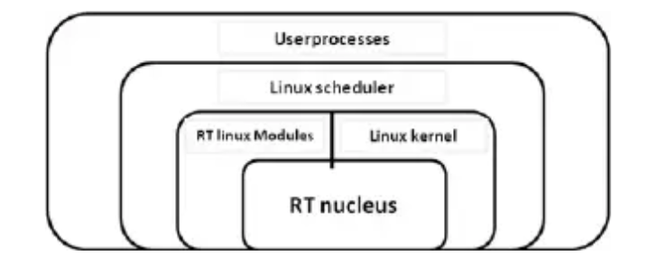

*Appendix Figure 1: Visualisation of the RT-Linux architecture*

This means that RT tasks would have to be reconfigured in order to communicate with Linux. This would create an unnecessary overhead [28, 29].

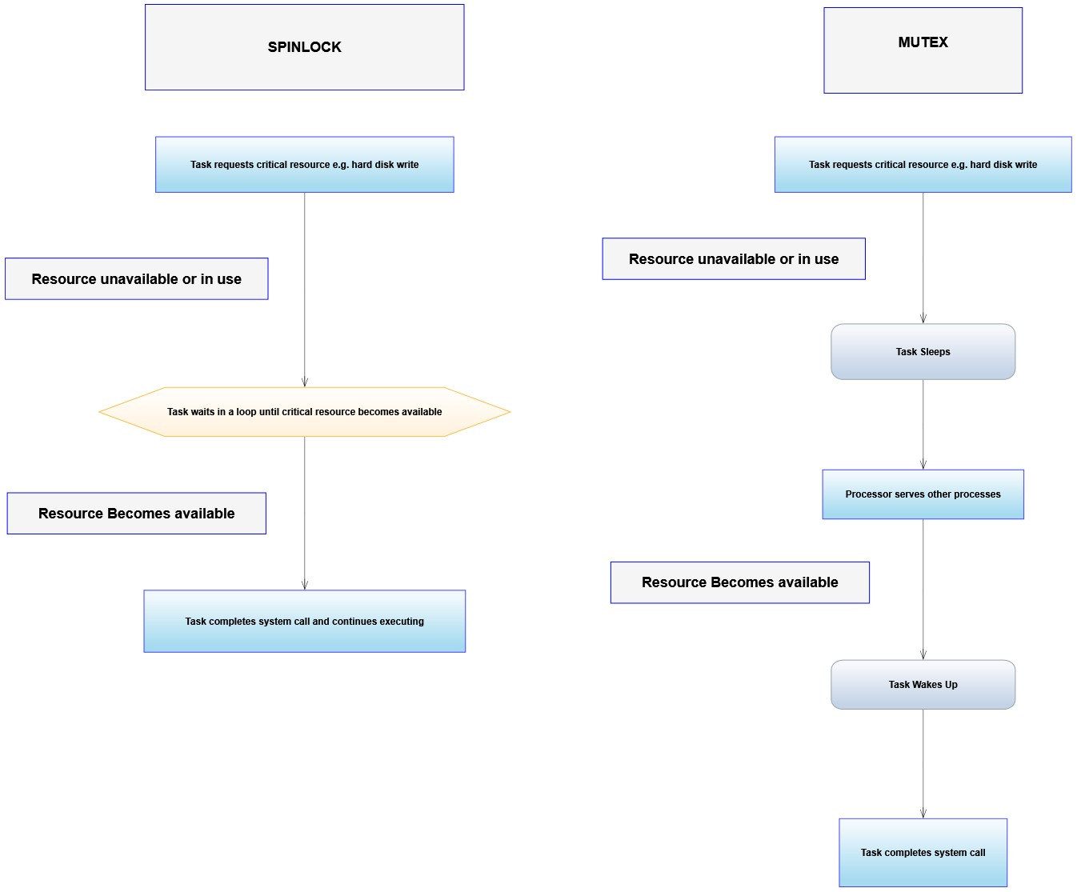

*Figure 2.5: Difference between spinlocks and mutexes*

### 2.2.2 Investigating new scheduling policy implementations

The EDF policy is considered superior to the default Linux RT scheduling policies – SCHED_FIFO and SCHED_RR - due to having dynamic priority values as opposed to static values. This means that unpredictable situations can be mitigated by updating priorities during runtime [4]. The Linux community released their own method of using the EDF policy with their SCHED_DEADLINE module in Linux 3.14. However, an issue with its inclusion is that it defines functions which are not within the POSIX standard; this has the potential to compromise the portability of the OS with some devices and distributions [5].

## Appendix 9 - Current Linux Scheduling Policies

The Linux process scheduler implements policies for RT and non-RT tasks [2]. For RT tasks, Linux implements a first-in-first-out policy, which executes a task until pre-empted (interrupted by another task which requires a shared resource), and a round-robin policy which executes a task until it exhausts its time slice. This is exemplified in Figure 1.1 and Figure 1.2.

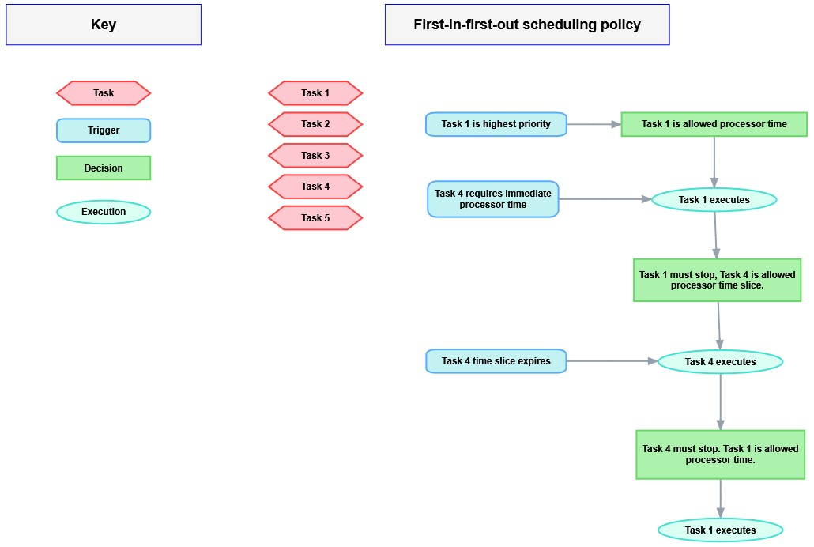

*Appendix Figure 2: Diagram of Linux’s FIFO RT scheduling policy*

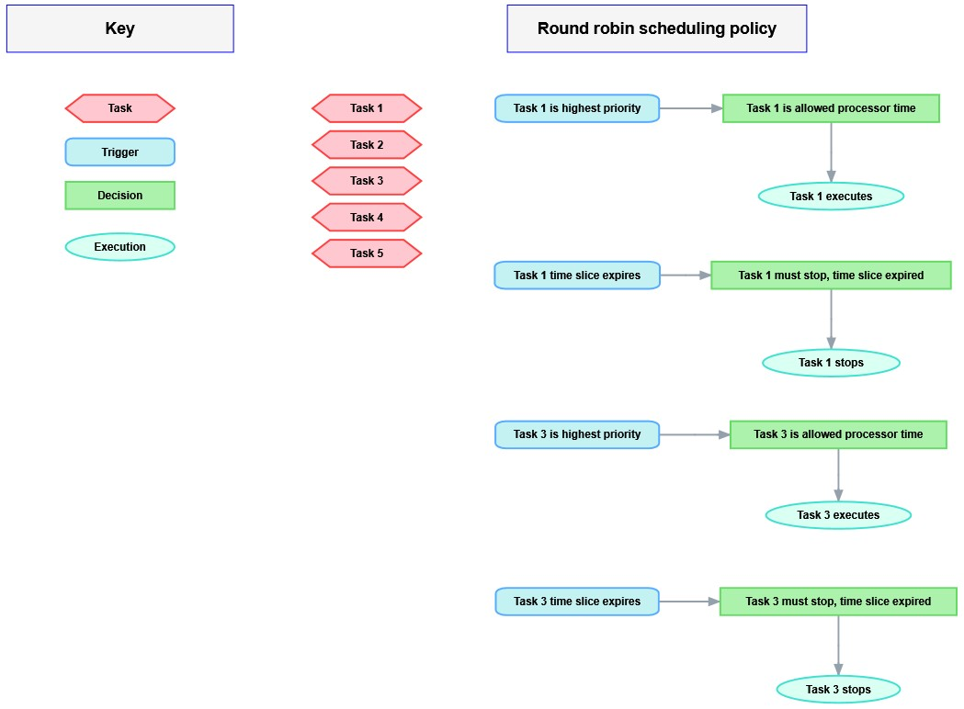

*Appendix Figure 3: Diagram of Linux’s RR RT scheduling policy.*

## Appendix 10 – SCHED_FIFO and SCHED_RR shortcomings

The two policies which Linux implements for RT tasks are SCHED_FIFO and SCHED_RR. Under these policies each RT task has a static priority value between 0 to 99 with 0 being highest priority and 99 being lowest priority.

A task with priority 1 shall be addressed by the processor before a task with priority 2. Hypothetically, using SCHED_FIFO, if two tasks run concurrently with the same priority value, the task which executes first is allowed to complete before the other task is allowed to begin. Using the same example, in SCHED_RR each task would be given a time-slice by the processor. The processor would then alternate between the two until both tasks were complete [30].

According to [3], both policies are limited in real-world applications due to unpredictable situations which can arise. An example of this is hardware interrupts: the processor must stop what it is doing and deal with the interruption as soon as it makes itself known. These policies static priority values mean that unpredictable events can sometimes miss their deadlines or cause other processes to miss theirs.

For this reason, an implementation of the EDF policy which was POSIX compliant was developed in [31] using the PREEMPT-RT patch. In this paper, it states that a new policy must be defined in the same class as the rest of the RT policies (rt_sched_class) in order to be POSIX compliant, as shown in Figure 2.6.

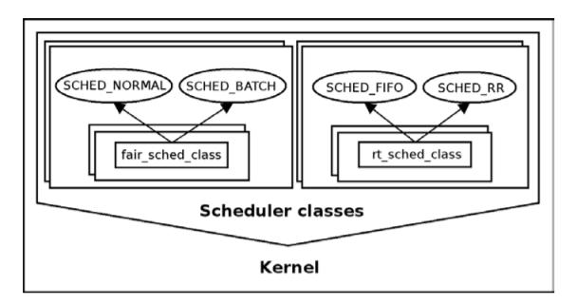

*Figure 2.6: POSIX compliant classes where non-real-time (left) and real-time (right) policies are stored*

Modifications were also made to task attributes, defined within the “*task_struct”* structure. Functions for task queueing/de-queueing to and from a processor run-queue (for more information on run-queues, see Appendix 4), task execution priority, and task pre-emption were also altered.

### 2.2.3 Conclusions

The necessity for the Preempt-RT patch has been established in this section. An example of implementations of alternate RT scheduling policies - the EDF policy - has been discussed. This proves that adding new policies to the Linux scheduler is feasible. Furthermore, it serves as a practical frame of reference which can be referred back to during development. A set of pseudocode files are also associated with [31] which strengthens this frame of reference.

## 2.3 Investigating previous attempts to improve RT system energy-efficiency using energy-efficient algorithms

### 2.3.1 Dynamic Voltage Frequency Scaling (DVFS) Algorithm definition

A well-researched way in which RT policies manage power consumption is by implementing algorithms which dynamically scale voltage and CPU frequency (DVFS) [32]. A DVFS algorithm will also aim to minimise processor activity and power transitions, whilst maintaining task schedulability [33].

A task set is schedulable if the processor utilisation (*U*) is less than or equal to the worst-case execution time (WCET) divided by the period (P) a task takes to complete for all tasks in the system. This is with respect to the number of processors in the system. This can also be seen in Formula 2.1:

***M = 1***

***T1: P1 = 8, WCET1 = 2***

***T2: P2 = 10 WCET2 = 4***

***T3: P3 = 4 WCET3 = 1***

***U = 1/4 + 2/8 + 4/10***

***U = 0.9***

***M < 0.9***

***U < M***

***In this example, M = the number of processors in the system.***

1. ***Task 1 (T1) has a period of 8 milliseconds and a worst-case execution time of 2 milliseconds. Task 2 has a period of 10 and a WCET of 4, and task 3 has a period of 4 and a WCET of 1. For simplicity, we will let these three tasks be the only tasks in the system.***
2. ***When dividing each task’s period by its WCET and summing the results, the overall utilisation equals 0.9.***
3. ***If we compare this to M, we see that U is less than M. If the scheduling policy being used has a schedulability of U <= 1, then this example would be considered schedulable using this policy.***

*Formula 2.1: How to find if a task set is schedulable on a processor(s)*

To put this in real terms, a processor is schedulable until it reaches a point of utilisation where it begins to miss task deadlines. So, if a scheduling policy was functional at 70% utilisation but began to miss deadlines above 80% utilisation, the policy would be described as schedulable up to 80%. If we represent this in the above format, it will look like this: *U <= 0.8*, or as a percentage *U <= 80%.*

For reference, EDF has a schedulability of *U <= 100%* when *M = 1* [4]. So, EDF is fully schedulable for uniprocessor systems, assuming the processor is not overclocked. It is also considered schedulable in multiprocessors. The ideal situation would be to find a DVFS scheduling policy which maintains schedulability close or equal to that of EDF.

### 2.3.2 Investigating previous studies into energy-efficient policies for RT systems

One of the policies discussed in [33] is the System-Wide Earliest Deadline First policy (SYS_EDF). This policy aims to balance the trade-off of device scheduling to job scheduling. This means when device idle time is prioritised, the CPU must increase its frequency to process tasks in a way to minimise device active time, and vice versa when low CPU frequency is prioritised:

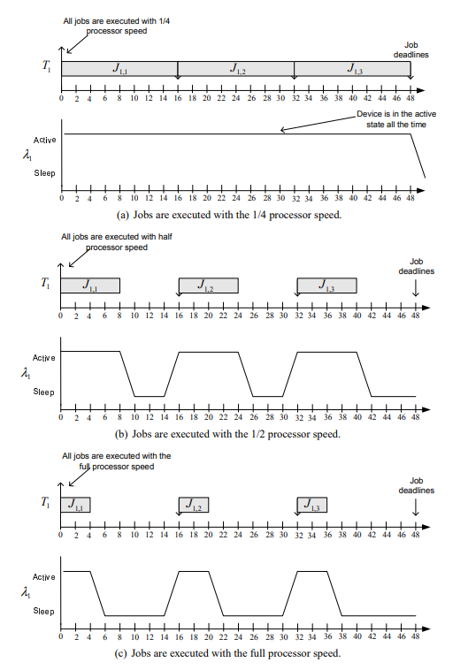

*Figure 2.7: Job schedule compared to device schedule when CPU frequency is prioritised (a), when CPU frequency and device time are even (b), and when device time is prioritised (c).*

SYS_EDF balances this is by taking note of the set of active devices and dynamically computing an energy-efficient CPU frequency based on this set. The SYS_EDF policy has a schedulability comparable to the EDF policy.

When *U* was at 40-50%, SYS_EDF was found to save up to 3.72% more energy when compared to two other algorithms in the same *U* range. However, when *U* was reaching upwards of 90%, it was only found to save 0.33% more energy. Information on how this compares to EDF could not be found. It would be interesting to see how this algorithm would perform in a real-world scenario where *U* is constantly changing.

No information can currently be obtained regarding the compatibility of this algorithm with Linux. SYS_EDF may be the ‘correct’ policy to consider for the scope of this project, but since the viability cannot be verified, it may be safer to use another policy.

Other investigations into DVFS scheduling policies have been explored in [32]. The main algorithms investigated were ones based on the EDF policy. This is because they could reduce power consumption whilst maintaining high schedulability.

One stand-out DVFS policy investigated was the Look-Ahead Earliest Deadline First (LA-EDF) policy. The way it works is similar to SYS_EDF because it tries to reduce CPU frequency wherever possible, however it is not as ‘smart’ as SYS_EDF; it does not consider device idle/active time.

Although during testing, the overall energy savings were 15% compared to EDF. This was when *U <=70%*. This was greater than less aggressive policies which saved 10-12% when *U <=70%*. As above, it would be good to see how a real-world scenario compared with these results.

The test environment used here was in Linux, which confirms it is possible to implement the LA-EDF policy for use in this project. For DVFS policies to be implemented, the processor needs to support CPU frequency scaling. Further information regarding this is also provided in [32].

### 2.3.3 Conclusions

An understanding of how energy-efficient policies can be used has been acquired. It seems that SYS_EDF would be the best policy to implement since it considers device idle time as well as CPU frequency. Both will be an important variable in a battery-powered system. However, it is not verified if this policy is applicable within a Linux environment. So, the next best option (according to the research) would be the LA-EDF policy. Reference material from [32] can be used in conjunction with section 2.2 of the literature review to aid in LA-EDF implementation for this project. Finally, since a DVFS policy will be used, a CPU which supports frequency scaling shall be used.

## 2.4 Investigate the components required to build an MAV and record the MAV performance metrics

This section details MAV related components which will be necessary for this project. A quadcopter multirotor MAV shall be used for this project due to its precision in terms of control and manoeuvrability.

## Appendix 11 – Multirotor MAV justification

MAVs will be used for various types of mission, as briefly mentioned in the project background. This will include Military operations – such as surveillance, commerce and crop dusting. According to [34], there are two main types of MAV available for most MAV mission use-cases.

These are Multirotor MAVs and Fixed-wing MAVs. Multirotors are copters which have multiple fixed rotors, normally 4 (quadcopter). This style of vehicle is very precise in terms manoeuvrability and easy to take-off, fly and land. The total battery life however is highly limited ranging anywhere between 10 and 30 minutes. This style of MAV would be used for precise missions such as surveillance. Fixed wing MAVs rely on wings to generate lift which makes vertical take-offs impossible, but they are capable of carrying heavier payloads and have a much greater battery life. They are better suited for endurance missions like crop dusting and long-range military operations.

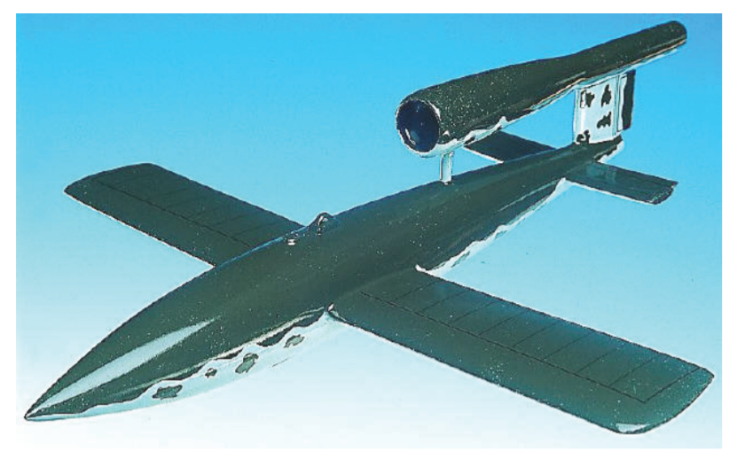

*Appendix Figure 4: Fixed-wing style of MAV*

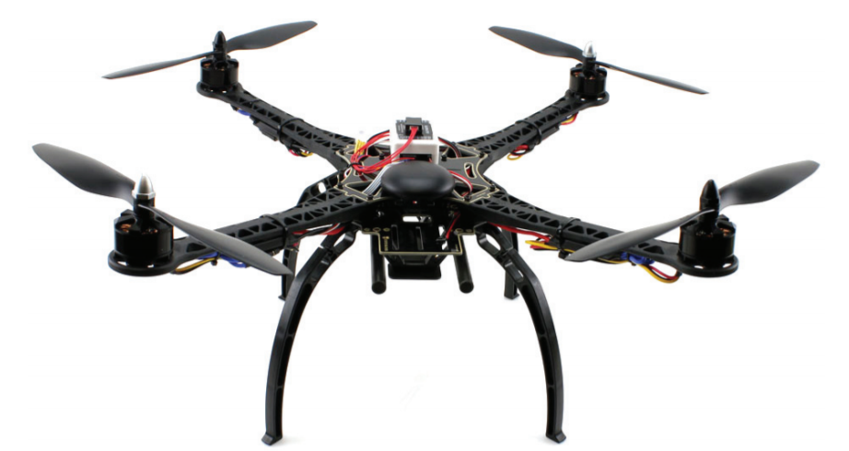

*Appendix Figure 3: Multirotor style UAV – in this case a quadcopter*

Since the test case will need repeating several times, it seems best to choose an option which will allow for swift setup and completion. It also seems sensible to keep the MAV control scheme as simple as possible for ease of use. Due to the nature of the project, the measurements will be fine grained and precise. It therefore makes sense that control of the MAV in a test case should be precise too. This leads to the belief that a multirotor style of MAV would most benefit this project.



*Appendix Figure 5: Multirotor style MAV – in this case a quadcopter*

Since the test case will need repeating several times, it seems best to choose an option which will allow for swift setup and completion. It also seems sensible to keep the MAV control scheme as simple as possible for ease of use. Due to the nature of the project, the measurements will be fine grained and precise. It therefore makes sense that control of the MAV in a test case should be precise too. This leads to the belief that a multirotor style of MAV would most benefit this project.

### 2.4.1 Investigating relevant MAV performance metrics and how they are measured

The most meaningful MAV performance metrics gathered in [34] were throttle, total continuous flight time, pitch, roll and yaw.

Throttle is defined as the total thrust the motors of the MAV have while flying. This can be measured by observing the total amount of power being sent to the motors over time.

Total continuous flight time is the time in which an MAV can fly without landing. This may be impractical to measure because that time may be unreasonably long per test case (>20 minutes for example). Instead for this project, changes in altitude could be observed over a set flight path. This would be measured with a barometer. This ensures the vehicle’s altitude remains consistent and controlled.

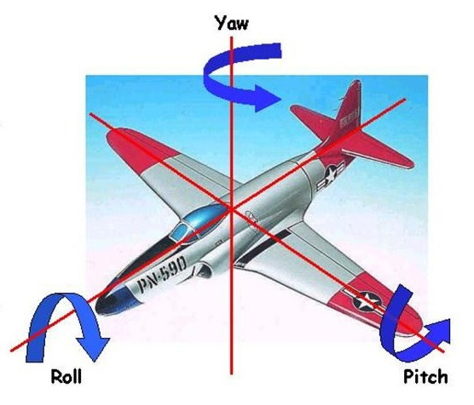Pitch is the movement of an aerial vehicle along a vertical axis, roll is the rotation along a horizontal axis and yaw is the rotation of the vehicle’s centre axis. These three metrics can be measured using an accelerometer. This quantifies how balanced the vehicle is during flight.

*Figure 2.8: Visual for Pitch, Roll and Yaw of an aerial vehicle [42]*

Measuring the variance of performance metrics against any power consumption changes will provide a solid real-world view into how usable the LA-EDF policy is in a battery-powered RT system.

### 2.4.2 Investigating MAV components and ground-control software

The Navio2 Shield is a flight controller which plugs into a Raspberry Pi 3b+ [35]. The standard for on-board controller software within the drone community seems to be ArduPilot. The makers of the Navio2 provide ArduPilot within a Raspbian image which comes with the controller. For this reason, the knowledge entry barrier for building a drone immediately becomes much lower when compared to other common boards e.g. PixHawk. This could save development time which may be spent on matters more relevant to the problem area. CPU Frequency scaling was found to be possible on a Raspberry Pi 3b+ and official support is almost available [37].

Mission Planner is ground control software designed specifically for MAVs [38]. It is supported in a Windows, Linux and MacOS environment and can be used to calibrate ArduPilot. It also provides waypoints, a GPS map view and vehicle position. This software seemed to have most relevant features when compared to similar pieces of software. The user may also download log files of performance metrics of the MAV.

Resources for MAV parts and how to assemble them properly are available from [39]. This is an online course which provides detailed specification of components necessary to build an MAV using a Raspberry Pi. Information on the design and implementation is also contained within. The course includes first-time flying drills and some simple scripts for autonomous flight. The course is expensive, and the components will cost money too, but for the level of specificity it seems like a worthwhile investment.

### 2.4.3 Conclusions

A multirotor style of MAV was identified as most appropriate for this project. The metrics most relevant to MAV performance were identified as changes in throttle, changes in altitude, and variances in pitch, roll and yaw. The hardware for the MAV on-board computer was decided upon as a Raspberry Pi 3b+ with a Navio2 board as the flight controller. This is because Linux is at the root of the system and because the board comes pre-configured. Ground control software was decided upon and the relevant documentation to procure MAV components and build the MAV system was also obtained.

# Execution

## Project Methodology and Design

As stated in section 2.4, the MAV used in this project will be a multirotor copter. This will be built first by understanding the design of the MAV and obtaining the necessary components, and then building the MAV according to the design. This will be time consuming, but it will also guarantee the desired configuration. That configuration being a stable version of PREEMPT-RT patched Linux with a Navio2 configured build of ArduPilot. The resource utilisation metrics will then be monitored using CollectD. These metrics will be used to determine the energy-efficiency of the EDF and LA-EDF policies.

The MAV is an RT-based system which will be engaging in air travel. As such, there can be no functional aspects of the system which are absent or poorly defined. For this reason, a methodology such as Agile is out of the question; the design documentation, as well as requirements for the MAV must be set out before any implementation. Therefore, a methodology such as Waterfall where requirements and design documentation are dealt with before implementation or testing occurs is more desirable. Once the MAV design is understood, implementation will begin. The Testing phase shall be modified slightly: as well as testing the functionality of the MAV system, a set of experimental test cases shall be defined and completed. This will be how LA-EDF feasibility will be evaluated.

### 3.1.1 System Architecture Overview

The operation of the MAV can be split up into two key features: the Linux environment which allocates memory, provides computational power and schedules all system processes. The OS also provides tools for monitoring the hardware on the Raspberry Pi. Many non-fundamental aspects of the OS, e.g. a GUI, have been stripped away the Raspbian configuration used in this project in order to minimise the number of interrupts from non-flight-critical processes [44].

The second feature is ArduPilot which is installed on the Navio2. ArduPilot runs as a set of processes in the Linux OS, which can be seen within the ‘Linux OS’ and ‘On-board Autopilot Software’ segments of Figure 3.1. This software is responsible for abstracting the MAV hardware and performing flight control tasks such as changing altitude, or moderating thrust. The autopilot has scheduling software of its own, but this is for flight control tasks only.

Modifying the ArduPilot scheduler may also have an impact on energy efficiency. However, it will not be modified because the domain-specific nature this scheduler has not been thoroughly researched and any modifications could result in catastrophic failure of the system.

So, for the purposes of this investigation only the Linux Scheduler, as highlighted in green in Figure 3.1, shall have the LA-EDF policy applied. Other elements of the Linux OS, such as System State Monitoring, are not relevant to this project.

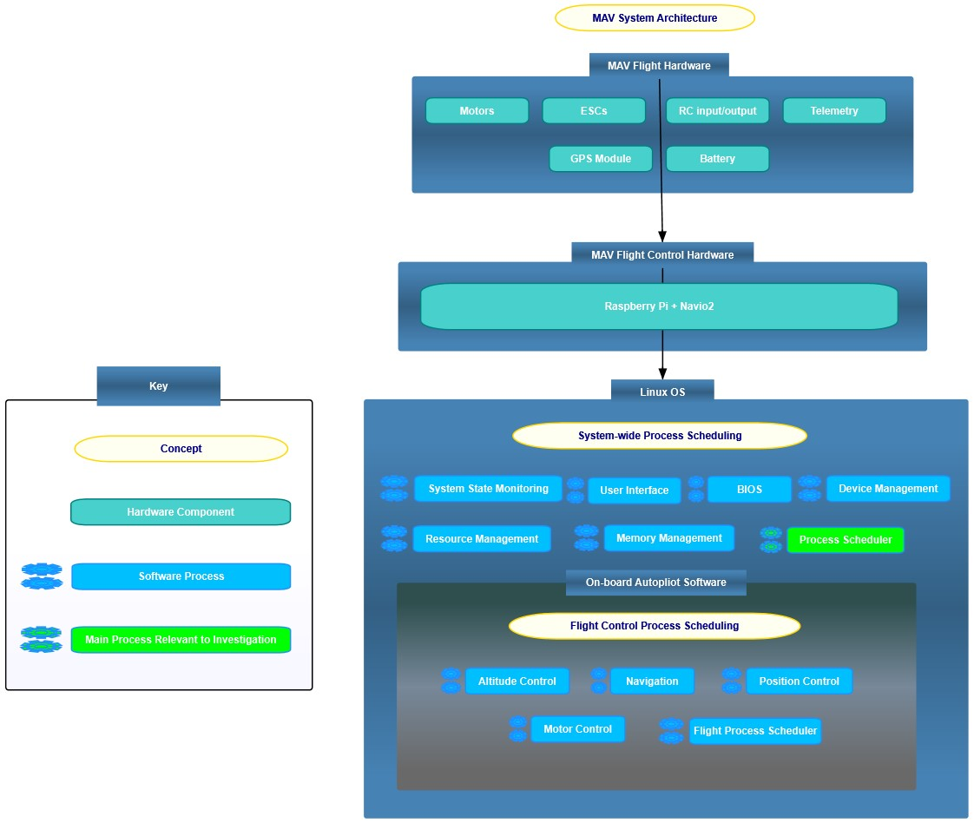

*Figure 3.1: High-level system architecture overview. The MAV hardware is connected to the flight control hardware – that being the Raspberry Pi and Navio2. The autopilot software, which governs flight control operations, runs as a set of processes within the Linux OS.*

To conceptualise the process scheduler in a simpler, one may think of it as a mediator in an event-driven architectural pattern. In this pattern, events within the system drive how the system behaves – that is, each new event causes some change in system state. Each event is handled by a mediator which ranges from message queues in Internet Chat Relays to sensor input queues in self driving cars. The mediator decides how, when and where each event it contains gets processed by the system.

Using the Process Scheduler as an example of this pattern, seen in Figure 3.2, new processes (write to log file) would be examples of events.

The scheduler calculates each processes’ priority weighting which determines when each process receives a CPU time slice. E.g. a process with highest priority (ping telemetry) may execute when the runtime equals 1, whereas a process with 2nd highest priority (check altitude) would only be allowed to execute after the 1st process had completed. In this example, the priority weighting for ‘write to log file’ has not yet been assigned because it has not yet been checked by the scheduler.

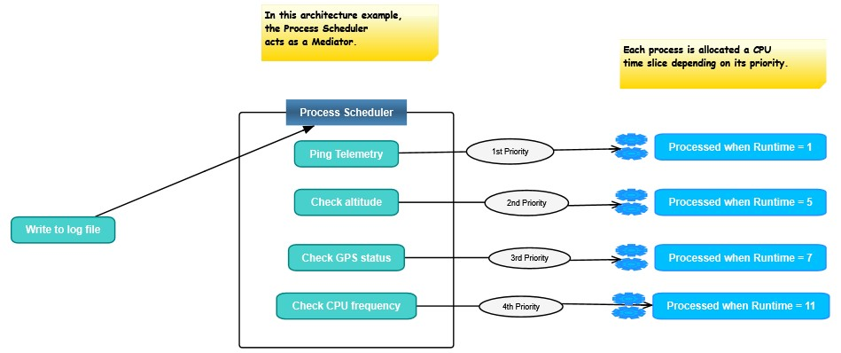

*Figure 3.2: Linux Process Scheduler in the context of an Event-Driven Architecture. “Write to log file” is a new event which is about to be addressed by the mediator. In this case, the mediator is the process scheduler.*

### 3.1.2 Current Design and Implementation of the EDF Scheduling Policy in Linux

EDF is currently implemented within Linux using the PREEMPT-RT patched version of the SCHED_DEADLINE algorithm [43]. This algorithm is written in C, mainly within the ‘sched.h’ file. Three attributes are used in the implementation of the EDF policy: period (P), runtime (R), and deadline (D). P defines how long a process may receive processor time, R defines how long the execution time should be and D defines when the process should complete.

An RT process has its own set of attributes to allow itself to be scheduled. These definitions will be found within whichever RT application the process operates in; in this case, ArduPilot. These attributes are the period (P) – how long the process shall be awake for, the deadline (D) – the latest possible time the process should complete by, and the worst-case execution time (WCET) – the maximum time a process should take to execute.

As seen in Formula 3.1, in order for a process to be prioritised by the SCHED_DEADLINE algorithm, the process P must be <= scheduler P, process WCET must be <= scheduler R, and process D must equal scheduler D:

*Process P <= Scheduler P*

*WCET <= R*

*Process D = Scheduler D*

*Formula 3.1: Determines if any given process within the system is capable of being scheduled by the Linux implementation of the EDF scheduling policy, where P = Period, R = Runtime, WCET = Worst-case Execution Time and D = Deadline.*

For simplicity’s sake, let us assume there are three processes in the system and each of these processes met the above scheduling requirements. For further simplicity, let us assume that each process’s deadline is equal to its period.

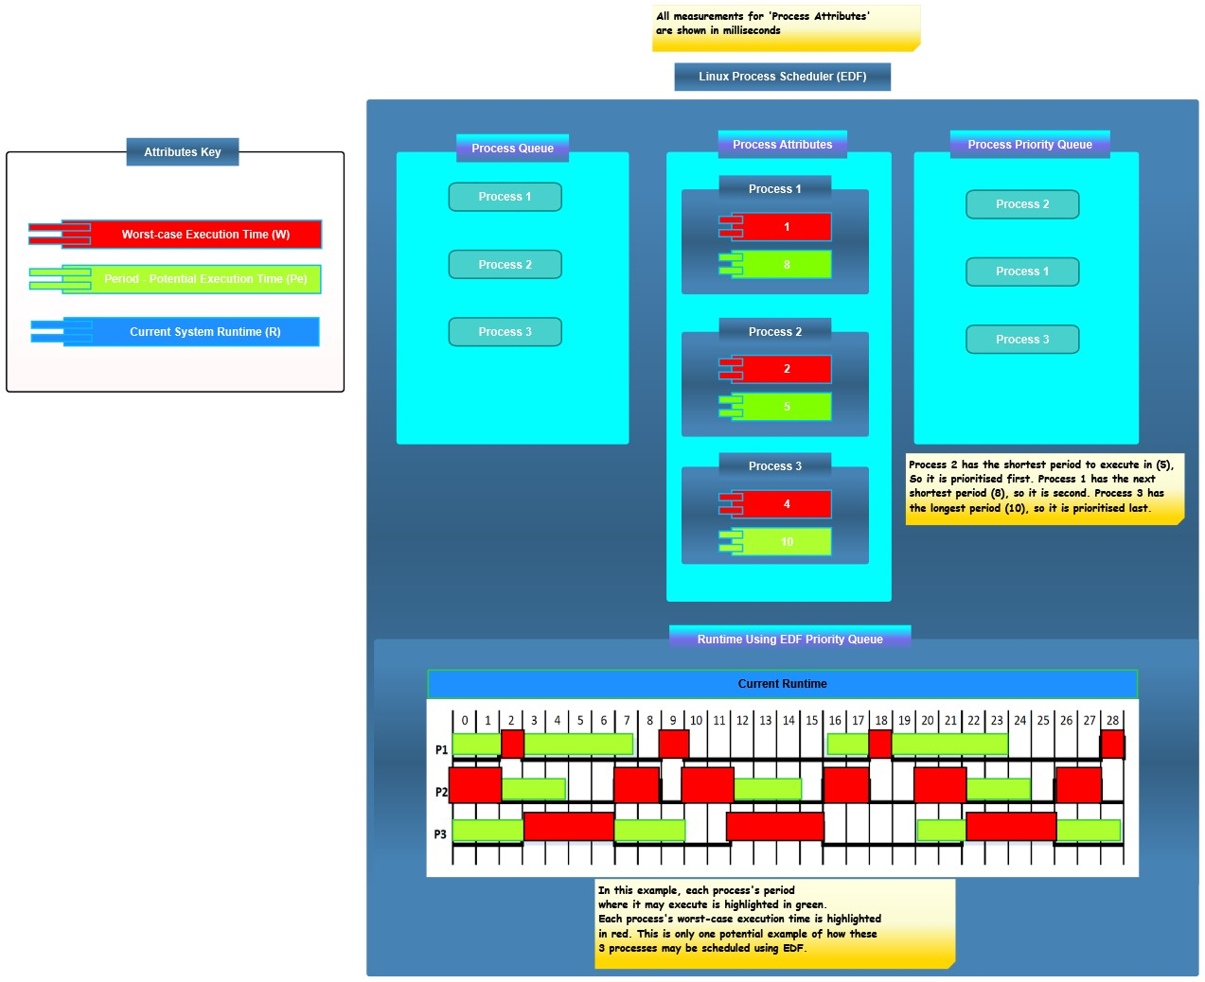With these assumptions in mind, the three processes would be prioritised according to their deadlines, with the shortest deadline being executed first. Process execution within the system’s runtime would be organised so that all processes execute successfully without missing their deadlines. The beauty of this implementation is that since the WCET is known, no process will have to block another process. Therefore, no process will cause the deadline of another process to be missed. A visual example of this implementation can be observed in Figure 3.3. In the ‘Runtime Using EDF Priority Queue’ section, it can be observed how all processes can successfully be scheduled on time using this policy. The task periods (Pe) are highlighted in green, while the task WCETs (W) are highlighted in red.

*Figure 3.3: A simplified example showing three processes being scheduled by the main SCHED_DEADLINE algorithm. Each process enters unprioritized, the WCET and period is computed, and the algorithm organises/executes each one by shortest deadline.*

This EDF scheduling policy implementation guarantees that all processes which meet the SCHED_DEADLINE requirements will complete before their deadlines. This is guaranteed until the CPU reaches 100% utilisation.

### 3.1.3 Speed Controllers, Motors and the Battery

The first part of the hardware design are Speed Controllers, as illustrated in Figure 3.4. These are components which control how fast the motors spin. There are three blue wires which are each soldered to a bullet connector and connected to a motor. A large black wire and a large red wire are soldered to the Power Distribution Board and finally a small black and red wire connect to the MAV on-board computer.

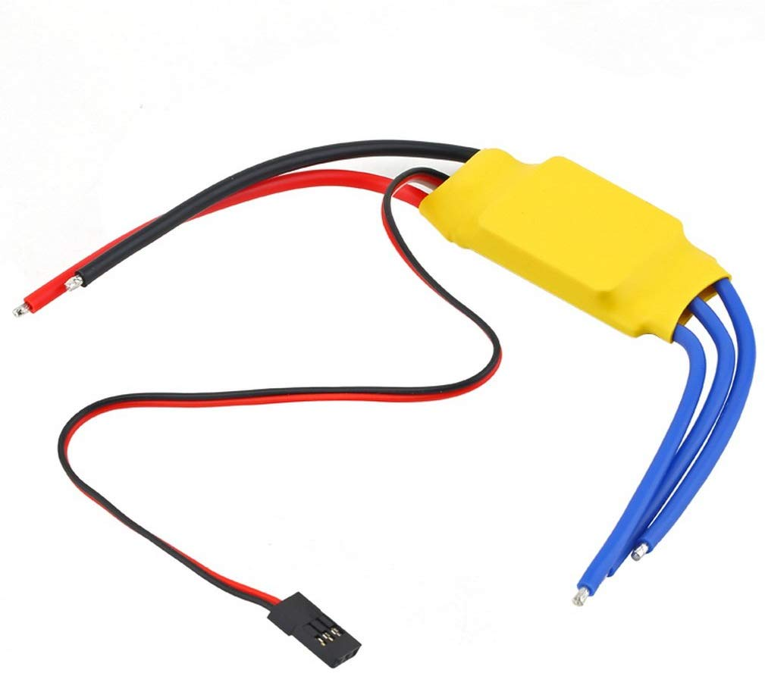

*Figure 3.4: The ESC (Electronic Speed Controller). The blue wires connect to the motors, the large red and black wires to the PDB, and the small red and black wire to the controller.*

Without speed controllers, the motors would either be spinning at full power, or not at all.

The speed controllers will connect to 4 motors: 2 front motors and 2 rear motors. These will drive the propellers which will give the MAV lift. They are the most crucial component of the MAV system and must be calibrated equally to avoid uneven flight. These motors can be seen in Figure 3.5.

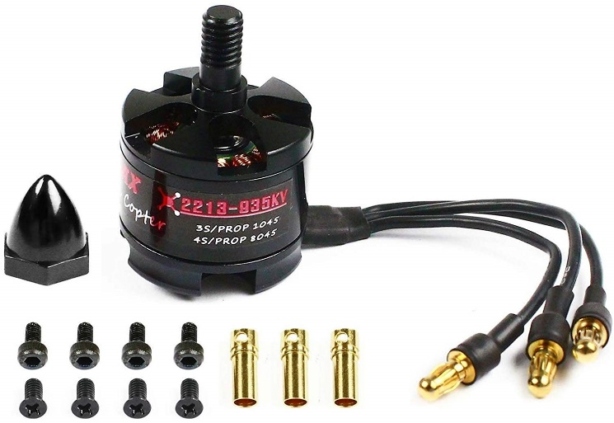

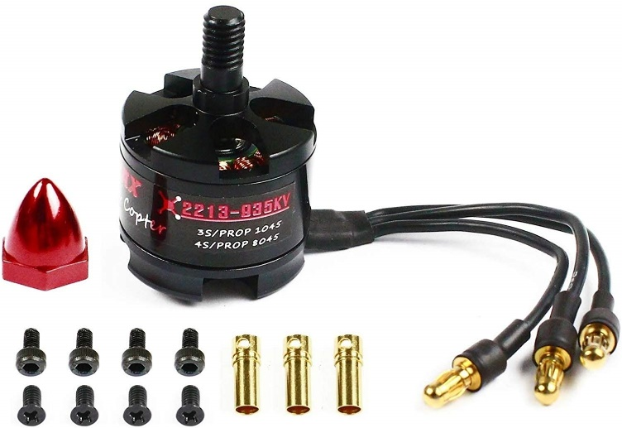

*Figure 3.5: Front motor (left) and rear motor (right). The three male bullet connectors attached to the motor connect to each of the three female bullet connectors. The female bullet connectors are soldered to the ESCs.*

The battery which will power the MAV is a 3000mAh battery, as pictured in Figure 3.6. This means that the battery will be able to provide approximately 1 hour of power for a device drawing up to 3000 milliamps.



*Figure 3.6: The battery which shall be used for this project. The battery shall provide power to all components of the MAV system.*

The total amount of power drawn from the system at any given time will depend on how the MAV is flying (e.g. continuously flying at a set altitude, flying in bursts, flying at maximum power, hovering at a low altitude, etc.) and how ArduPilot designates when and for how long each component receives power.

CollectD will be used to monitor battery charge and discharge under both the EDF and LA-EDF policies. Any changes between the two policies will be used to determine which policy is more energy-efficient in this regard.

A limitation of this project shall be understanding exactly how much of a difference the LA-EDF will make to the energy efficiency of the system since no hardware power consumption measurement methods are being used.

### 3.1.4 Raspberry Pi 3b+, Navio2 Shield, Telemetry and GPS Module

The Raspberry Pi is the computer for the MAV. A modified version of PREEMPT-RT patched Raspbian is flashed onto the Pi with a micro-SD card. The Navio2 is attached to the top of the Raspberry Pi through the PCI port. A complete view of this can be seen on the left-hand side of Figure 3.7 and the logistics of how the Navio2 shield fits into the Pi can be seen on the right-hand side. This is the board which will utilise ArduPilot and physically connect to all other MAV components.

Both human and non-human flight control shall be possible using this configuration. Human control shall be achieved using a receiver on the MAV and an RC transmitter. Non-human control uses automated flight scripts programmed in Python. Human control can be re-acquired at any time, which is a useful failsafe in case a script has been incorrectly programmed, or malfunctions during flight.

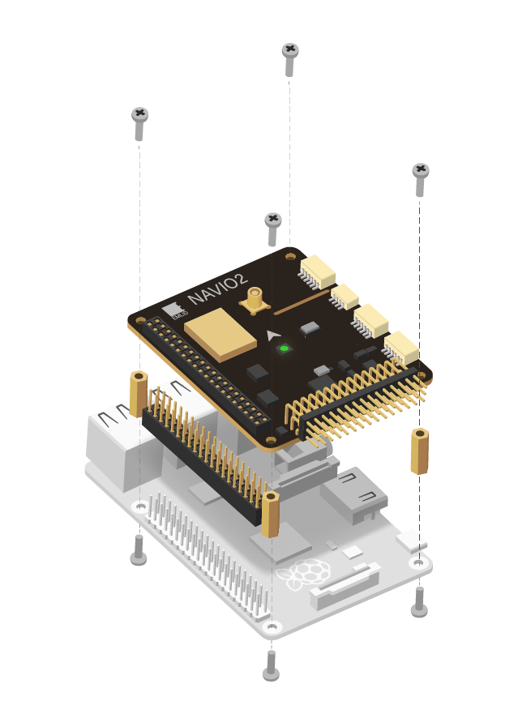

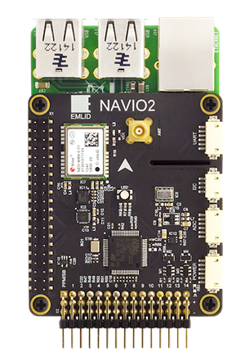

*Figure 3.7: The Navio2 connected to the Raspberry Pi (left). The logistics of how the Navio2 controller attaches to the Raspberry Pi (right).*

Now, the MAV is ready for flight. However, it still has no way of connecting to ground control software, which is a crucial element of monitoring and recording performance metrics. It also reports potential hardware issues, and other flight metrics such as GPS location. Monitoring performance metrics is necessary to analyse the potential consequences improving energy-efficiency would have on MAV functionality.

The way Navio2 will communicate with ground control software is through radio telemetry. The radio receiver is connected to the laptop the ground control software is operating on and the transmitter is connected to Navio2, as seen in Figure 3.8. The Navio2 sends relevant flight data to the receiver. The ground control software interprets and displays this data to the user.

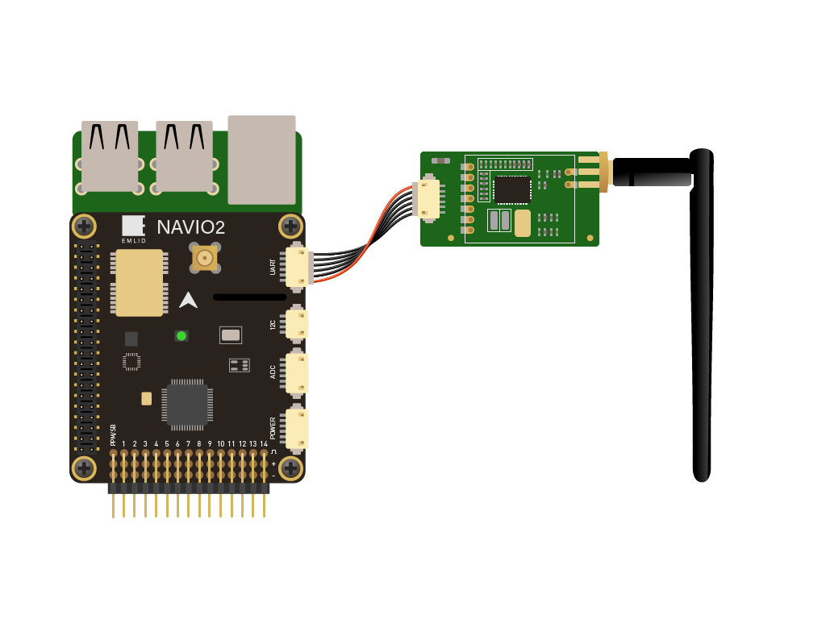

*Figure 3.8: Telemetry transmitter connected to the Navio2. This will send flight information to the telemetry receiver.*

The flight controller won’t be able to send GPS information without having a GPS module connected to it. This module is attached to a stand which is in turn attached to one of the MAV’s legs. The module connects to the Navio2 controller through a micro-coaxial input as seen in Figure 3.9.

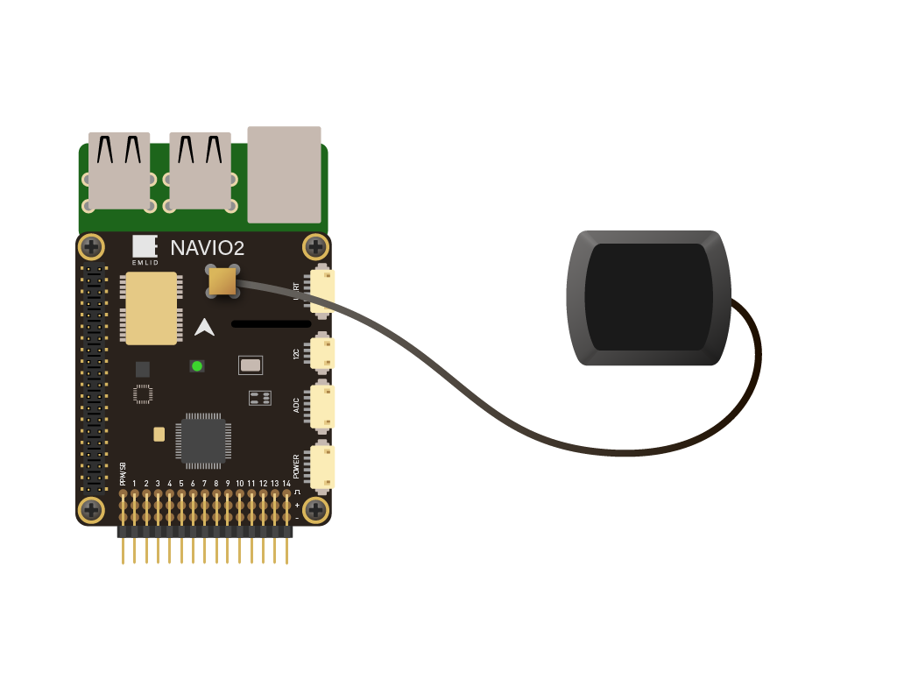

*Figure 3.9: GPS module connected to the Micro-Coaxial (MCX) input in the top of the Navio2.*

## Linux Process Scheduler Modifications

Within Linux, there exist tools which can monitor and change system properties. One such tool is ‘cpufreq’ located within the ‘proc’ directory of the Linux kernel. This tool can be used to view the current CPU frequency as well as change it. For a Raspberry Pi 3b+, the default minimum is 600MHz and the maximum is 1400MHz. Both values can be found in the ‘sys/devices/system/cpu/cpu*x*/cpufreq’ file. The frequency can be set to either value. This limits the number of frequencies which can be selected to two for this project, which means that the total energy savings may be less significant than with a configuration which had access to more CPU frequency steps. It was thought that the Raspberry Pi 3b+ had more steps than just maximum and minimum, but the model acquired for this project only had access to this many.

The lower the CPU frequency, the less total cycles the CPU will perform, and therefore less power shall be consumed overall. With this, one may assume that the frequency could simply be permanently set to minimum. As previously discussed however, the nature of RT systems means that there would be no guarantee that all processes would meet their deadlines at minimum CPU frequency.

The goal of LA-EDF is to defer as many processes as possible until after the highest priority process has completed. The CPU frequency is then adjusted to the lowest possible level in which this will be achievable. With reference to how the LA-EDF policy is designed [45], the modification will be broken down into five main steps, which can be seen in Formula 3.2:

1. **Process begins**
   1. ***The WCET of the current process is set to a global variable, and a function called ‘defer()’ is called.***
2. **Future work for later processes is deferred** 
   1. ***The total Utilisation (U) for all tasks is calculated.***
   2. ***Each task is iterated through in reverse order – i.e. latest deadline first.***
   3. ***U is then updated for every process up to the latest one currently being iterated: U = U – WCETi/Pi.***
   4. ***The minimum number of clock cycles which need to occur before the earliest deadline is calculated for each process.***
   5. ***U is updated once again to reflect the utilisation of each process after the earliest deadline has passed.***
   6. ***The minimum number of clock cycles for each task is summed into a total value in MHz (s). If this is less than 0, then 0 shall be used instead.***
   7. ***Finally, s is divided by the current runtime (CR) subtracted from the earliest deadline (Dn). This will be the minimum frequency which can be used whilst keeping the system schedulable (f).***
3. **Frequency for process is selected**
   1. ***The lowest possible frequency shall be selected for the current process. This value shall be greater or equal to (f). Ideally, it should equal (f).***
4. **Process Executes**
   1. ***The WCET of the current process is decremented until process completion, or until the WCET is less than 0. If the WCET goes below 0, then the deadline has been missed. This should be logged by the scheduler for later analysis.***
5. **Process Completes**
   1. ***The WCET global variable is set to 0. Steps 2 and 3 are then executed again. This set of steps will repeat for every new process which is started using the LA-EDF policy.***

*Formula 3.2: The algorithm steps for LA-EDF*

These steps shall be implemented as functions using C in the ‘sched.h’ file. Modifying the ‘sched.h’ file directly ensures POSIX compliance. It will be ensured that these functions are only ever called during the scheduling of tasks which adhere to SCHED_DEADLINE. This will prevent other tasks which cannot be scheduled using the EDF policy from affecting the CPU frequency.

Formula 3.2 has been illustrated below as annotated pseudocode in Figure 3.10: ‘upon task_release’ illustrates step 1, where the WCET of the highest-priority process is represented by *c_lefti.* Step 2 is shown in ‘defer’ with *x* being the minimum frequency of a task and *s* being the cumulative minimum frequency for the task set. Step 3 is shown with ‘select_frequency’ where *fi* is a set of possible frequencies that the CPU can use. Step 4 is represented by ‘during task_execution’ and step 5 is shown in ‘upon task_completion’ where the WCET (*c_lefti*) is reset to 0 and ‘defer’ is re-called.

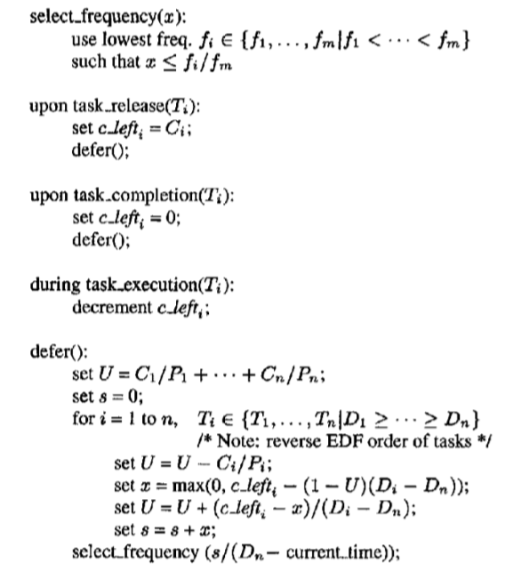

*Figure 3.10: The design of the LA-EDF scheduling policy in pseudocode [45], where T is a process, C is the worst-case execution time of a process, P is the period of a process and D is the deadline of a process.*

These steps are also illustrated visually in Figures 3.11a, b and c. 3.11a shows steps 1-2. The value of *s* in this example is found to be 3. For the sake of illustrating this in more of a real-world context, 3 will be scaled to 300Mhz. 3.11b shows steps 3-5. Assuming this algorithm was operating on a Raspberry Pi 3b+, 600Mhz would be selected for this task. Step 2 is also repeated to reset the value of *s* once the task has completed, which is 0Mhz in this example. Finally, step 3 is re-illustrated in Figure 3.11c; once again, in the context of the Pi, the frequency would remain at 600Mhz.

*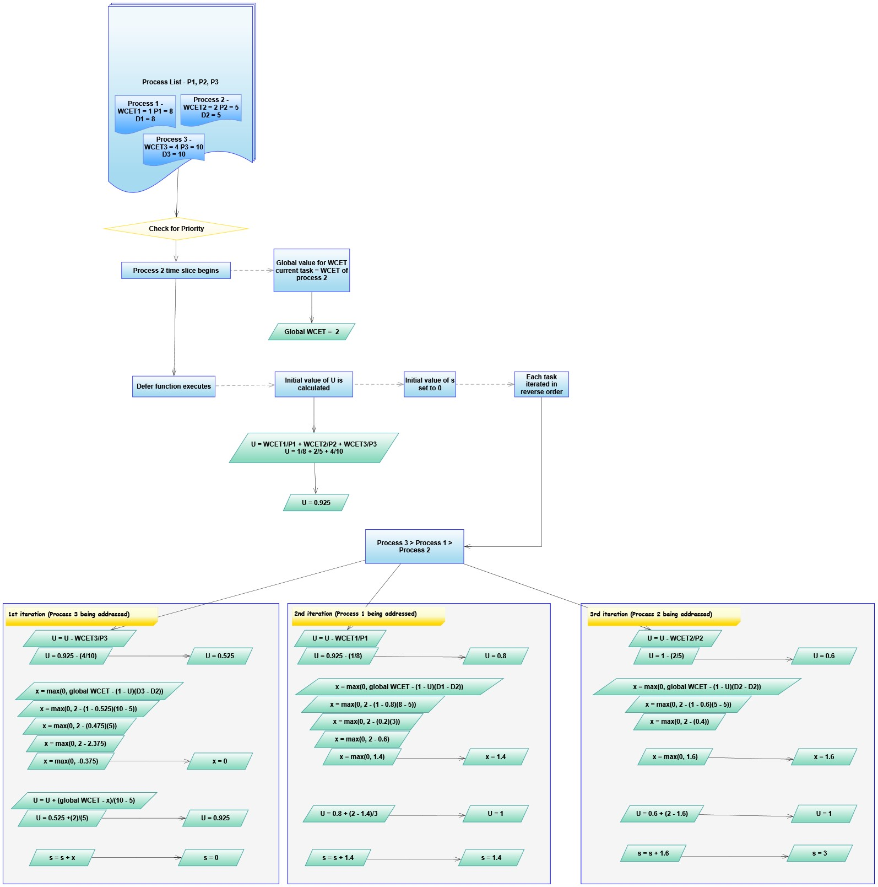Figure 3.11a: The highest priority process (process 2) begins. The global variable for the WCET is set to be equal to the WCET of process 2. Then, the defer function executes which calculates an initial value of* U*. It also finds the minimum frequency of each process (*x*) by iterating in reverse order. The cumulative value of* U *is updated after this is done. The total minimum frequency in MHz (*s*) is found by summing all values of* x.

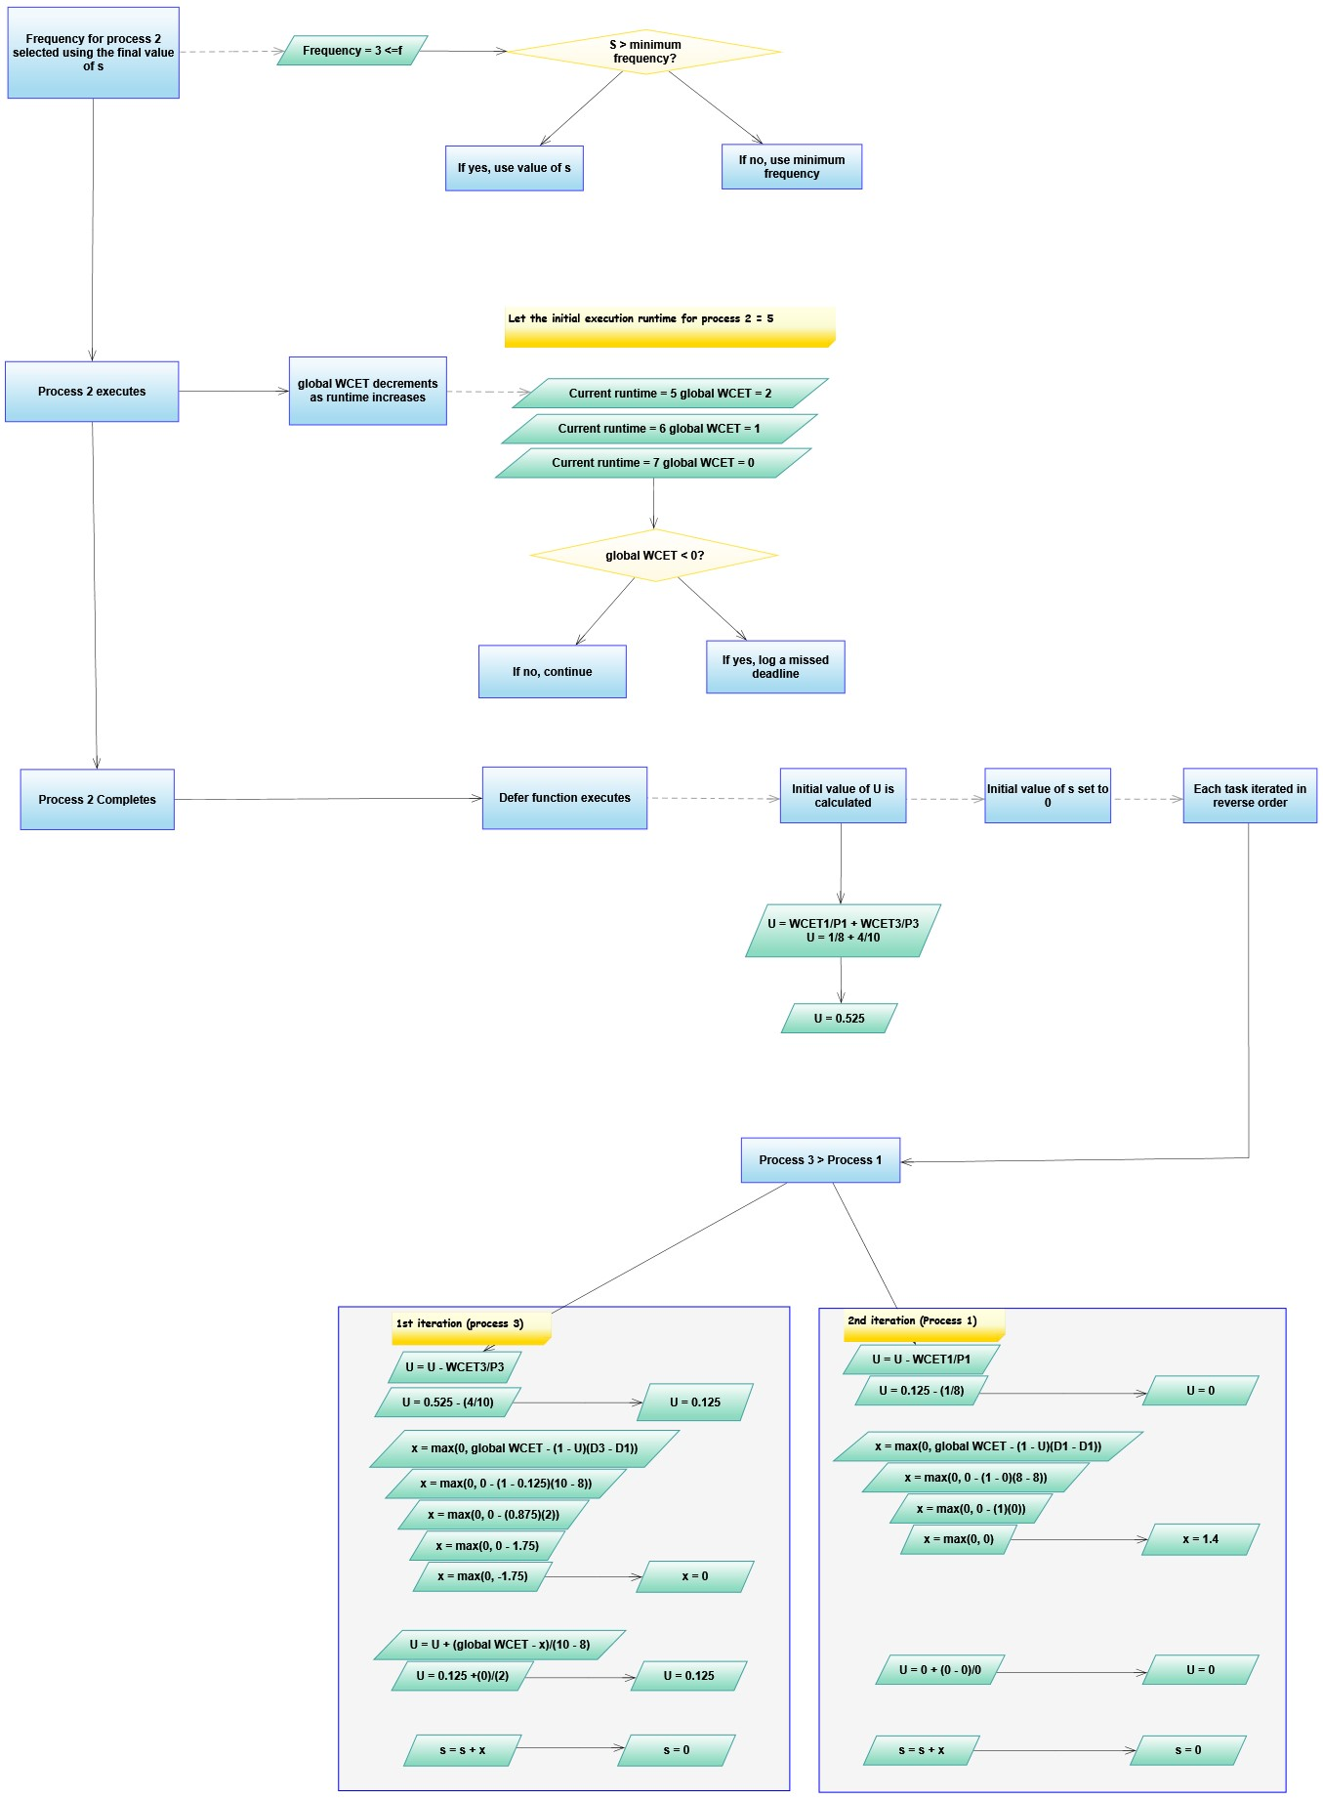*Figure 3.11b: Once the defer function completes, the appropriate frequency for the current process (process 2) is selected. This is done by choosing a frequency which is greater than or equal to the total minimum frequency (*s*). Then, process 2 will execute and the global WCET will decrease until the process is complete. The defer function is called again when the process does complete.*

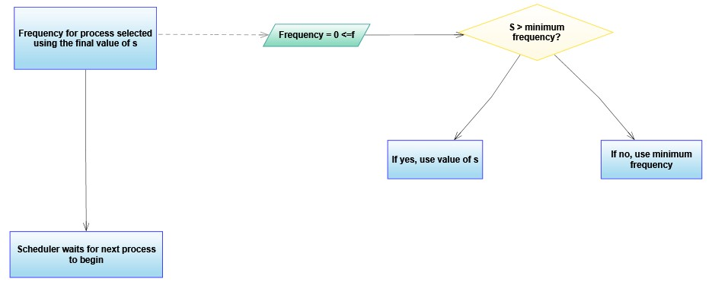

*Figure 3.11c: Finally, the new idle frequency is calculated (usually will be 0), and the scheduler waits for the next process in the system to get allocated its time slice.*

It would be interesting to see if this implementation of LA-EDF will result in a lower CPU frequency during system usage compared to the current implementation of the EDF scheduling policy.

Hypothetically speaking, this would result in lower CPU idle time since the same amount of work would be completed at a lower CPU frequency. A lower overall CPU frequency would mean the system is consuming less power for the same number of tasks, and therefore that the energy-efficiency of the system has been improved.

## Appendix 12 – Actual sched.h modifications in detail

To begin, the pid_alive function, which checks each process in the runqueue every time a new task transitions from one state to another. This prevents any potentially hung/zombied processes from taking up CPU attention and memory.

The modification will perform a check on the task’s current state before returning the process ID. The function will then call the ‘find_wcet’ function to obtain the worst-case execution time (WCET) of the current task if the current task has just begun or has not entered a state of execution yet. The ‘defer’ function is then called using this WCET.

If the task has completed and is stopping, the ‘defer’ function is called using a value of 0 as the WCET, since the task has completed and therefore will have an execution time of 0. The code for this function can be seen in Appendix Figure 4.

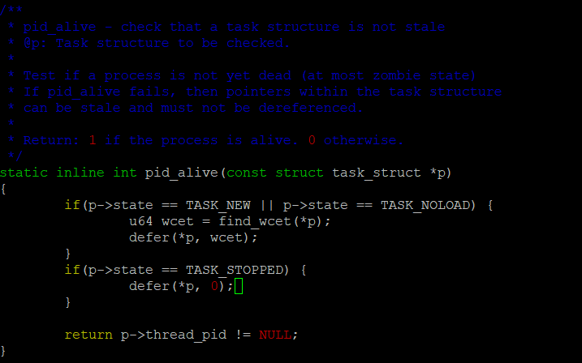

*Appendix Figure 6: Modified pid_alive function within sched.h. Before returning the process ID which the task belongs to, the task state is checked. If it is new, or has not yet began to execute, the ‘find_wcet’ function is called to obtain the WCET. The ‘defer’ function is then called. If the task has completed, only the ‘defer’ function is called using 0 as the WCET.*

The ‘find_wcet’ function – as seen in Appendix Figure 5 - also performs a check on the task status to ensure it has not been called erroneously. The task’s maximum runtime from the task’s dl structure is retrieved. The dl structure will only exist if the task is an RT task. As in the ‘pid_alive’ function, the runtime will only be retrieved if the task is new or has not yet began executing. If the task has completed, 0 shall be returned.

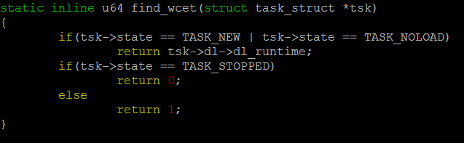

*Appendix Figure 7: New function ‘find_wcet’ which checks if the task is new or not yet began executing, or if it has completed. If it is new/not executing, the task’s maximum runtime is retrieved. If it is complete, this value is returned as 0.*

The ‘defer’ function shall be broken down into two parts. The defer function is referred to in algorithm step 2 in section 3.2.

The first part of the function obtains the initial value for total processor utilisation for each RT task in the runqueue, which can be seen in Appendix Figure 6. This is completed thusly:

First, the deadline is retrieved from the task structure. If the task is a SCHED_DEADLINE task, then this shall have a value. If not, then the rest of the function will not run, and the task shall be ignored. The initial utilisation and the total minimum frequency are both set to 0.

Each task is stored in a red-black tree which contains a full set of tasks for each runqueue. Next, this red-black tree which the task is stored on is retrieved.

The memory address of the last task in the red-black tree, as well as the current task, is found. If the tasks on the red-black tree are found to be SCHED_DEADLINE tasks, then they are used. Any non-SCHED_DEADLINE tasks are ignored.

Each SCHED_DEADLINE task’s WCET is found and added to the total value for processor utilisation (U). The tasks on the red-black tree are iterated through in EDF order.

As can be seen in Appendix Figure 6, the address of the last task on the red-black tree is obtained using the red-black tree’s ‘rb_last’ function. When the address of the current task is the same as the address of the last task in the red-black tree, the loop breaks since the end of the red-black tree has been reached.

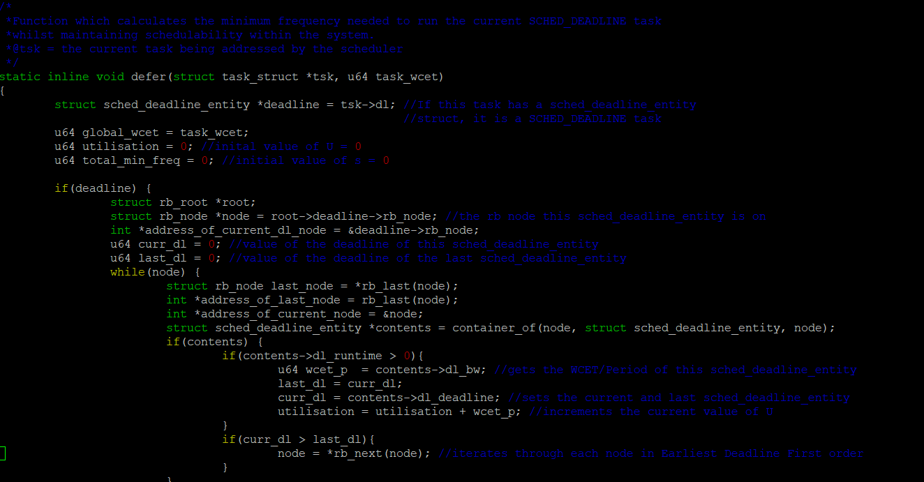

**

*Appendix Figure 8: First part of the new ‘defer’ function. The total initial utilisation is calculated using the total number of tasks on the current processor runqueue. This ‘utilisation’ value shall then be used in the second part of the ‘defer’ function.*

The second part of the ‘defer’ function can be seen in Appendix Figure 7. This part of the function iterates over the total number of tasks in the runqueue again, and this time obtains the minimum CPU frequency to run each one. The cumulative value for the new utilisation at this frequency is also calculated to ensure that the task-set remains schedulable.

The tasks are iterated in reverse-EDF order this time. This is another measure which ensures the task-set remains schedulable. The minimum frequencies for each task are summed into a total value. This value will then be used in the ‘select_freq’ function.

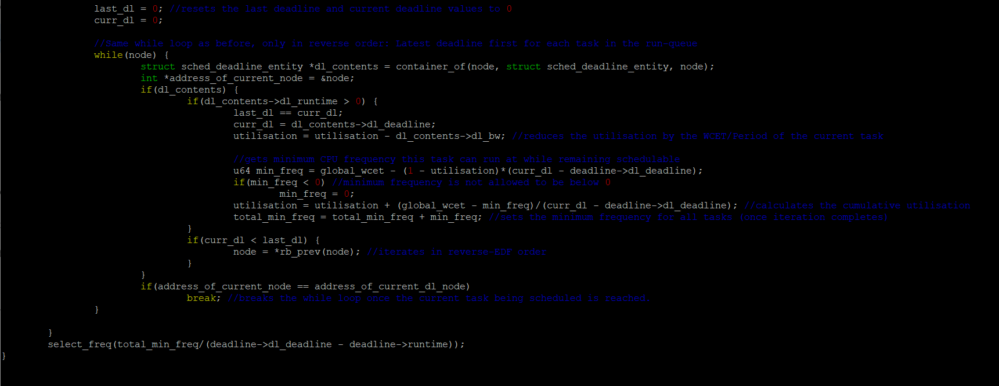

*Appendix Figure 9: The second part of the new ‘defer’ function. This segment of the function iterates over each SCHED_DEADLINE task in the processor runqueue and calculates the minimum frequency each task needs in order to remain schedulable. This time, the red-black tree is iterated over in reverse-EDF order.*

The final modification is another new function called ‘select_freq’. This function will simply perform a call to the Linux CPU frequency governor and instruct it on which governor to use. As seen in Appendix Figure 8, if the frequency value is less than or equal to the minimum selectable frequency, the Powersave governor shall be used. If the frequency value is greater than the minimum selectable frequency, the Performance governor shall be used.

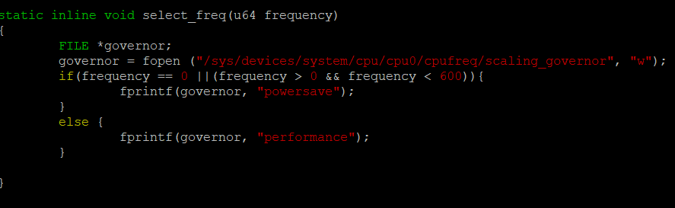

*Appendix Figure 10: New function ‘select_freq’ which opens the Linux CPU frequency governor, and tells it which governor to use (Powersave, or Performance) based on the value of the argument passed into the ‘select_freq’ function.*

# Test Cases and Results

## Social and Legal Considerations

There are no human subjects involved in the testing of this project. Since this is an airborne vehicle, considerations have been made regarding UK airspace laws and social boundaries. According UK government law [47], anybody can fly an MAV within UK airspace, as long as the height does not exceed 400ft, images taken do not break privacy and confidentiality laws, the vehicle does not come within 50 metres of another person, and the vehicle does not enter airports or interfere with other aircraft.

Addressing each of these concerns: the total height shall not exceed 2 metres, there is no camera fitted to the vehicle since this is outside the scope of the project, the tests will be taking place on private property (no testing shall occur when other people are passing by) and this private property is nowhere near any airports or large aircraft.

## 4.2 Test Case Metric Definitions

### 4.2.1 CollectD Metrics and Front-end RRD GUI

As concluded in section 2.1 of the Literature Review, the best method for collating resource utilisation metrics for this project will be through CollectD.

## Appendix 13 – Notes on CollectD in practice, the observer effect in practice and daemons

It has already been established that monitoring system metrics can inadvertently influence said metrics if the monitoring software is running on the system that it is gathering data from. The developers of CollectD must have known this and taken it into account, because the software itself is compiled as a system daemon.

A system daemon is similar to a process, but it runs exclusively in the background and cannot be interacted with by the user, or any other user-level process for that matter. This effectively minimises the observer effect by limiting the scope of the monitoring software to writing data to a round-robin database and nothing more.

These results can then be viewed using a web-based GUI front-end. There are three CollectD plugins which will be of relevance for this project: CPU, CPUFreq and Battery.

Table 4.1 details the resource utilisation metrics in greater detail. CPU states which are of significance here will be System, User, Wait-IO and Idle. System represents the amount of processing power which is being executed on a system-level, i.e. through system calls and kernel processes. User represents the amount of power being executed on a user level – through other non-system-level processes. Wait-IO represents the time spent by the processor interfacing with a peripheral. It is relevant here because the processor will interface with the Navio2 Shield a lot during flight. The Idle state represents when the CPU is not currently processing information.

The System, User, Wait-IO and Idle times shall be collected over the course of the MAV flight test. Then, an average of System (AvSystem), User (AvUser), Wait-IO (AvWait-IO) and Idle (AvIdle) states shall be calculated.

CPU states are measured in ‘jiffies. There are 100 jiffies in a second in Linux configurations, so for the purposes of this project, it is reasonable to treat jiffies as a CPU usage percentage.

The CPUFreq plugin collects data on the current frequency of the processor. In theory, this is where the modifications to SCHED_DEADLINE will be most apparent.

The CPU frequency (CPUfreq) shall be analysed from the start of the MAV flight test script – that is, when the MAV begins to rise into the air – to the end of the test script – when the vehicle lands. The average CPU frequency shall also be calculated (AvCPU Freq).

The Battery plugin collects data based on the current charge, voltage and current of the system’s power supply. Due to an oversight, this functionality will not be usable on the MAV. This is because an extra component for detecting battery metrics and relaying them to the Raspberry Pi was necessary for the computer to detect the power supply. This was not known, and the component was not incorporated into the design of the MAV before implementation.

So, for the purposes of this project only CPU state and CPU frequency data shall be recorded and analysed. Whilst an accurate view of energy efficiency cannot be entirely achieved, the comparison of these metrics between the unmodified and modified versions of the scheduler shall be a sufficient basis for future study.

In section 2.1.1 and 2.1.2 of the Literature Review, these metrics for resource utilisation are justified. A greater focus is placed on CPU frequency. However, it is still important to measure the CPU state as a general view of processor utilisation.

In Table 4.1, the metrics prefixed with $\frac{s}{\sqrt{n}}$ represent the margin of error for the averages, where *s* equals the standard deviation and $\sqrt{n}$ equals the square root of the number of data points used. The reason for doing this is because only a sample of all available data points are used when calculating an average.

|  |  |
| --- | --- |
| **Resource Allocation Metrics** | **Metric Description** |
| System (jiffies) | The number of scheduling ticks where the processor is dealing with a system-level process for any given data point. |
| User (jiffies) | The number of scheduling ticks where the processor is dealing with a user-level process for any given data point. |
| Wait-IO (jiffies) | The number of scheduling ticks where the processor is reading/writing to disk, interfacing with a peripheral, or waiting for another component to complete a task. |
| Idle (jiffies) | The number of scheduling ticks where the processor is not processing any information for any given data point. |
| AvSystem (jiffies) | The average number of scheduling ticks where the processor is dealing with a system-level process using sample data points. |
| AvUser (jiffies) | The average number of scheduling ticks where the processor is dealing with a user-level process using sample data points. |
| AvWait-IO (jiffies) | The average number of scheduling ticks where the processor is in a Wait-IO state using sample data points. |
| AvIdle (jiffies) | The average number of scheduling ticks where the processor is not processing information using sample data points. |
| CPUFreq (MHz) | The current frequency of the CPU in MHz for any given data point. |
| AvCPUFreq(MHz) | The average frequency of the CPU in MHz using sample data points. |
| $\frac{s}{\sqrt{n}}$ System/User/Idle/CPUFreq | Margin of error for the chosen data points when calculating the averages of the System, User, Idle and CPUFreq metrics. |

*Table 4.1: System Resource Utilisation metrics.*

The number of writes which occur may begin to affect system memory after a point. E.g. 1 write to the CollectD database every 30 seconds will be negligible to system resources. 1 write every 2 seconds may take a larger toll on the system. This would then be reflected in the metrics recorded and could skew results. For this reason, after some benchmark tests of running the automated flight script at varying write speeds, 1 write every 5 seconds was deemed to be a suitable compromise between regular metric-keeping and system memory conservation.

### 4.2.2 ArduCopter Flight Data Logs and Performance Metrics

The next step of the project’s implementation is to have a method of quantifying and analysing the performance metrics of the MAV during a flight mission to observe any energy-performance trade-off. This is done automatically as a feature in ArduPilot. For clarity, the relevant metrics shall be separated into two groups, which can be seen in Table 4.2 for group 1 and Table 4.3 for group 2.

The first group shall measure vehicle stability and heading over the course of the whole mission. Group 1 shall be called ‘Attitude’ and group 2 shall be called ‘Throttle and Altitude’. The justification for the metrics chosen to be measured in both groups can be found in section 2.4.1 and 2.4.3 of the Literature Review.

Stability is measured by comparing the desired yaw (DesYaw), pitch (DesPitch) and roll (DesRoll) of the vehicle with the actual yaw (Yaw), pitch (Pitch) and roll (Roll). The yaw shall be used as an identifier of the vehicles heading, i.e. where the vehicle is facing. The pitch and roll shall be used as an identifier of the vehicles tilt, i.e. how shallow/deep the vehicles stability on thehorizontaland vertical axes is.

The average of the desired pitch (AvDesPitch), yaw (AvDesYaw) and roll (AvDesRoll) shall be calculated and compared with the actual average of each respective metric (AvPitch, AvYaw, AvRoll).

Then, an average percentage of accuracy shall be found using the difference of these result sets. It can be seen in Table 4.2 that the yaw, pitch and roll metrics are measured in degrees.

As a further insight to accuracy, the greatest difference between the desired yaw, pitch and roll, and actual yaw, pitch and roll shall be recorded, as seen in Table 4.2 as MaxYawDiff, MaxPitchDiff and MaxRollDiff. The smallest difference shall also be recorded (MinYawDiff, MinPitchDiff, MinRollDiff).

|  |  |
| --- | --- |
| **Attitude metrics** | **Metric Description** |
| AvDesYaw (degrees) | Average desired yaw (rotation on the *y* axis) based on all sampled data points |
| AvDesPitch (degrees) | Average desired pitch (rotation on the *z* axis) based on all sampled data points |
| AvDesRoll (degrees) | Average desired roll (rotation on the *x* axis) based on all sampled data points |
| AvYaw (degrees) | Average actual yaw based on all sampled data points |
| AvPitch (degrees) | Average actual pitch based on all sampled data points |
| AvRoll (degrees) | Average actual roll based on all sampled data points |
| MaxYawDiff (degrees) | Greatest difference between the desired yaw and actual yaw |
| MinYawDiff (degrees) | Smallest difference between the desired yaw and actual yaw |
| MaxPitchDiff (degrees) | Greatest difference between the desired pitch and actual pitch |
| MinPitchDiff (degrees) | Smallest difference between the desired pitch and actual pitch |
| MaxRollDiff (degrees) | Greatest difference between the desired roll and actual roll |
| MinRollDiff (degrees) | Smallest difference between the desired roll and actual roll |

*Table 4.2: Attitude metrics which will be collected and analysed. Attitude represents the vehicles tilt and heading on the* x, y and z *axes.*

The metrics measured in group 2 will be the throttle – or thrust - of the MAV (Thl), what the current altitude should be (DAlt) and what the current altitude actually is (Alt). An average of the throttle, desired altitude and actual altitude over the course of the mission shall be collated. These metric definitions can be seen below in Table 4.3.

A desired throttle level is not recorded by ArduPilot. Considering that this software has been designed, compiled and built by a community of experts in the field of MAV technology, it will be assumed that a desired throttle speed is not necessary for MAV operation.

The minimum and maximum difference between the desired altitude and actual altitude will also be recorded, as can be seen in Table 4.3.

|  |  |
| --- | --- |
| **Throttle and Altitude Metrics** | **Metric Description** |
| Thl (pulse-width modulation) | Current throttle of the vehicle at any given data point |
| AvThl (PWM) | Average throttle of the vehicle |
| AvDAlt (Metres) | Average desired altitude of the vehicle based on all sampled desired altitude data points |
| AvAlt (Metres) | Average actual altitude of the vehicle based on all sampled actual altitude data points |
| MinAltDiff (Metres) | Smallest difference between the desired altitude and the actual altitude |
| MaxAltDiff (Metres) | Greatest difference between the desired altitude and the actual altitude |

## Appendix 14 – Measuring Throttle Using Pulse-Width Modulation Frequencies

The throttle, or acceleration, of an MAV is measured using Pulse-Width Modulation units, or PWM. This is a method of controlling the amount of power sent to an electrical device by very rapidly switching the flow of electricity on and off. The higher the PWM value, the longer the flow of electricity is switched on [46].

This is an optimal way of making slight alterations to electrical components which drive moving parts, particularly motors. Examples of this technology can be seen in railway lines, some aeronautical components and MAVs, of course.

By observing the PWM, a general idea of MAV acceleration can be obtained, assuming that <0 is no acceleration at all, and 1 is maximum acceleration.

*Table 4.3: Throttle and Altitude metrics. This represents thrust and altitude.*

### 4.2.3 Automated Flight Script

To maximise flight consistency, an automated flight script has been written in Python. The script implements DroneKit, which is a set of libraries that allows an MAV to interface with high-level flight commands. This allows users to program an MAV easily without having to know domain-specific code ArduPilot code. This flight script will be executed three times, using both EDF and LA-EDF. Averages of each metric shall be calculated using each test flight on both schedulers. So, a total of 6 tests shall be made – 3 using EDF and 3 using LA-EDF.

This script will consist of the following steps. Each step is accompanied with a figure which describes the code in greater detail:

1. Connect to the MAV, as seen in ‘connectMyCopter’ in Figure 4.1. The IP address and port number the vehicle is listening on are provided by the user. Safety checks are made to ensure that all hardware is functioning and interfacing correctly with ArduPilot. This functionality can be observed within ‘arm_and_takeoff’ with the ‘is_armable’ flag.

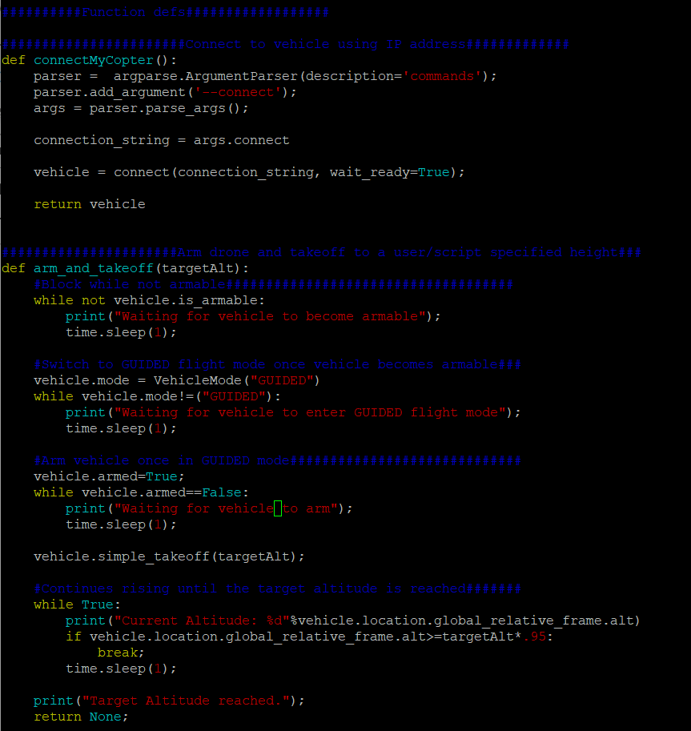

*Figure 4.1: The functions in the flight script which connect to the vehicle, (connectMyCopter()) perform safety checks, arm the vehicle and take off to a specified altitude (arm_and_takeoff(targetAlt))*

1. The MAV will arm and take off to an altitude of 2 metres. This can be seen within ‘arm_and_takeoff’ on the line ‘vehicle.simple_takeoff(targetAlt)’ in Figure 4.1.
2. The MAV will begin circling the test area. It will do this by travelling North, East, South and West each for 1 second. As can be seen in the ‘time.sleep(1)’ command located in the ‘while counter<1’ loop in Figure 4.2, a brief pause will be made between directions to give a better view of when the MAV is changing direction. The MAV circles the test area 3 times.

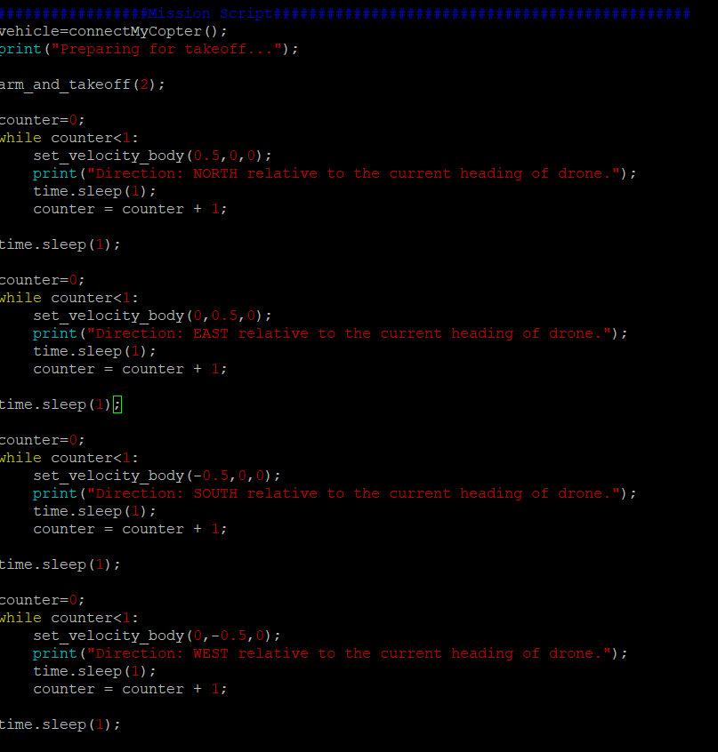

*Figure 4.2: The script which controls where the MAV flies. The vehicle moves on a North bearing, then East, South and West to achieve a full circle of the test area.*

1. The MAV will disarm and the connection to the flight script shall be severed. In Figure 4.3, we see that this is accomplished by putting the vehicle in ‘Land’ mode. The version of ArduPilot is printed and the connection is closed.

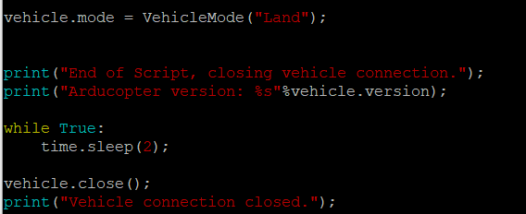

*Figure 4.3: The drone enters ‘land’ mode, returns to the ground and remains stationary for 2 seconds. The connection to the vehicle is then closed.*

## EDF Test Results

### 4.3.1 Resource Utilisation Results

In Figure 4.4, processor utilisation on each core from approximately 19:27– 19:32 can be seen. Figure 4.5 shows the processor utilisation from 19:35 – 19:40. The flight script for each test was executed at 19:27:20, 19:28:00 and 19:35:00 respectively. Each test took 25 seconds to complete.

When studying Figure 4.4 and Figure 4.5, the idle state for each processor is upwards of 70 jiffies. It can be hypothesised that the idle state for each processor will decrease during the LA-EDF tests. This is because, in theory, the overall CPU frequency shall be lower, and the processor shall have less cycles to complete the task set.

The granularity of these results cannot be any finer than shown in Figure 4.4 and 4.5 due to data being recorded once every 5 seconds. For each test, five data points shall be selected – five second increments from the beginning to the end of each test.

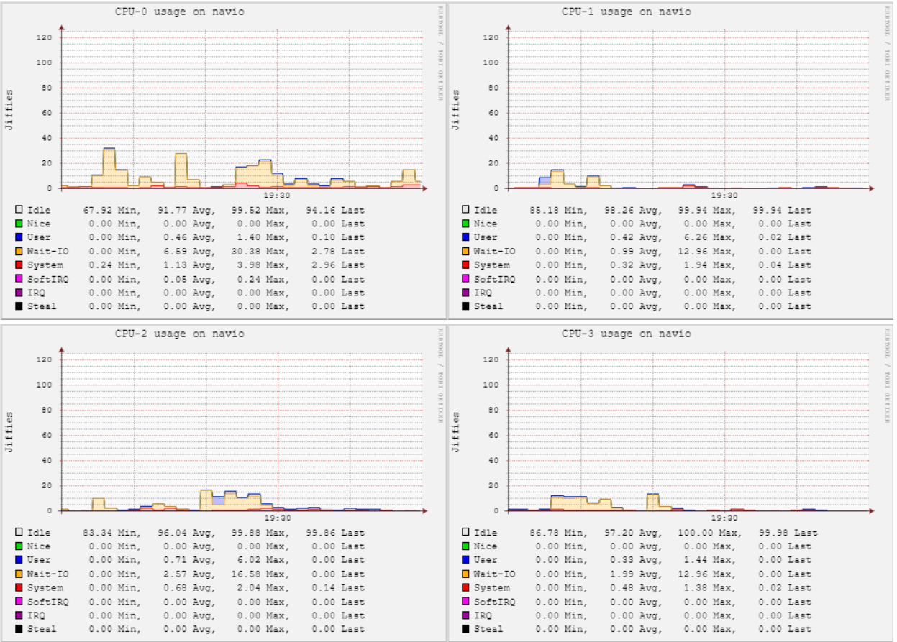

*Figure 4.4: The CPU state of all processor cores during flight script test 1 (19:27) and 2 (19:28) using the unmodified Linux Process Scheduler.*

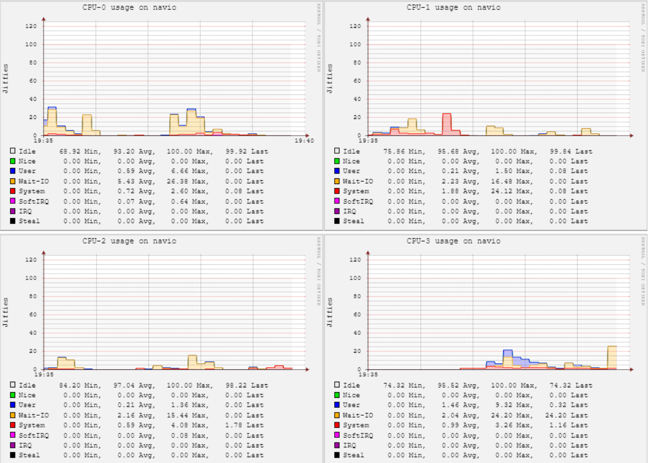

*Figure 4.5: The CPU state of all processor cores during flight script test 3 (19:35) using the unmodified Linux Process Scheduler.*

Table 4.4 takes each CPU state metric for each flight and uses their values to generate average values.

|  |  |  |  |  |  |
| --- | --- | --- | --- | --- | --- |
|  | **Time** | **System** | **User** | **Wait-IO** | **Idle** |
| **EDF Test 1** | 19:27:25 | 3 | 8 | 20 | 369 |
| 19:27:30 | 3 | 3 | 55 | 339 |
| 19:27:35 | 3 | 3 | 45 | 349 |
| 19:27:40 | 2 | 2 | 30 | 366 |
| 19:27:45 | 2 | 2 | 30 | 366 |
| **EDF Test 2** | 19:28:00 | 4 | 5 | 15 | 376 |
| 19:28:05 | 4 | 3 | 25 | 368 |
| 19:28:10 | 4 | 3 | 25 | 368 |
| 19:28:15 | 5 | 0 | 21 | 374 |
| 19:28:20 | 5 | 1 | 21 | 373 |
| **EDF Test 3** | 19:35:00 | 2 | 8 | 10 | 380 |
| 19:35:05 | 4 | 8 | 10 | 378 |
| 19:35:10 | 5 | 9 | 28 | 358 |
| 19:35:15 | 4 | 3 | 21 | 372 |
| 19:35:20 | 4 | 3 | 21 | 372 |
|  | | | | | |
|  | **AvSystem** | **AvUser** | **AvWaitIO** | **AvIdle** | $\frac{s}{\sqrt{n}}$**System** | $\frac{s}{\sqrt{n}}$**User** | $\frac{s}{\sqrt{n}}$**Wait-IO** | $\frac{s}{\sqrt{n}}$**Idle** |
| **EDF Test 1** | 2.6 | 3.6 | 36 | 357.8 | 0.22 | 1.00 | 5.29 | 5.26 |
| **EDF Test 2** | 4.4 | 2.4 | 21.4 | 371.8 | 0.22 | 0.78 | 1.64 | 1.45 |
| **EDF Test 3** | 3.8 | 6.2 | 18 | 372 | 0.44 | 1.18 | 3.14 | 3.64 |

*Table 4.4: System utilisation metrics collected for the MAV during the test script. This result set is for the unmodified Linux Scheduler.*

Table 4.5 shows the overall average taken using the averages from each test. A margin of error is also calculated for these results. These values will be considered the final results for EDF CPU states and shall be compared with the LA-EDF results.

The Error Range metric shows the range of values that the overall average for each state could have been when taking the margins of error into account.

|  |  |  |  |  |  |  |  |
| --- | --- | --- | --- | --- | --- | --- | --- |
| **Overall AvSystem** | **Overall AvUser** | **Overall Wait-IO** | **Overall AvIdle** | **Overall $\frac{s}{\sqrt{n}}$ System** | **Overall $\frac{s}{\sqrt{n}}$ User** | **Overall $\frac{s}{\sqrt{n}}$ Wait-IO** | **Overall Idle** |
| 3.6 | 4.1 | 25.1 | 367.2 | 0.43 | 0.92 | 4.51 | 3.84 |
| **System Error Range** | **User Error Range** | **Wait-IO Error Range** | **Idle Error Range** |
| 3.58 – 3.62 | 4.06 – 4.14 | 24.0 – 26.2 | 353.1 – 381.3 |

*Table 4.5: The total averages for System, User and Idle processor states. The margins of error for each, as well as an error range, are also provided.*

The final results for the average System, User, Wait-IO and Idle states during the tests are observed to be 3.6, 4.1, 25.1 and 367.2 jiffies for each respective state. It was hypothesised that the overall CPU utilisation would be higher than this due to the number of RT operations occurring within the vehicle. Looking at the results, this is evidently not the case.

This final set of results obtained from Table 4.5 shall be used as a frame of reference for normal resource utilisation using EDF when observing results using LA-EDF.

The results for the CPU frequency during the test script were less interesting. As seen by Figure 4.5, the CPU frequency remained consistently at 1400Mhz during all three tests.

The reason for this is simple: in Linux, CPU frequency is maintained and changed by a governor. There are two governors within the configuration being used for this project: Performance, which ensures clock speed is always at maximum, and Powersave, which ensures clock speed is always at minimum.

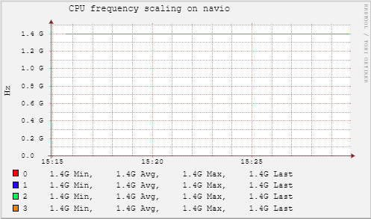*Figure 4.6: CPU Frequency over the course of all three tests. The CPU frequency remained at 1.4Ghz, which is maximum performance.*

### 4.3.2 MAV Performance Results

Figure 4.7 shows the desired pitch (red) against the actual pitch (green) for test 1. Figure 4.8 and 4.9 show this for test 2 and 3, respectively.

24-hour time is not recorded in the logs; a timer begins counting from the time that ArduPilot starts, hence why each test begins at a seemingly arbitrary time, as exemplified in Figure 4.6, 4.7 and 4.8.

The Roll is documented in the same manner in Figures 4.10, 4.11 and 4.12. The Yaw is documented in Figures 4.13, 4.14 and 4.15.

Mission Planner calculates the minimum, maximum and mean automatically.

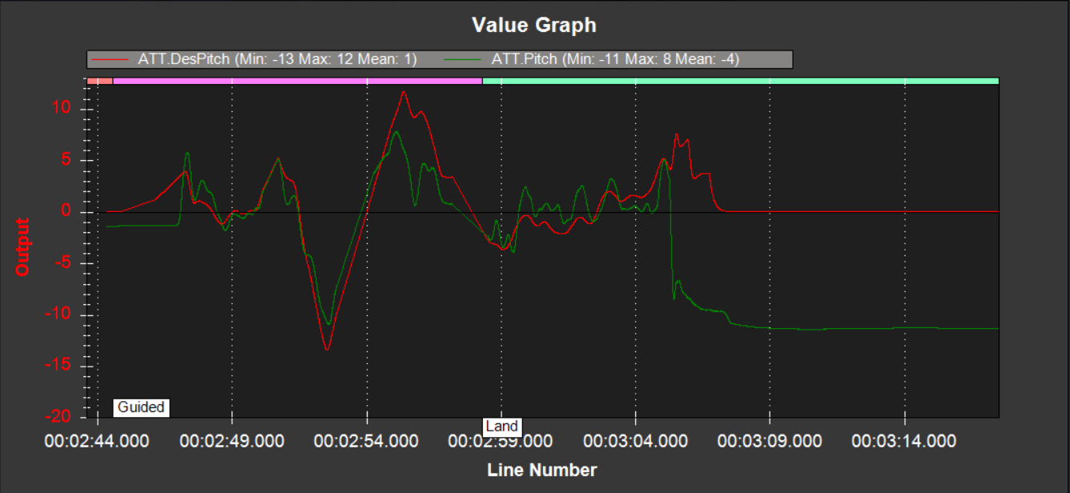

*Figure 4.7: Desired Pitch (red) compared to Actual Pitch (green) over time for Test 1.*

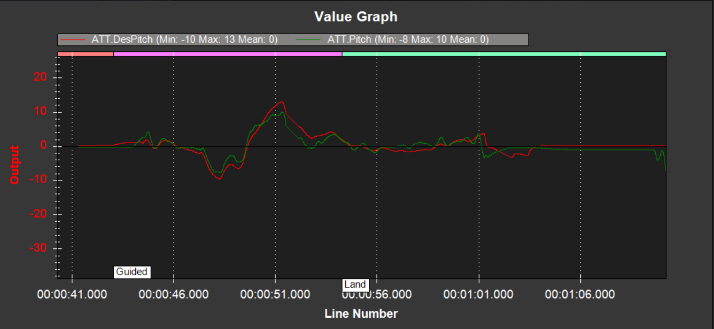

*Figure 4.8: Desired Pitch (red) compared to Actual Pitch (green) over time for Test 2.*

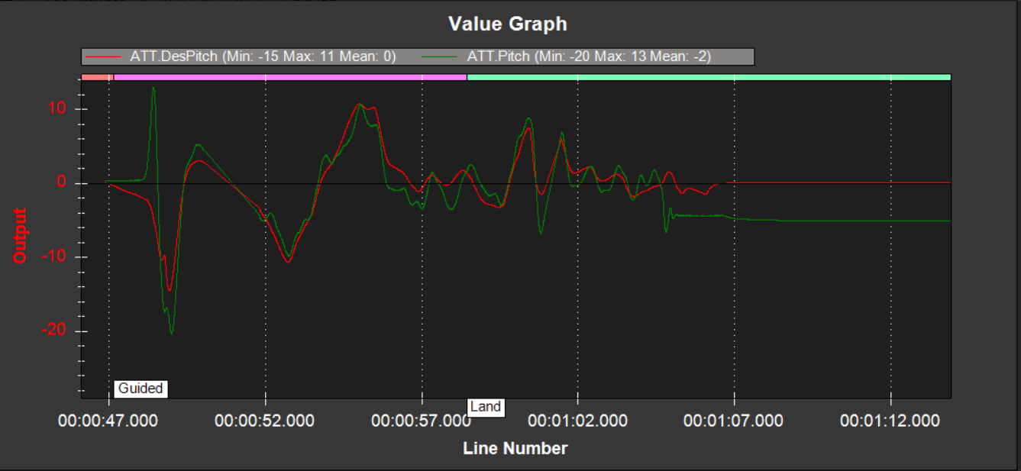

*Figure 4.9: Desired Pitch (red) compared to Actual Pitch (green) for Test 3.*

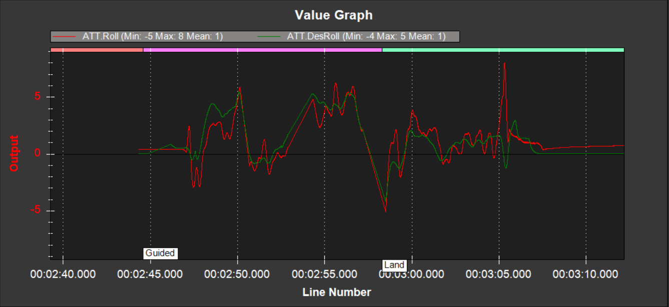

*Figure 4.10: Desired Roll (red) compared to Actual Roll (green) for Test 1.*

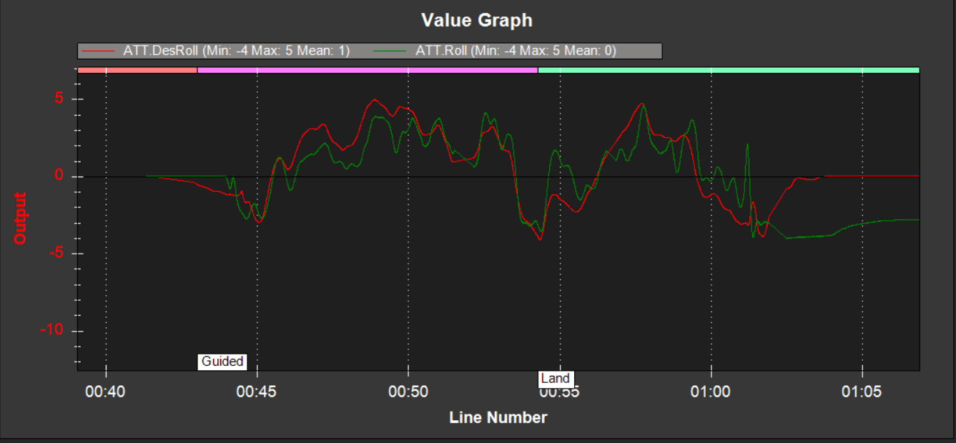

*Figure 4.11: Desired Roll (red) compared to Actual Roll for Test 2.*

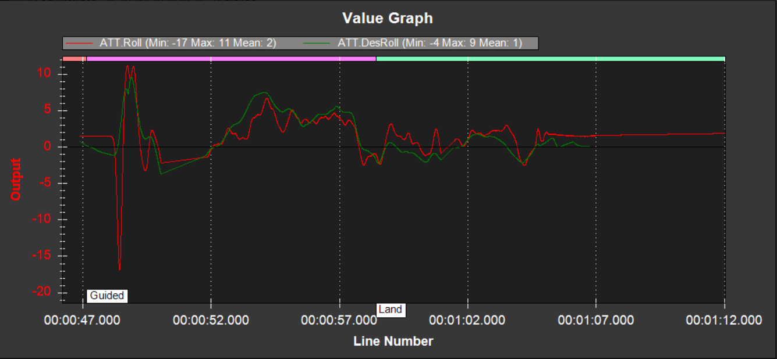

*Figure 4.12: Desired Roll (red) compared to Actual Roll for Test 3.*

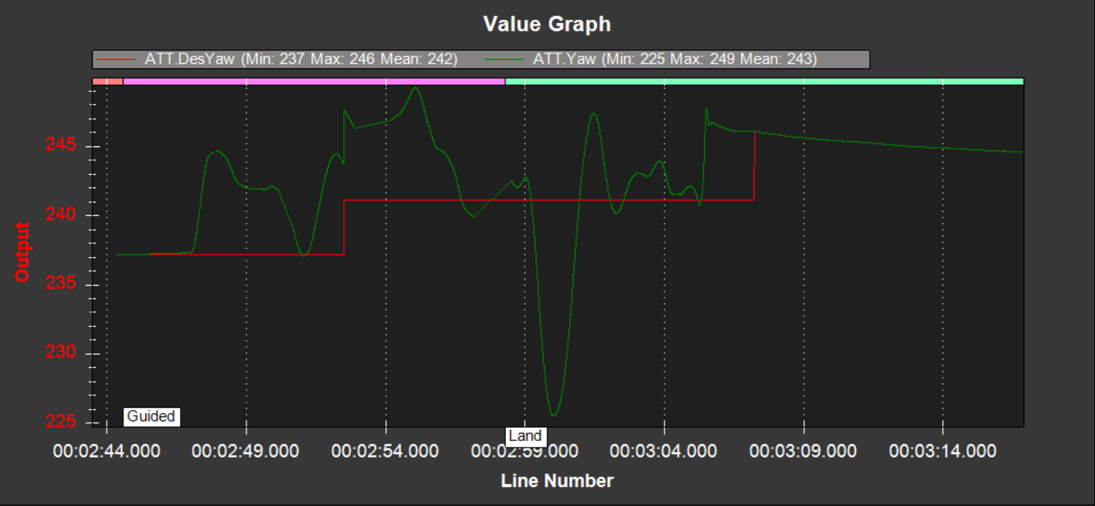

*Figure 4.13: Desired Yaw compared to Actual Yaw for Test 1.*

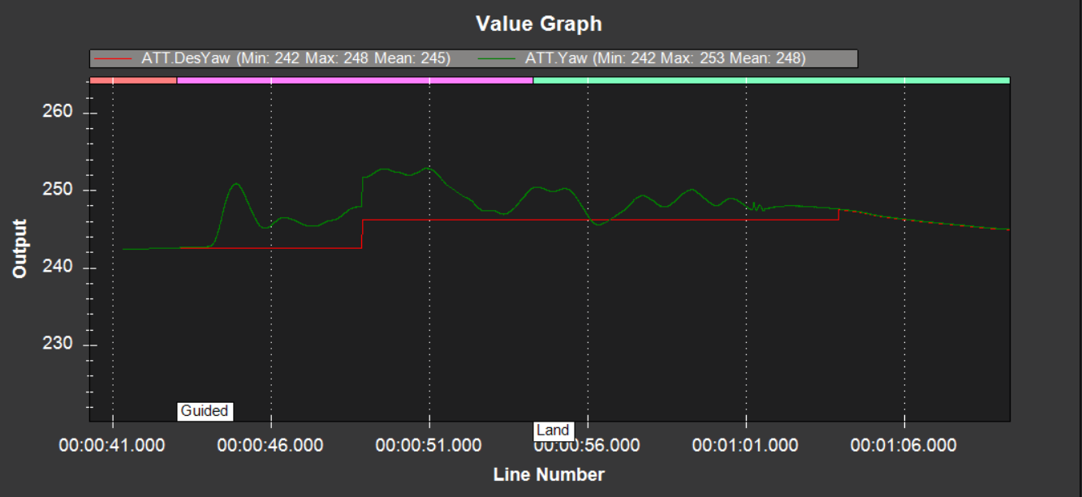

*Figure 4.14: Desired Yaw compared to Actual Yaw for Test 2.*

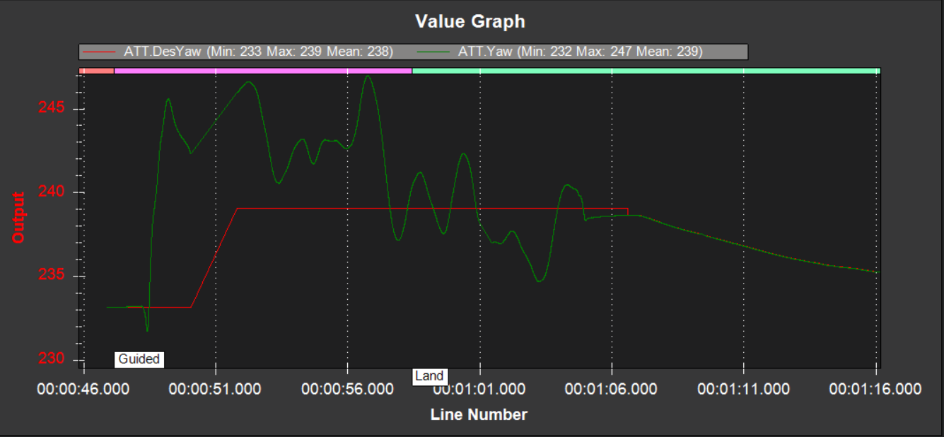

*Figure 4.15: Desired Yaw compared to Actual Yaw for Test 3.*

Table 4.6 shows the collated mean results for each test. The table includes the Pitch, Roll and Yaw for each test.

In Table 4.7, the minimum and maximum differences between the desired and actual metrics for each test are shown. Once again, below these results are the average minimum and maximum differences.

These final values for the average desired metrics, actual metrics and differences between desired and actual metrics shall represent the overall ‘Attitude’ performance of the MAV using EDF.

|  |  |  |  |  |  |  |
| --- | --- | --- | --- | --- | --- | --- |
|  | **AvDesPitch** | **AvDesRoll** | **AvDesYaw** | **AvPitch** | **AvRoll** | **AvYaw** |
| **EDF Test 1** | 1° | 1° | 242° | -4° | 1° | 243° |
| **EDF Test 2** | 0° | 1° | 245° | 0° | 0° | 248° |
| **EDF Test 3** | 0° | 2° | 238° | -2° | 1° | 239° |
|  |  |  |  |  |  |  |
|  | **Overall AvDesPitch** | **Overall AvDesRoll** | **Overall AvDesYaw** | **Overall AvPitch** | **Overall AvRoll** | **Overall AvYaw** |
|  | 0.33° | 1.33° | 241.67° | -2° | 0.67° | 243.33° |

*Table 4.6: The average desired pitch, roll and yaw compared to the average actual pitch, roll and yaw for each test case. The overall averages for all test cases are shown below these results.*

|  |  |  |  |  |  |  |
| --- | --- | --- | --- | --- | --- | --- |
|  | **MaxPitchDiff** | **MinPitchDiff** | **MaxRollDiff** | **MinRollDiff** | **MaxYawDiff** | **MinYawDiff** |
| **EDF Test 1** | 15.07° | 0.20° | 7° | 0.10° | 15.62° | 0.46° |
| **EDF Test 2** | 4.33° | 0.63° | 5.03° | 0.97° | 8.33° | 0.68° |
| **EDF Test 3** | 17.45° | 0.44° | 17.48° | 0.20° | 12.44° | 0.41° |
|  |  |  |  |  |  |  |
|  | **Average MaxPitchDiff** | **Average MinPitchDiff** | **Average MaxRollDiff** | **Average MinRollDiff** | **Average MaxYawDiff** | **Average MinYawDiff** |
|  | 12.28° | 0.42° | 9.84° | 0.42° | 12.13° | 0.52° |

*Table 4.7: The minimum and maximum differences between the desired pitch, roll and yaw, and the actual pitch, roll and yaw for each test case. The overall average differences are shown below these results.*

There is discrepancy between the overall average desired metrics and the actual metrics. This discrepancy is minimal – 1.67°, 0.66° and 1.66° for pitch, roll and yaw respectively.

The average minimum difference for each metric was consistently below 1°. This is a good thing as it means that the vehicle has always managed to meet its attitude requirements within one degree at least once for each test case.

The average MaxPitchDiff was 12.28°. The MaxRollDiff was 9.84°, and the MaxYawDiff was 12.13°. For high-precision missions this may be problematic. However, for the scope of this project it has not resulted in failure, i.e. a crash. It can therefore be considered acceptable. So, for this project, an average maximum difference of up to 12.28° will be the frame of reference as to what is considered an acceptable difference between desired and actual attitude metrics.

Figure 4.16 – 4.18 show the desired altitude compared to the actual altitude for tests 1 – 3 respectively.

It can also be seen in Figures 4.16 – 4.18 that the minimum altitude is -1 metre. The reason for this is that the landing area was consistently at a lower elevation from where the vehicle took off. Although the guidance system for landing is accurate, it is not perfect, and unavoidably, some inconsistencies occurred.

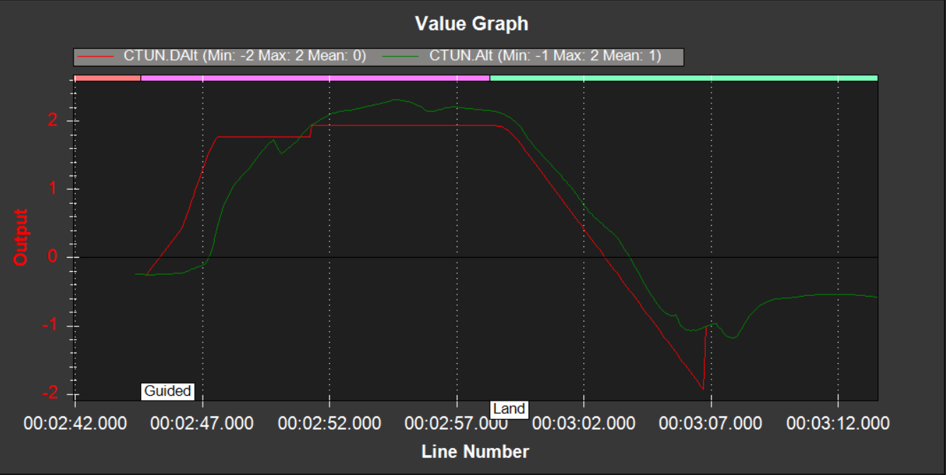

*Figure 4.16: Desired altitude compared to actual altitude for test case 1*

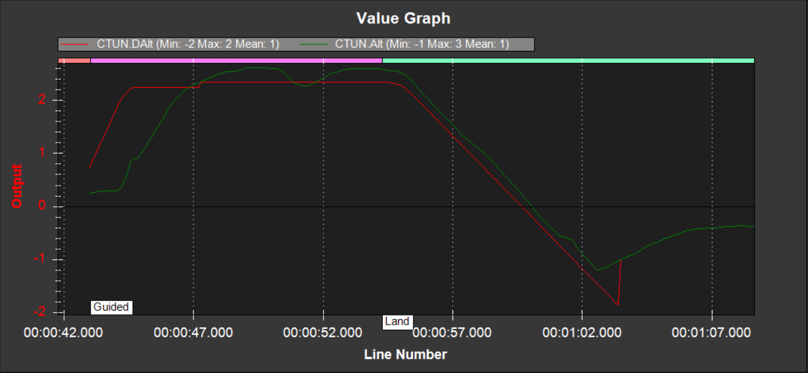

*Figure 4.17: Desired altitude compared to actual altitude for test case 2*

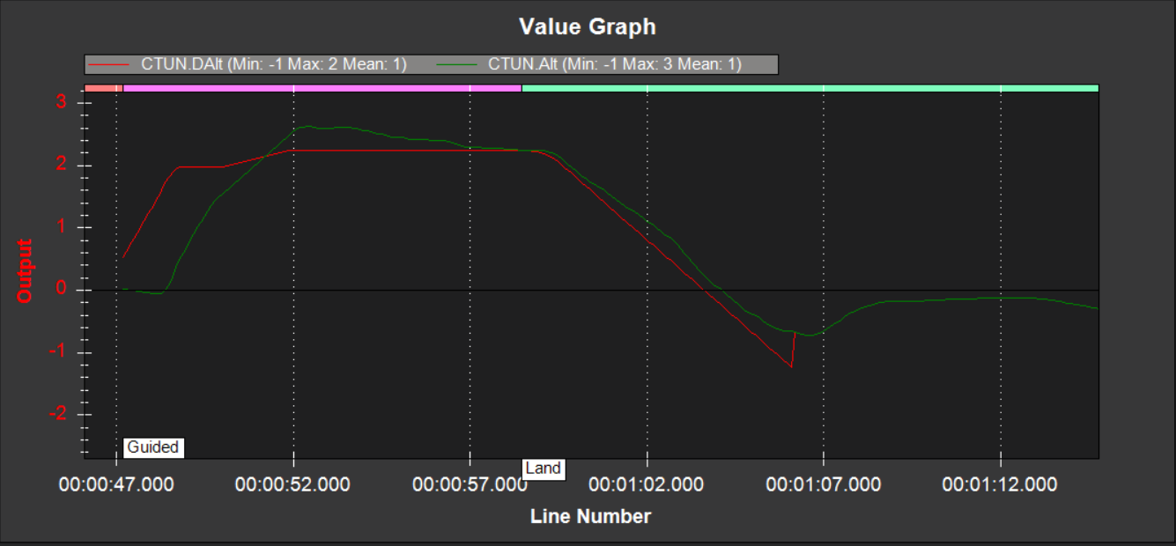

*Figure 4.18: Desired altitude compared to actual altitude for test case 3*

Figures 4.19 – 4.21 show the throttle metrics for test cases 1 – 3 respectively. Any potential thrust-loss in the LA-EDF tests shall be notated by comparing the overall average throttle in both the EDF and LA-EDF tests.

As seen in each figure, the PWM dips below 0 towards the end of each test. This is the point at which the vehicle has landed. If we compare Figure 4.16 to 4.19, Figure 4.17 to 4.20, Figure 4.18 to figure 4.21 we see the time at which the altitude falls to its minimum is equal to the time at which the throttle falls below 0.

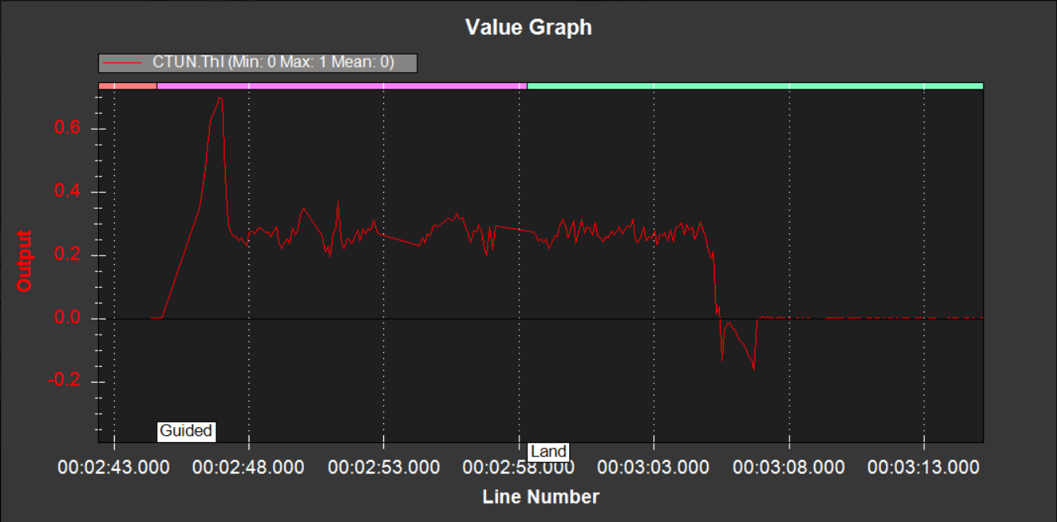

*Figure 4.19: The throttle in PWM for test case 1*

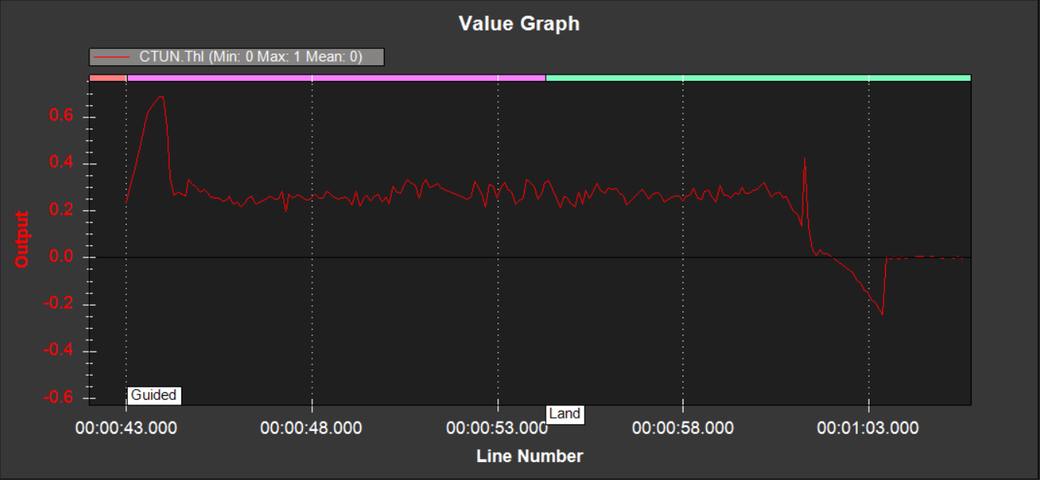

*Figure 4.20: The throttle in PWM for test case 2*

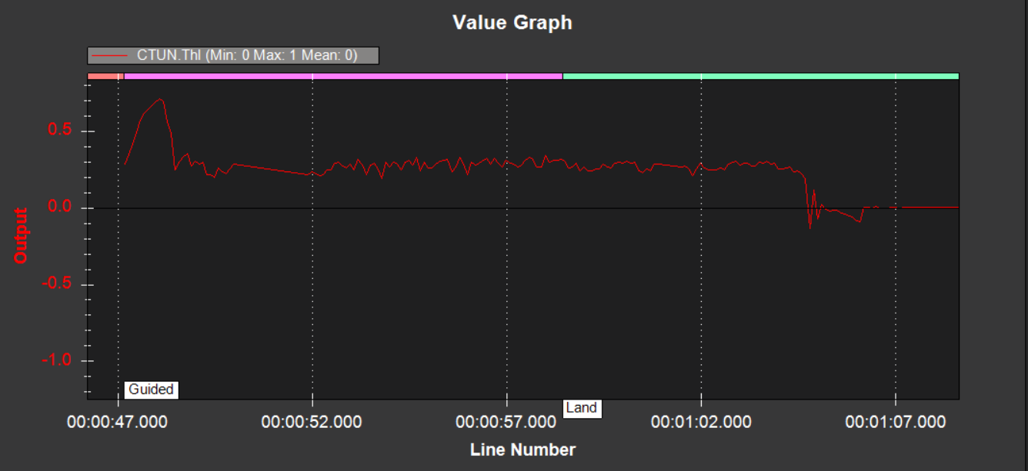

*Figure 4.21: The throttle in PWM for test case 3*

|  |  |  |  |  |  |  |  |  |  |
| --- | --- | --- | --- | --- | --- | --- | --- | --- | --- |
|  | **AvDesAlt** | **AvAlt** | **Alt =>2 from flight – landing?** | **MaxAltDiff** | | **MinAltDiff** | | **AvThl** | |
| **EDF Test 1** | 0 metres | 1 metre | Yes | 0.42 metres | | 0.03 metres | | 0 PWM | |
| **EDF Test 2** | 1 metre | 1 metre | Yes | 0.28 metre | | 0.10 metres | | 0 PWM | |
| **EDF Test 3** | 1 metre | 1 metre | Yes | 0.29 metres | | 0.01 metres | | 0 PWM | |
|  |  |  |  |  | |  | |  | |
|  | **Overall AvDesAlt** | **Overall AvAlt** | **Overall MaxAltDiff** | | **Overall MinAltDiff** | | **Overall AvThl** | |
|  | 0.67 metres | 1 metre | 0.33 metres | | 0.05 metres | | 0 PWM | |

*Table 4.8: Average desired altitude and actual altitude as well as the average throttle. The minimum and maximum difference between the desired altitude and actual altitude is also recorded. The overall averages for all test cases are shown below these results.*

Table 4.8 shows the average desired and actual altitude along with the maximum and minimum differences between the desired and actual altitudes. The average throttle is also shown here.

The altitude was consistent throughout each test case, with overall AvDesAlt being 0.67 metres and overall AvAlt being at 1 metre. This means that, on average, the actual altitude was within 0.33 metres of the desired altitude.

The altitude reached a maximum of 0.42 metres higher than the desired altitude. The average MaxAltDiff was 0.33 metres, which matches the difference between overall AvDesAlt and overall AvAlt. This encouraging: it shows the MAV can accurately process altitude instructions, calculate its altitude and maintain a specified height.

The maximum difference between DesAlt and Alt has been measured from the point at which the vehicle completes take-off and begins executing velocity commands. In Figures 4.16 to 4.18, this can be identified once the altitude has reached 2 metres.

The overall average for throttle PWM was seen to be 0. From this, we can assume that any average falling below 0 would indicate thrust-loss, and a decrease in performance. We can also ascertain that any test case in which the altitude falls below 2 metres can be considered a loss of altitude.

## LA-EDF Test Results

### 4.4.1 Resource Utilisation Results

Figure 4.22 – 4.24 show the CPU states for tests 1, 2 and 3 respectively. Test 1 for the modified scheduler began at 19:37:10, but this initial test resulted in a crash. Thankfully, the damage was minimal, and after replacing a broken propeller the vehicle was operational again. The test ran for approximately 12 seconds before the crash occurred. The motors kept spinning for approximately 10 seconds before disarming.

Test 2 ran more smoothly, but it can be seen from Figure 4.23 that a large spike in the System and User utilisation occurs on the fourth processor core from about 19:54:00 to 19:56:30 after the test has completed. What causes this spike is unknown. While there is not enough information to say it was a result of the LA-EDF modification, it is not possible to rule this out entirely.

Test 2 began at 19:52:00 and ran for 25 seconds. Test case 3 began at 19:57:00 and executed for 35 seconds. Upon landing, the MAV seemed to incorrectly gauge its altitude and attempted to take-off again. It was given a moment to correct itself, and when it was observed that it could not, the vehicle was landed manually.

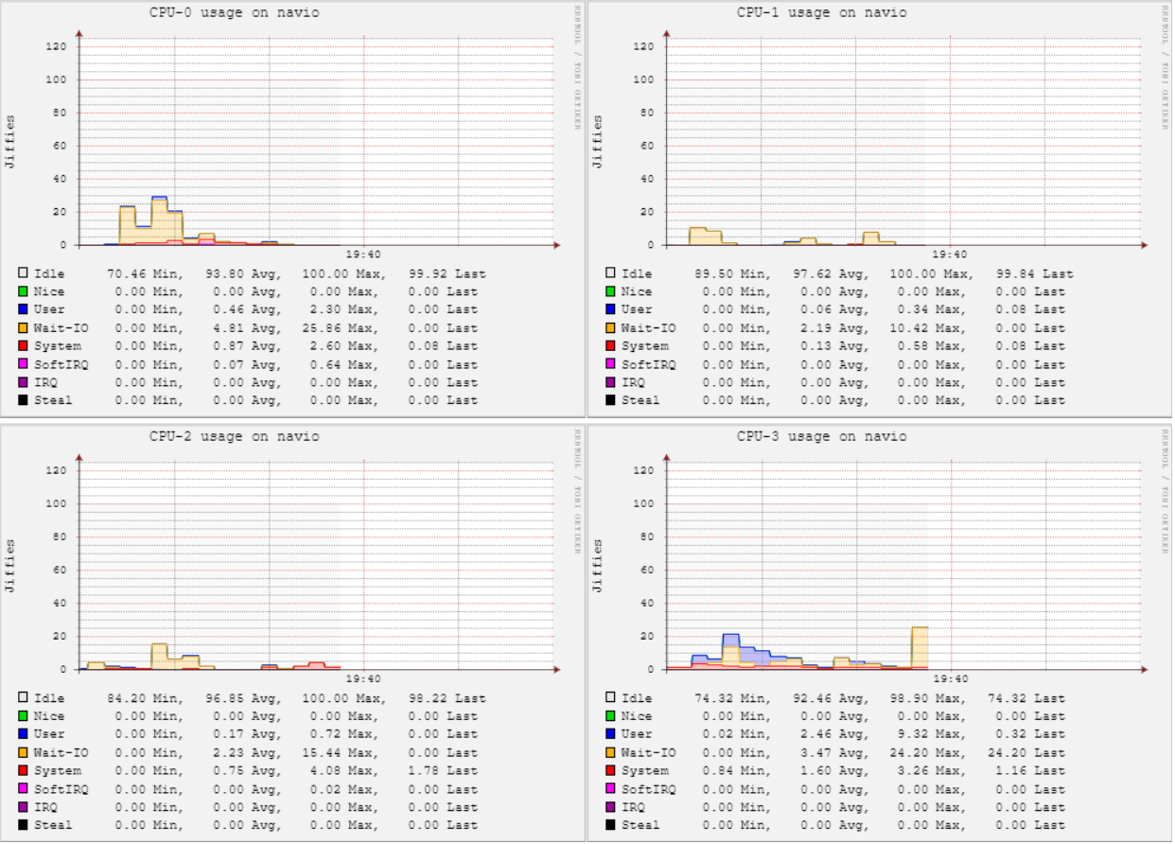

*Figure 4.22: The CPU states (User, System, Wait-IO and Idle) for Test 1 using LA-EDF*

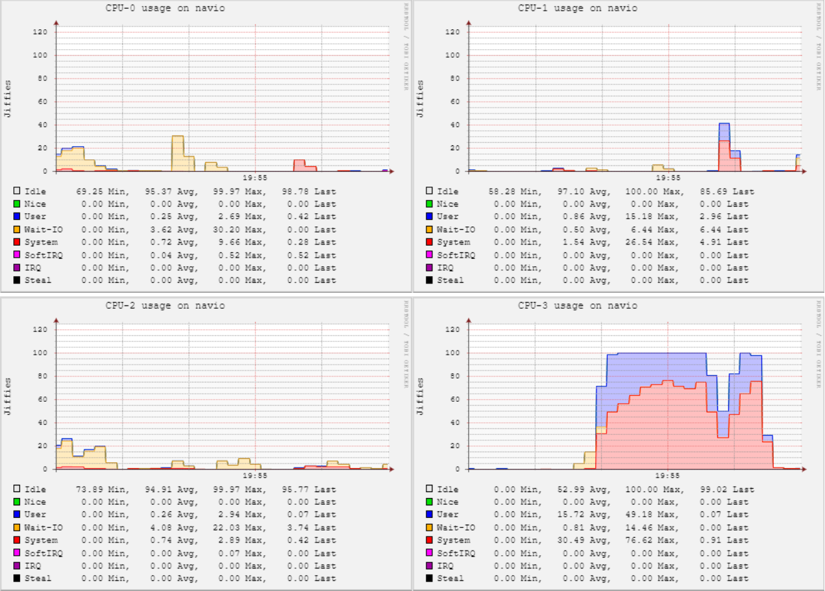

*Figure 4.23: CPU states (User, System, Wait-IO and Idle) for Test 2 using LA-EDF*

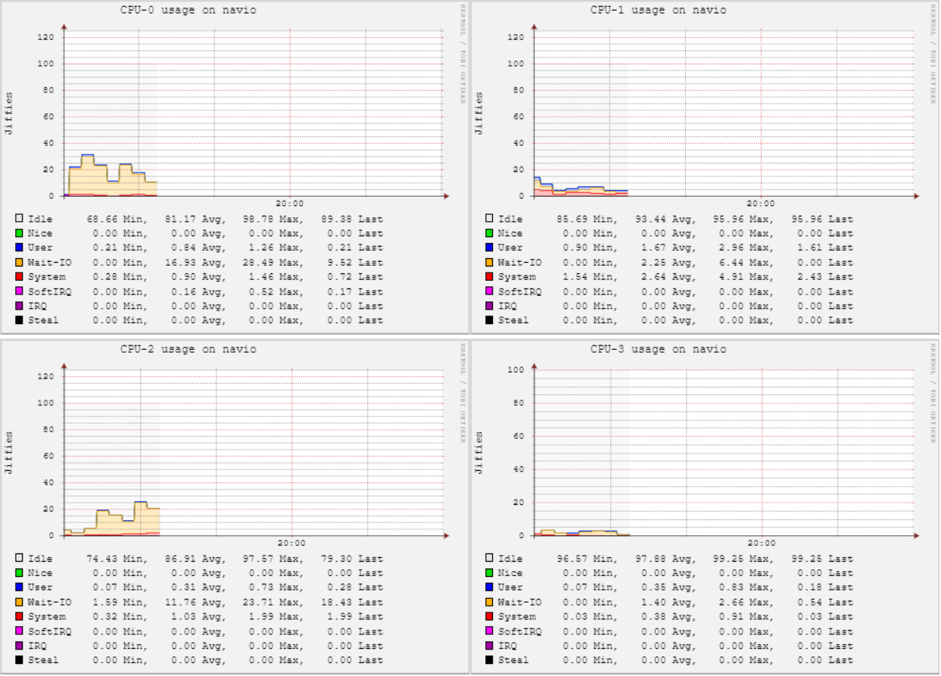

*Figure 4.24: The CPU states (User, System, Wait-IO and Idle) for Test 3 using LA-EDF*

Table 4.9 shows the average values for each CPU state for each test.

Table 4.10 then shows the overall averages for each CPU state along with the final margin of error for the overall results.

The differences between these results and the EDF test results are also shown in Table 4.10. These differences shall then be discussed.

|  |  |  |  |  |  |
| --- | --- | --- | --- | --- | --- |
|  | **Time** | **System** | **User** | **Wait-IO** | **Idle** |
| **LA-EDF Test 1** | 19:37:10 | 3 | 4 | 10 | 380 |
| 19:37:15 | 4 | 4 | 10 | 379 |
| 19:37:20 | 2 | 2 | 30 | 366 |
| 19:37:25 | 2 | 2 | 30 | 366 |
| 19:37:30 | 3 | 6 | 40 | 351 |
| **LA-EDF Test 2** | 19:52:00 | 2 | 3 | 32 | 363 |
| 19:52:05 | 4 | 5 | 38 | 353 |
| 19:52:10 | 4 | 5 | 38 | 353 |
| 19:52:15 | 3 | 2 | 26 | 369 |
| 19:52:20 | 3 | 3 | 26 | 370 |
| **LA-EDF Test 3** | 19:57:00 | 6 | 3 | 10 | 381 |
| 19:57:05 | 7 | 4 | 33 | 356 |
| 19:57:10 | 6 | 3 | 26 | 365 |
| 19:57:15 | 2 | 3 | 38 | 357 |
| 19:57:20 | 2 | 3 | 38 | 357 |
|  | | | | | |
|  | **AvSystem** | **AvUser** | **AvWaitIO** | **AvIdle** | $\frac{s}{\sqrt{n}}$**System** | $\frac{s}{\sqrt{n}}$**User** | $\frac{s}{\sqrt{n}}$**Wait-IO** | $\frac{s}{\sqrt{n}}$**Idle** |
| **LA-EDF Test 1** | 2.8 | 3.6 | 24 | 368.4 | 0.33 | 0.67 | 5.37 | 4.74 |
| **LA-EDF Test 2** | 3.2 | 3.6 | 32 | 361.6 | 0.33 | 0.54 | 2.40 | 3.32 |
| **LA-EDF Test 3** | 4.6 | 3.2 | 29 | 363.2 | 0.96 | 0.18 | 4.68 | 4.24 |

*Table 4.9: System utilisation metrics collected for the MAV during the test script. This result set is for LA-EDF. The metrics include the System, User and Idle states, as well as their averages and margins of error.*

|  |  |  |  |  |  |  |  |  |  |  |  |  |  |  |  |
| --- | --- | --- | --- | --- | --- | --- | --- | --- | --- | --- | --- | --- | --- | --- | --- |
| **LA-EDF Averages** | | | | | | | | | | | | | | | |
| **Overall AvSystem** | **Overall AvUser** | | **Overall Wait-IO** | | **Overall AvIdle** | | | **Overall $\frac{s}{\sqrt{n}}$ System** | | **Overall $\frac{s}{\sqrt{n}}$ User** | | **Overall $\frac{s}{\sqrt{n}}$ Wait-IO** | | **Overall $\frac{s}{\sqrt{n}}$ Idle** | |
| 3.53 | 3.47 | | 28.33 | | 364.4 | | | 0.45 | | 0.11 | | 1.90 | | 1.68 | |
| **System Error Range** | **User Error Range** | | **Wait-IO Error Range** | | **Idle Error Range** | | |
| 3.51 – 3.55 | 3.47 | | 27.79 – 28.87 | | 358.28 – 370.52 | | |
| **EDF Averages** | | | | | | | | | | | | | | | |
| **Overall AvSystem** | | **Overall AvUser** | | **Overall Wait-IO** | | **Overall AvIdle** | **Overall $\frac{s}{\sqrt{n}}$ System** | | **Overall $\frac{s}{\sqrt{n}}$ User** | | **Overall $\frac{s}{\sqrt{n}}$ Wait-IO** | | **Overall Idle** | |
| 3.6 | | 4.1 | | 25.1 | | 367.2 | 0.43 | | 0.92 | | 4.51 | | 3.84 | |
| **System Error Range** | | **User Error Range** | | **Wait-IO Error Range** | | **Idle Error Range** |
| 3.58 – 3.62 | | 4.06 – 4.14 | | 24.0 – 26.2 | | 353.1 – 381.3 |

*Table 4.10: The total averages for System, User and Idle processor states. The margins of error for each, as well as an error range, are also provided. These metrics for EDF are shown here alongside the modified results for comparison.*

In Table 4.10, some differences can be observed from the EDF results to the LA-EDF results. The overall average System state utilisation was almost identical – there was a decrease of 0.07 jiffies. The User state utilisation also decreased slightly by 0.53 jiffies. The overall Wait-IO average increased in the LA-EDF tests by 3.23 jiffies.

This decrease in System and User CPU utilisation is surprising: it was hypothesised that the total CPU utilisation would increase under LA-EDF. This suggests that the LA-EDF modification is not operating as expected. However, this cannot be confirmed without studying the CPU frequency data and comparing any changes in CPU frequency with CPU state. This comparison would be made at the point in time where the CPU frequency changed.

Even though the scheduler had been modified with LA-EDF, the CPU frequency never reduced below maximum. Figures 4.25 – 4.27 show this to be the case for all three tests.

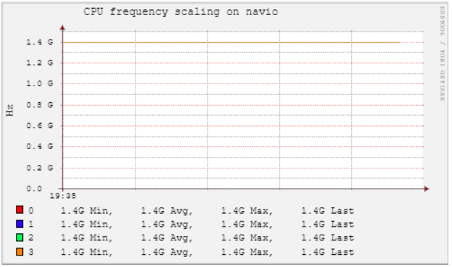

*Figure 4.25: CPU Frequency for Test 1 using LA-EDF*

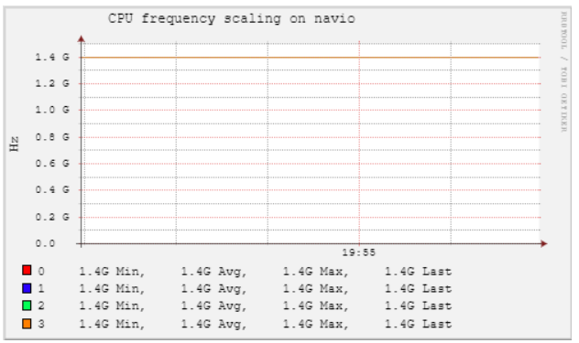

*Figure 4.26: CPU Frequency for Test 2 using LA-EDF*

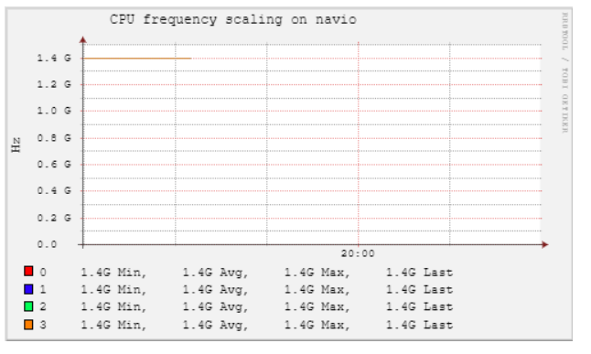

*Figure 4.27: CPU Frequency for Test 3 using LA-EDF*

This could be for a variety of reasons: it could be that when all task sets were calculated the overall minimum frequency never fell below 600MHz. A solution to this would be to use a computer with a greater selection of CPU frequency steps. Another reason could be that an error occurred in the LA-EDF modification code. Since this is kernel-level code, the means of testing whether this is the case are unconventional, complex and frankly out of the student’s current knowledge scope.

Since CPU frequency did not change, there is nothing to compare with CPU state.

### 4.4.2 MAV Performance Results

Figures 4.28 – 4.30 show desired pitch compared to actual pitch for tests 1, 2 and 3. Figures 4.31 – 4.33 show desired roll compared to actual roll for tests 1, 2 and 3. Finally, Figures 4.34 – 4.36 show desired yaw compared to actual yaw for tests 1 2 and 3. All figures represent the tests using LA-EDF.

The pitch, roll and yaw figures for test 1 are inconsistent with the pitch, roll and yaw for tests 2 and 3. This is because the MAV skewed off-script and crashed.

This can be observed in Figures 4.28, 4.31 and 4.34 for the pitch, roll and yaw respectively. The crash occurs at 00:00:56.000; in each case, the desired and actual metrics spike erratically. This is likely due to the vehicle striking an object. ArduPilot detects the crash and safely disarms after a period of approximately 10 seconds.

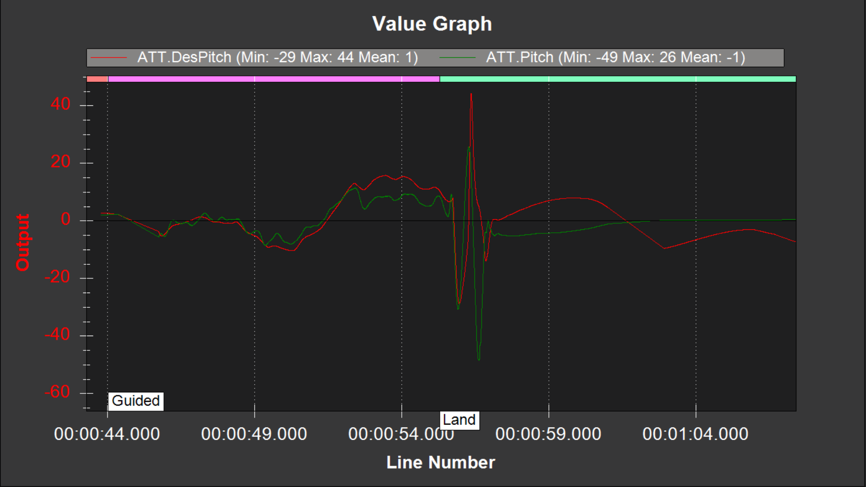

*Figure 4.28: Desired Pitch compared to Actual Pitch for Test 1 using LA-EDF*

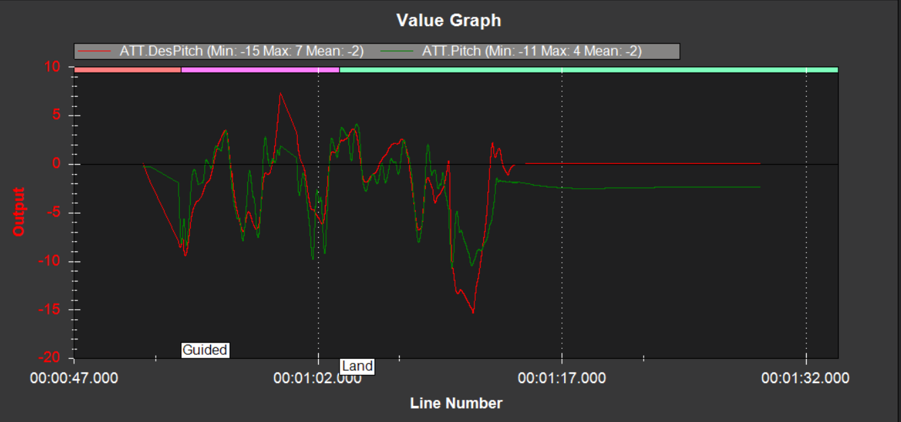

*Figure 4.29: Desired Pitch compared to Actual Pitch for Test 2 using LA-EDF*

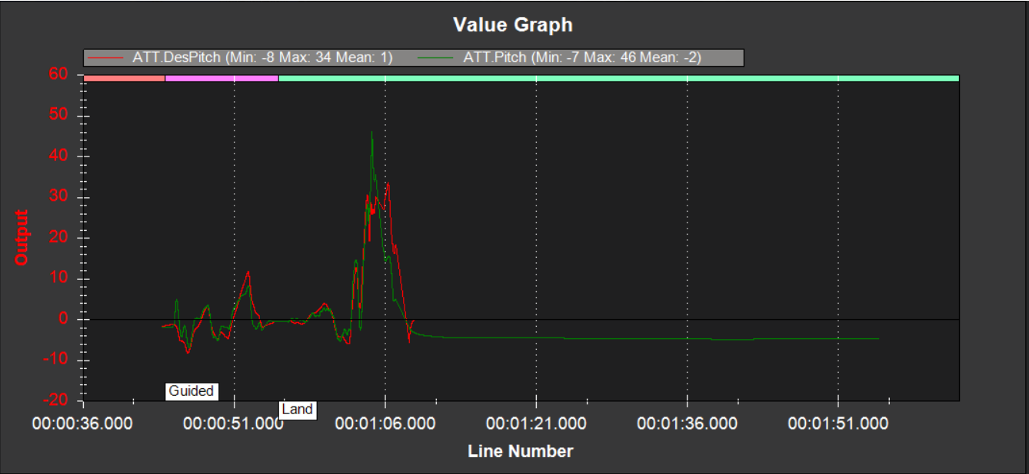

*Figure 4.30: Desired Pitch compared to Actual Pitch for Test 3 using LA-EDF*

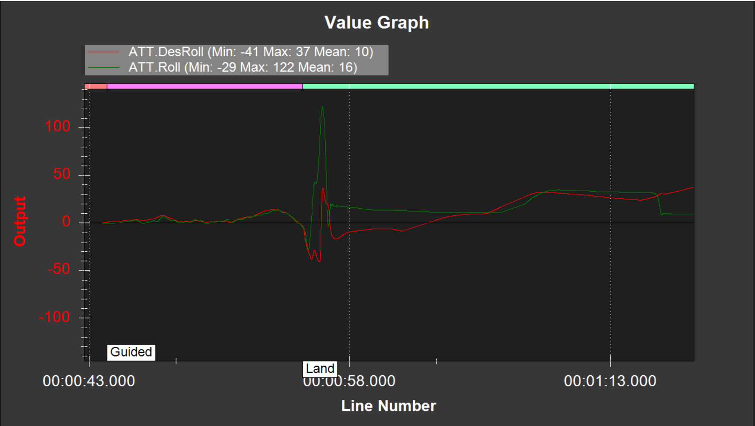

*Figure 4.31: Desired Roll compared to Actual Roll for Test 1 using LA-EDF*

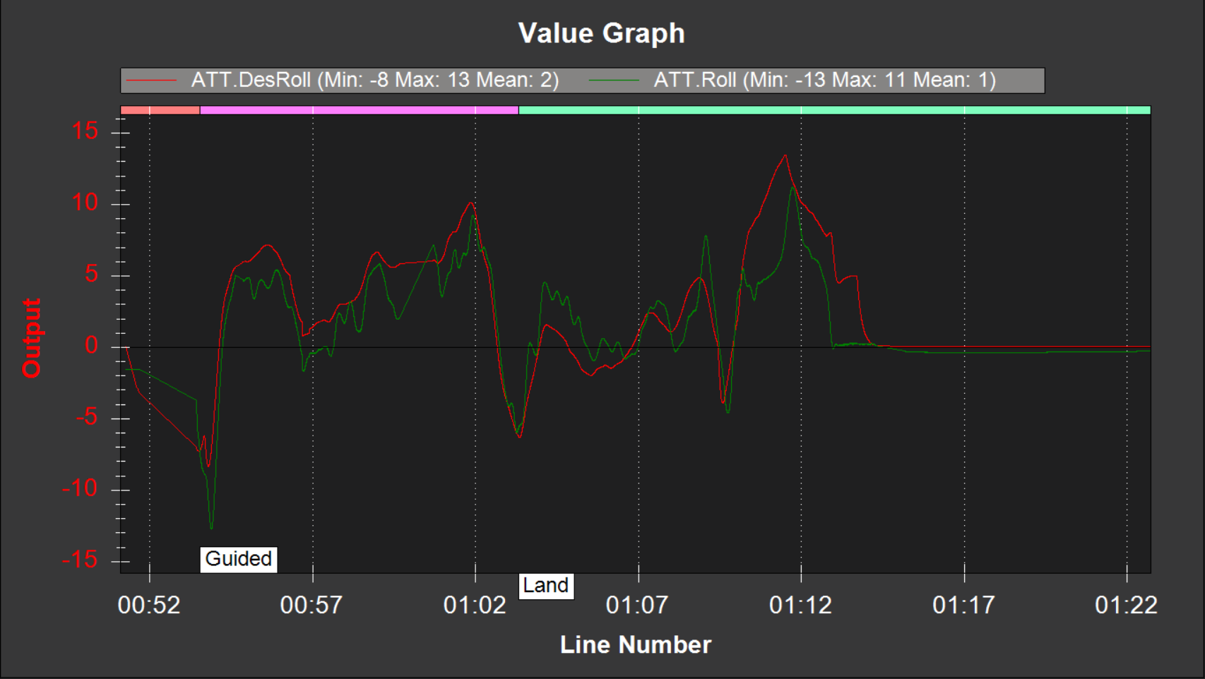

*Figure 4.32: Desired Roll compared to Actual Roll for Test 2 using LA-EDF*

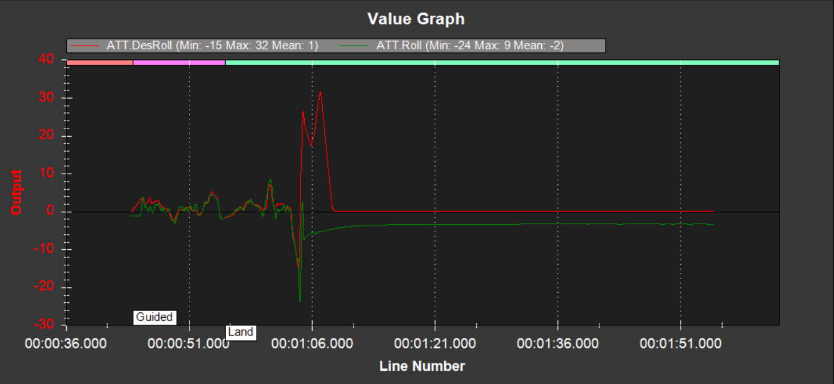

*Figure 4.33: Desired Roll compared to Actual Roll for Test 3 using LA-EDF*

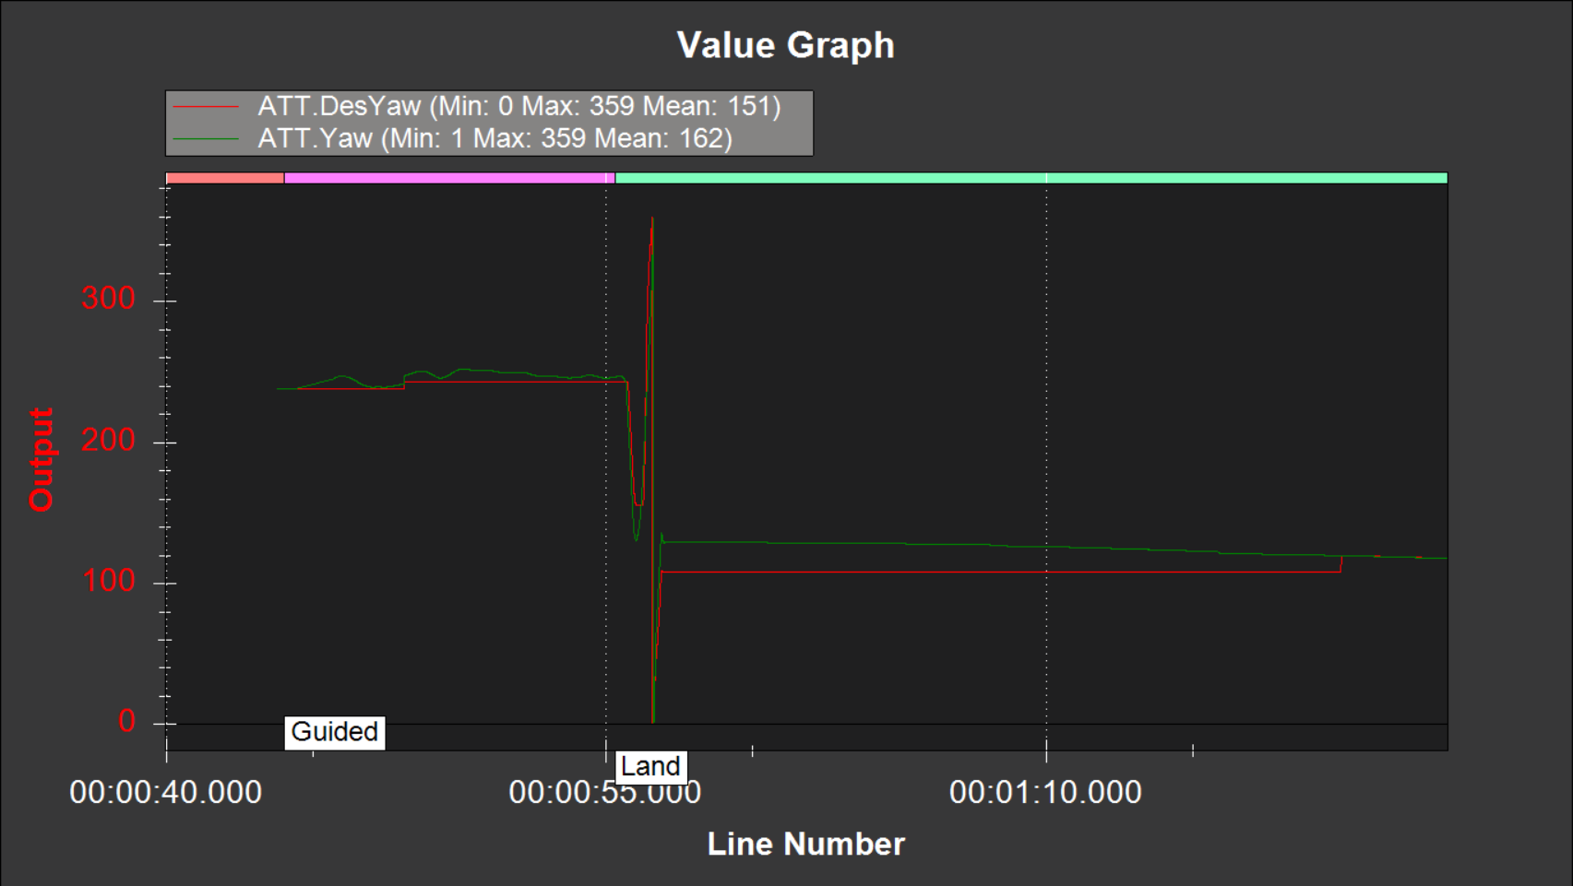

*Figure 4.34: Desired Yaw compared to Actual Yaw for Test 1 using LA-EDF*

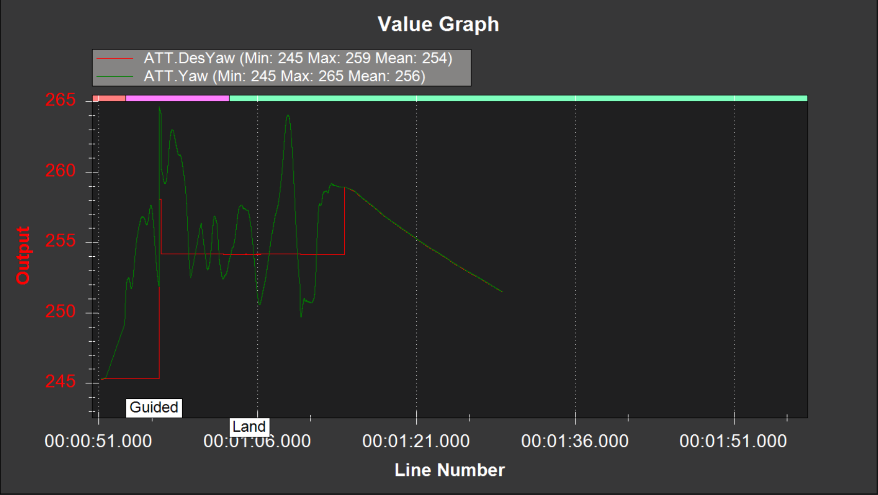

*Figure 4.35: Desired Yaw compared to Actual Yaw for Test 2 using LA-EDF*

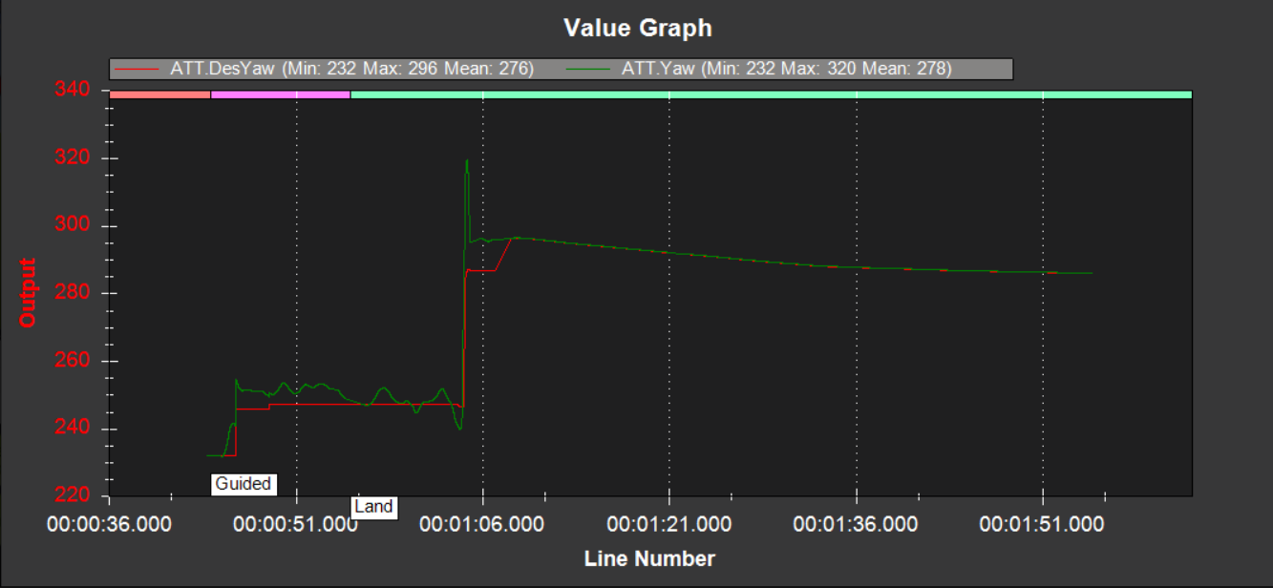

*Figure 4.36: Desired Yaw compared to Actual Yaw for Test 3 using LA-EDF*

Table 4.11 shows average pitch, roll and yaw for each test, as well as overall averages. Below this, the EDF overall averages are shown for comparison.

Table 4.12 shows the minimum and maximum differences between each desired and actual metric. The EDF results are also shown at the bottom of this table for comparison.

|  |  |  |  |  |  |  |
| --- | --- | --- | --- | --- | --- | --- |
|  | **AvDesPitch** | **AvDesRoll** | **AvDesYaw** | **AvPitch** | **AvRoll** | **AvYaw** |
| **LA-EDF Test 1** | 1° | 10° | 151° | -1° | 16° | 162° |
| **LA-EDF Test 2** | -2° | 2° | 254° | -2° | 1° | 256° |
| **LA-EDF Test 3** | 1° | 1° | 276° | -2° | -2° | 278° |
| **LA-EDF Overall Averages** | | | | | | |
|  | **Overall AvDesPitch** | **Overall AvDesRoll** | **Overall AvDesYaw** | **Overall AvPitch** | **Overall AvRoll** | **Overall AvYaw** |
|  | 0° | 4.33° | 227° | -1.67° | 6.33° | 232° |
| **EDF Overall Averages** | | | | | | |
|  | **Overall AvDesPitch** | **Overall AvDesRoll** | **Overall AvDesYaw** | **Overall AvPitch** | **Overall AvRoll** | **Overall AvYaw** |
|  | 0.33° | 1.33° | 241.67° | -2° | 0.67° | 243.33° |

*Table 4.11: The average desired pitch, roll and yaw compared to the average actual pitch, roll and yaw for each LA-EDF test. The overall averages for all tests are shown below these results.*

|  |  |  |  |  |  |  |
| --- | --- | --- | --- | --- | --- | --- |
|  | **MaxPitchDiff** | **MinPitchDiff** | **MaxRollDiff** | **MinRollDiff** | **MaxYawDiff** | **MinYawDiff** |
| **LA-EDF Test 1** | 92.73° | 2.14° | 85.36° | 0.08° | 358.64° | 2.49° |
| **LA-EDF Test 2** | 8.43° | 0.20° | 5.26° | 0.43° | 9.89° | 2.23° |
| **LA-EDF Test 3** | 19.9° | 0.25° | 37.01° | 0.30° | 32.70° | 1.00° |
| **LA-EDF Min/Max Differences** | | | | | | |
|  | **Overall MaxPitchDiff** | **Overall MinPitchDiff** | **Overall MaxRollDiff** | **Overall MinRollDiff** | **Overall MaxYawDiff** | **Overall MinYawDiff** |
|  | 40.35° | 0.86° | 42.54° | 0.27° | 133.74° | 1.91° |
| **EDF Min/Max Differences** | | | | | | |
|  | **Overall MaxPitchDiff** | **Overall MinPitchDiff** | **Overall MaxRollDiff** | **Overall MinRollDiff** | **Overall MaxYawDiff** | **Overall MinYawDiff** |
|  | 12.28° | 0.42° | 9.84° | 0.42° | 12.13° | 0.52° |

*Table 4.12: The minimum and maximum differences between the desired pitch, roll and yaw, and the actual pitch, roll and yaw for each LA-EDF test. The overall average differences are shown below these results.*

As seen in Table 4.11, LA-EDF failed to achieve the same degree of attitude accuracy when compared to EDF. Using LA-EDF, the only exception to this is the vehicle’s actual average pitch which came within 1.67° of the desired average pitch. Whereas, the vehicle using EDF came within 2.67°.

The actual roll and yaw averages came within 2° and 5° of the desired roll and yaw averages respectively using LA-EDF. The EDF results were superior since the discrepancy was 0.66° between desired and actual roll, and 2.66° between desired and actual yaw.

Analysing Table 4.12 shows that the minimum and maximum differences between the desired and actual pitch, roll and yaw are greater in the LA-EDF results compared to the EDF results. The only exception to this is the minimum roll difference, in which LA-EDF’s is smaller by 0.15°. Since the maximum and minimum differences are larger for every other metric, this suggests that the MAV’s attitude performance was not as consistent using LA-EDF compared to when it used EDF. The fact that a crash occurred using LA-EDF and not EDF also strongly suggests this.

Figures 4.37 – 4.39 show the desired altitude compared to the actual altitude for each LA-EDF test.

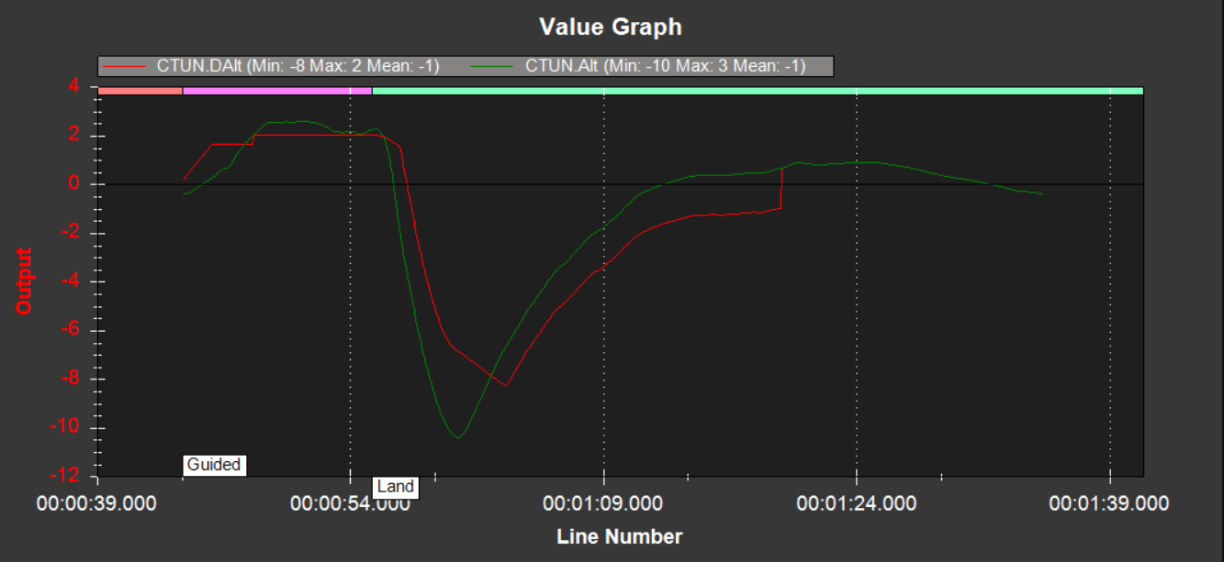

*Figure 4.37: The desired altitude compared to the actual altitude for test case 1 using LA-EDF*

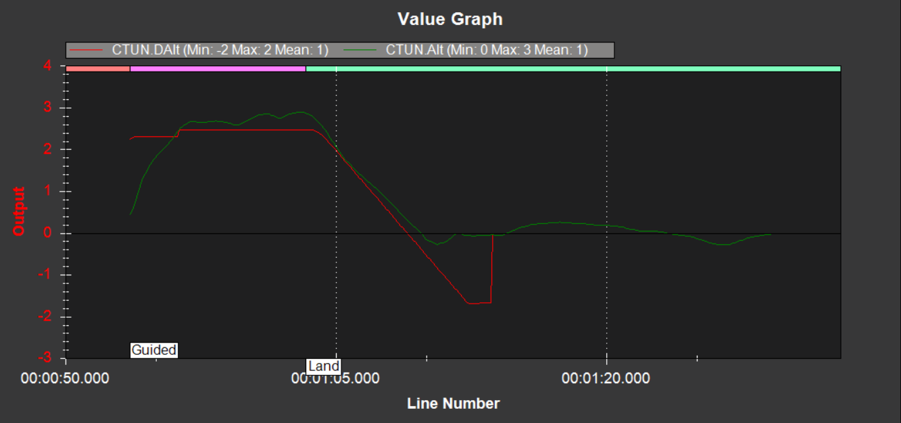

*Figure 4.38: The desired altitude compared to the actual altitude for test case 2 using LA-EDF*

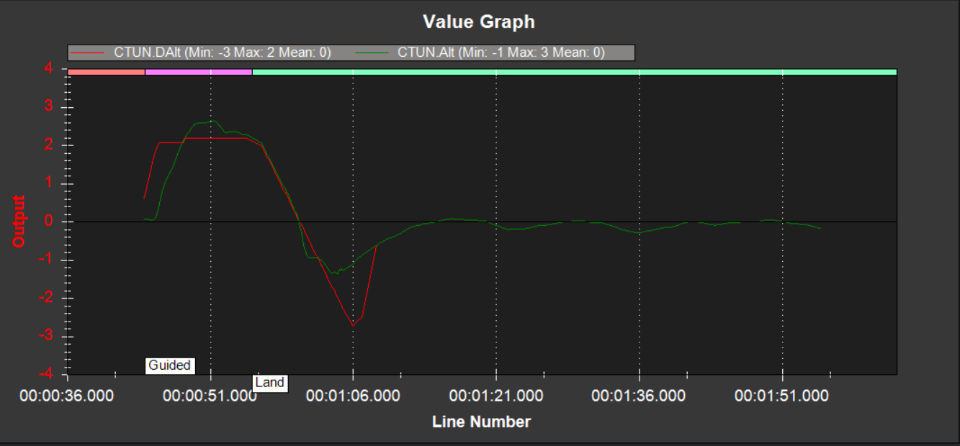

*Figure 4.39: The desired altitude compared to the actual altitude for test case 3 using LA-EDF*

Figures 4.40 – 4.42 show the throttle metrics for the vehicle using LA-EDF. In test 1 as seen in Figure 4.40, the throttle spikes up at the same time that the altitude spikes down. This is because when the vehicle crashed, it detected a loss in altitude before it detected a crash. Therefore, the throttle increased in an attempt to fix the altitude loss. Once a crash had been detected, the throttle gradually decreased. The vehicle then safely disarmed, and the throttle fell below 0.

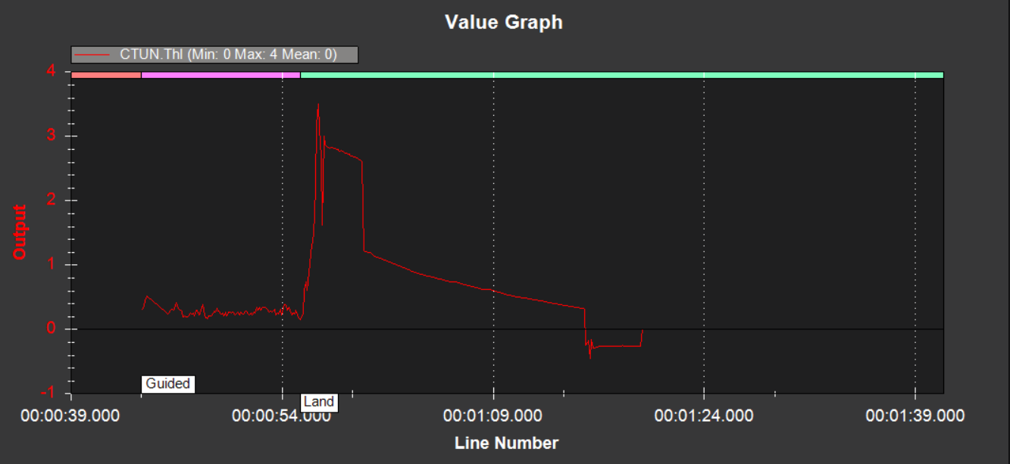

*Figure 4.40: The throttle for test case 1 using LA-EDF.*

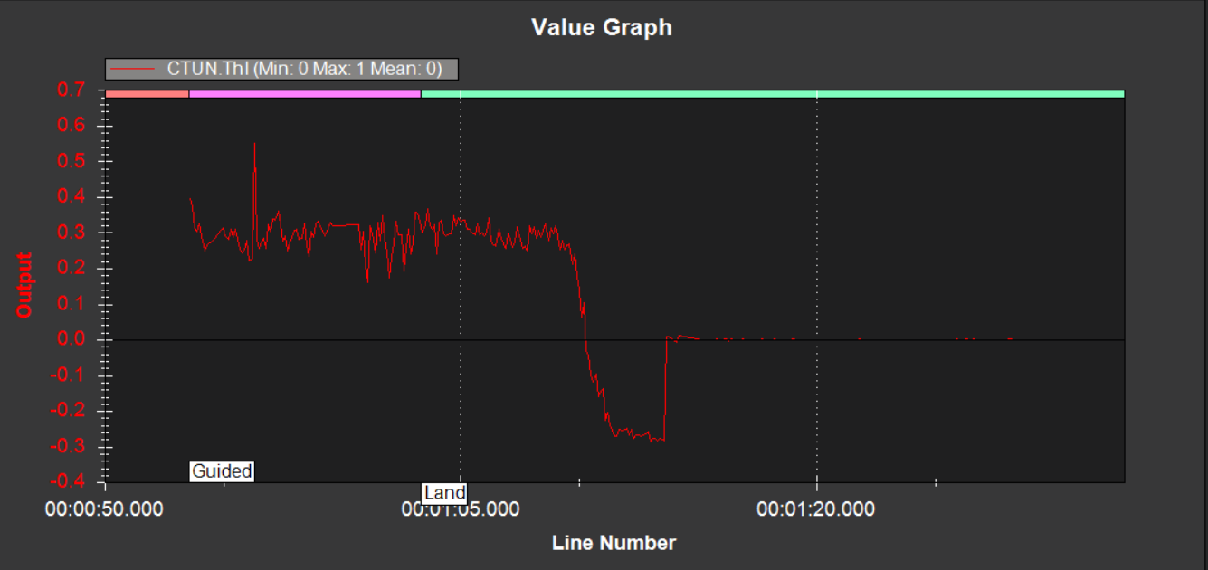

*Figure 4.41: The throttle for test case 2 using LA-EDF*

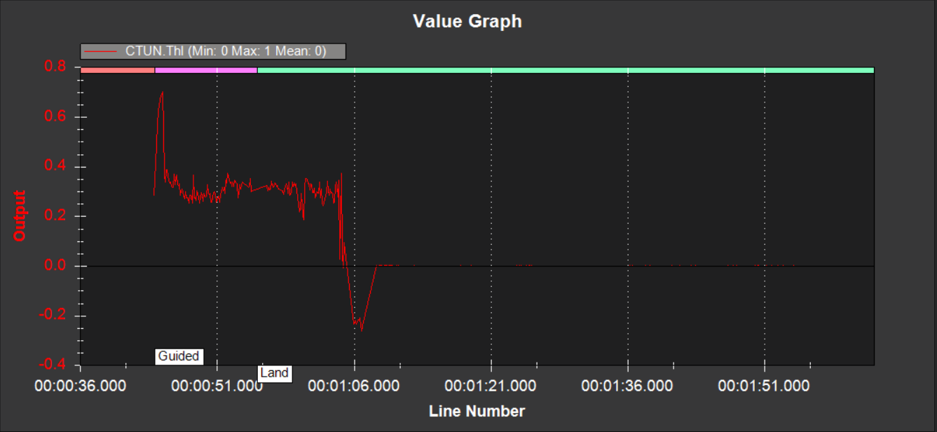

*Figure 4.42: The throttle for test case 3 using LA-EDF*

Table 4.13 shows the average desired and actual altitude, the minimum and maximum difference between the desired and actual altitude, and the average throttle. The overall averages using LA-EDF are then compared to the overall averages using EDF.

|  |  |  |  |  |  |  |  |  |  |
| --- | --- | --- | --- | --- | --- | --- | --- | --- | --- |
|  | **AvDesAlt** | **AvAlt** | **Alt =>2 from flight – landing?** | **MaxAltDiff** | | **MinAltDiff** | | **AvThl** | |
| **LA-EDF Test 1** | -1 metres | -1 metre | No | 3.52 metres | | 0.28 metres | | 0 PWM | |
| **LA-EDF Test 2** | 0 metre | 0 metre | Yes | 0.43 metre | | 0.11 metres | | 0 PWM | |
| **LA-EDF Test 3** | 1 metre | 1 metre | Yes | 0.46 metres | | 0.09 metres | | 0 PWM | |
| **LA-EDF Overall Averages** | | | | | | | | | |
|  | **Overall AvDesAlt** | **Overall AvAlt** | **Overall MaxAltDiff** | | **Overall MinAltDiff** | | **Overall AvThl** | |
|  | 0 metres | 0 metre | 1.47 metres | | 0.16 metres | | 0 PWM | |
| **EDF Overall Averages** | | | | | | | | | |
|  | **Overall AvDesAlt** | **Overall AvAlt** | **Overall MaxAltDiff** | | **Overall MinAltDiff** | | **Overall AvThl** | |
|  | 0.67 metres | 1 metre | 0.33 metres | | 0.05 metres | | 0 PWM | |

*Table 4.13: Average desired altitude and actual altitude as well as the average throttle using LA-EDF. The minimum and maximum difference between the desired altitude and actual altitude is also recorded. The overall averages for all tests are compared to those of the EDF tests below these results.*

No thrust-loss occurred using the LA-EDF modification, or EDF since average PWM usage did not fall below 0 in either case. The overall averages of desired and actual altitude were more accurate using LA-EDF; the discrepancy was 0 metres, whereas in the unmodified scheduler, the discrepancy was 0.33 metres.

However, this must not be taken at face value: the first test resulted in a crash, and it is highly likely that both the desired altitude and actual altitude were logged in error during that test since the minimum altitude was logged as -10 metres, which was not possible.

The maximum difference in desired and actual altitude was higher using LA-EDF: the difference was 1.47 metres using EDF compared to 0.33 metres using LA-EDF. The minimum difference was also slightly higher in the LA-EDF modification: 0.16 metres compared to 0.05 metres in EDF.

# Conclusions and Future Work

## Project Resume

The goal of this project was to address the problem statement defined in section 1.2.1.

The way that the current Linux Process Scheduler manages RT tasks using the PREEMPT-RT patch was explored, and relevant modifications for improving energy-efficiency were also explored. It was found that through the use of DVFS algorithms that the energy-efficiency could be improved by reducing the processor clock speed periodically. The periods at which the clock speed would be reduced would depend on the deadlines of the RT tasks in the system.

Once this experimental approach had been identified, relevant performance metrics of the MAV and resource utilisation metrics of the MAV computer were investigated. Quantifying the processor’s CPU frequency and CPU states were found to be the most feasible method of measuring power consumption. This was found to be less accurate than a hardware solution, but more suited towards this project. The relevant performance metrics to be investigated were the vehicle’s pitch, roll, yaw, altitude and throttle. The reason these metrics were to be collected was to observe how great the energy-performance trade-off would be when applying the DVFS algorithm to the scheduler.

An MAV was then designed, built and tested. The internals of the vehicle and software architecture of the Linux Process Scheduler were explained. How the vehicle’s autopilot software related to the Linux OS was also explained. Each step of the LA-EDF policy, the chosen algorithm, was explored. An LA-EDF modification was then written into the ‘sched.h’ file of the Linux process scheduler.

Finally, a control set of three test cases were executed using the EDF policy and an automated flight script. The script ensured consistency and greater scientific validity for comparison between each of the test cases. Then, the same test cases were repeated using the LA-EDF policy applied to it. The resource utilisation and performance metrics were quantified and analysed for each set of test cases.

These results were used to relate back to the project hypothesis defined in section 1.2.3.

## Conclusions and Critiques

According to the results of the tests, the proposed LA-EDF modification when applied to the Linux Process Scheduler did not appear to be particularly useful; at least, not when using the configuration chosen for this project. This is for three outstanding reasons: when using the LA-EDF scheduler no changes to the CPU frequency occurred during the tests. The total resource utilisation appeared to slightly increase when using LA-EDF, despite no changes occurring in CPU frequency. Finally, the overall performance metrics were less consistent – the LA-EDF test resulted in a crash – and less accurate in terms of stability. The overall altitude appeared to be more consistent in the LA-EDF result set, however.

It is not accurate to state that the LA-EDF policy is unsuitable for improving energy-efficiency in a Linux-based RT system context. Considering that there are a multitude of Linux versions, patches and configurations, it is more apt to say that under the chosen configuration for this project the LA-EDF implementation was not successful in improving system energy efficiency.

The quantification methods for resource utilisation and performance were limited in this project. A general observation as to whether the overall energy efficiency had improved could be made, but no conclusive statement regarding how much energy had been saved would have been possible to make. This is because there was no method implemented to measure battery charge/discharge and no hardware in place to monitor how much power was being consumed over the course of the test cases. The software chosen to monitor the resource utilisation was also found to not be fine grained enough to obtain highly accurate results.

Regarding the performance metrics, pitch, roll, yaw, altitude and velocity are a very small number of total performance metrics which can be recorded using ArduPilot. Hypothetically, if each of these metrics were not affected by the LA-EDF policy, there could have been another set of performance metrics – e.g. compass variance, climb rate, logging threads, etc. which were. It is impossible to say since these metrics were not recorded. The point is that in order for truly accurate results, a larger variety of performance metrics have to be obtained. These metrics also have to be obtained through more accurate means and analysed with greater scrutiny.

In future studies, it would be wise to have a team member who understands how to analyse MAV performance metrics in greater detail.

Moving past the results, it is important to discuss and critique the chosen hardware and software architecture.

A person(s) with greater experience in the Linux Kernel would be of great benefit to this area of research since the functionality, syntactical correctness and level of testing for any kernel modifications would be more in-depth. Being able to prove the usability of LA-EDF, or any other DVFS algorithm within Linux in a more in-depth mathematical basis would also be useful for future study.

It was not known to the student that the number of CPU frequency steps in a Raspberry Pi 3b+ may be limited. Ideally, a greater number of CPU frequency should be available to the processor. This means that even if the total frequency required to complete an RT task set does not fall below minimum, it may not necessarily have to run at maximum capacity either.

Only two governors were present in this configuration – Powersave and Performance. Ideally for this type of project, it would be wise to seek out a configuration which included the Userspace governor; this governor allows for the CPU frequency to be adjusted to any selectable CPU frequency step.

For future work, other configurations/versions of Linux should be explored which have a greater variety of governors and less limiting architectures in terms of DVFS implementations.

One such version of Linux which may be of interest is CentOS. This is the version of Linux used in [32]. While it is mainly designed for use as a testbed for task set simulations, it may be possible to operate an MAV or another battery-operated RT system using CentOS as the environment.

The number of cores within the CPU is something which was also not thoroughly explored in this study. It is generally accepted that RT task sets function with least schedulability errors on uniprocessor machines [4]. As previously mentioned, the Raspberry Pi 3b+ is a quad-core machine. In future work, it could be interesting to carry out a similar study on both uniprocessors and multiprocessors to see which option is best in terms of maintaining schedulability whilst prioritising energy-efficiency.

Linux may possibly be a difficult OS environment to use as a way of optimising energy-efficiency in RT systems. However, there do exist domain specific RTOSs which are designed around RT systems; it may be easier to achieve the same goal using one such environment over Linux. The issues with this are availability, cost of the OS, a potentially steep learning curve, and a potential lack of portability between hardware configurations.

Research into different methods of RT system energy-efficiency, such as energy-efficient RT task load-balancing could be investigated as a more configurable, alternative to DVFS algorithms. Such methods have been somewhat explored in theory, such as in [33] where RT tasks are selectively re-balanced between each processor’s run-queue based on task runtime. This method of approaching energy-efficiency for RT systems within Linux could be very interesting to observe in a real-life domain context.

A potential extension to this paper could be to re-create the MAV design and configuration and look at investigating task load-balancing instead of prioritising CPU frequency minimisation.

# References

[1] KANGRALKAR, NARENDRA, June 2015. An Introduction to the Linux Kernel, *Open Source for You; New Delhi*

[2] STALLINGS, WILLIAM, 2005. Operating Systems: Internals and Design Principles, pp 468

[3] SOUSA, PAULO; PEREIRA, NUNO; TOVAR, EDUARDO, Nov 2012. Enhancing the real-time capabilities of the Linux kernel, *ACM SIGBED Review* **9**(4), pp. 45-48

[4] BURTSEVA, LARYSA; DIAZ-RAMIREZ, ARNOLDO; AMARO, VIDBLAIN; LIZARRAGA, MAYRA L; BUELNA, ANDRES, May 2017. A Real-Time System Using the Preempt-RT patch and the RM, PIP and EDF scheduling policies*, Congreso Internacional de Robotica y Computacion*, pp 86-91

[5] ABENI, LUCA, 2014. Real Time Scheduling and Threads: Basics, slides 39-44, <http://disi.unitn.it/~abeni/rtslike.pdf> [online]

[6] PENG, ZIRAN; WANG, GUOJIN, May 2017. An Optimal Energy-saving Real-Time Task –Scheduling Algorithm for Mobile Terminals, *International Journal of Distributed Sensor Networks*.

[7] SHAIFUL ALAM CHOWDHURY; STEPHANIE GIL; STEPHEN ROMANSKY; ABRAM HINDLE, Feb 2017. Did I Make A Mistake? Finding the Impact of Code Change on Energy Regression, *PeerJ PrePrints; San Diego*

[8] Nov 2017. The Global Military UAV Market 2017-2027, *Strategic Defence Intelligence*

[9] CHA, MOON-YONG; KIM, MINJIN; SOHN, YOUNG-JUN; YANG, TAE-HYUN; KIM, SEUNG-GON; March 2016. Flight Paths for a Regenerative Fuel Cell-Based High Altitude Long Endurance Unmanned Aerial Vehicle, *Journal of Mechanical Science and Technology.* **30**(7), pp 3401-340

[10] ILYA ANISHCHENKO; 2018. Design, Development and Validation of a High-Performance Tilt-Frame Unmanned Aerial System for Landing in Tree Orchards, *University of California*

[11] QIN, YUBO; 2016. Exploring Power-Performance-Quality Trade-offs for Exascale Combustion Simulation, *Rutgers: The State University of New Jersey*

[12] STALLINGS, WILLIAM, 2005. Operating Systems: Internals and Design Principles, pp 454

[13] DEEPTI, V; MAHENDER, K; VENKATRAM, N; June 2014. Development of Real Time Application Platform for Linux Kernel with Preempt-RT, *International Journal of Computer Applications*. **95**(22), pp 21-25

[14] Open Source for You; New Delhi, Oct 3 2013. Why and How to Compile a Custom Kernel: This article goes deeper into the Linux kernel and highlights the importance of building a custom kernel

[15] WEBB, WARREN, 2004. Embedded Linux nears real time, *EDM.* **49(**19), pp 55-62

[16] CHOI, EUNSEOK; JANG, MINWOO; KIM, BONGJAE, August 2013. Improving and Evaluating Real-time Performance for Smart Devices, *International Information Institute of Tokyo.* **16**(8), pp 5733-5743

[17] HOOK, LESLIE, July 2016. Amazon to test drones in UK suburbs and rural areas, *The Financial Times.*

[18] HOWARD, COURTNEY E, April 2012. RTOS Required, *Military and Aerospace Electronics; Westborough* **23**(4), pp 20, 22-27

[19] LIU, CHI HAROLD; CHEN, ZHEYU; TANG, JIAN; XU JIE; PIAO, CHENGZHE, Energy-Efficient UAV Control for Effective and Fair Communication Coverage: A Deep Reinforcement Learning Approach, *IEEE Journal on Selected Areas in Communications* **36**(9), pp 2059-2070

[20] BERKOWITZ, ROGER, Summer 2014. Drones and the Question of “The Human", *Ethics & International Affairs; New York* **28**(2), pp 159, 169

[21] JONES, MILDRED V, September 2014. Drones: The Sky’s the Limit – or is it?, *Technology and Engineering Teacher; Reston* **74**(1) pp 28-32

[22] HASSANALIAN, M; ABDELKEFI, A, May 2017. Classifications, applications, and design challenges of drones: A review, *Progress in Aerospace Sciences; Oxford* **91**, pp 99-131

[23] HINDLE, ABRAM, September 2015. Green Mining: a methodology of relating software change and configuration to power consumption*, Empirical Software Engineering; Dordrecht* **20**(2) pp 374-409

[24] BACLAWSKI, KEN, June 2018. The Observer Effect, *IEEE Conference on Cognitive and Computational Aspects of Situation Management (CogSIMA)*

[25] ABDULHALIM, FADWA; ALGHAMDI, OMAR; NAIK, KSHIRASAGAR. 2015, Modelling the Energy Cost of Application Software for Developers, *Proceedings of the International Conference on Software Engineering Research and Practice (SERP),* pp 57-63

[26] Gentec-eo official website - <https://www.gentec-eo.com/laser-power-meter/portable> [online resource]

[27] CollectD official website – <https://collectd.org> [online resource]

[28] The Linux Foundation, March 2013. Intro to Real-Time Linux for Embedded Developers - <https://www.linuxfoundation.org/blog/2013/03/intro-to-real-time-linux-for-embedded-developers/> [online resource]

[29] RINKU, DHRUVA; CINTOJI, SANDEEP. Implementation of Earliest Deadline First Scheduling Algorithm on Standard Linux, *CVR College of Engineering*

[30] JAMES, SOJAN, June 2014. Understanding Linux Scheduling - <https://www.linkedin.com/pulse/20140629145049-21586023-understanding-linux-scheduling> [online resource]

[31] WERNER, FRANK; AMARO, VIDBLAIN; DIAZ-RAMIREZ, ARNOLDO; FLORES RIOS, BRENDA; GONZALEZ-NAVARRO; BURTSEVA, LARYSA, March 2018. A Scheduling Extension Scheme of the Earliest Deadline First Policy For Hard Real-Time Uniprocessor Systems Integrated on POSIX Threads Based on Unix, *Computer Systems Science and Engineering* **33**(1)

[32] SAHA, SONAL, Sept. 2011. An Experimental Evaluation of Real-Time DVFS Scheduling Algorithms, *Virginia Polytechnic Institute and State University*

[33] CHENG, HUI, 2006. Energy-Efficient Scheduling Algorithms for Real-Time Systems, *University of Nebraska*

[34] ANISHCHENKO, ILYA, 2018. Design, Development and Validation of a High-Performance Tilt-Frame Unmanned Aerial System for Landing in Tree Orchards, *University of California*

[35] March 2018. Selecting a Drone Flight Controller - <https://dojofordrones.com/drone-flight-controller/> [online resource]

[36] May 2013. Changing the BeagleBone CPU Frequency - <http://derekmolloy.ie/changing-the-beaglebone-cpu-frequency/> [online resource]

[37] LARABEL, MICHAEL, May 2019. Raspberry Pi Close to Seeing CPUFreq Support, *Arm*

[38] Choosing a Ground Station - <http://ardupilot.org/plane/docs/common-choosing-a-ground-station.html> [online resource]

[39] BERGQUIST, CALEB. How to Build a Raspberry Pi Drone - <https://courses.dojofordrones.com/p/how-to-build-a-raspberry-pi-drone/> [online resource]

[40] PowerTop example image - <https://hobo.house/2015/12/18/linux-laptop-power-usage-tuning-with-powertop/> [figure 1 reference]

[41] CollectD example data - <https://collectd.org/wiki/index.php/Table_of_Plugins> [figures 2, 3 and 4 reference]

[42] Pitch, Roll and Yaw visual - <http://electrodone.blogspot.com/2015/10/how-to-build-quadcopter-choosing.html> [figure 8 reference]

[43] Documentation of the Linux EDF scheduling policy implementation (SCHED_DEADLINE) - <https://www.kernel.org/doc/html/latest/scheduler/sched-deadline.html>

[44] Emlid Raspbian 2 Details + Discussion - <https://community.emlid.com/t/new-emlid-raspbian-stable-image-emlid-raspbian-20170323/5528>

[45] PILLAI, PADMANABHAN; SHIN, KANG G., 2001. Real-Time Dynamic Voltage Scaling for Low-Power Embedded Operating Systems, *Proceedings of the eighteenth ACM symposium on Operating systems principles,* pp 89-107

[46] SONG, WENGSHEN; WANG, SHUNLIANG; XIONG, CHENGLIN; GE, XINGLAI; FENG, XIAOYUN, 2014. Single-phase three-level space vector pulse width modulation algorithm for grid-side railway traction converter and its relationship of carrier-based pulse width modulation, *IET Electrical Systems in Transportation; Stevenage* **4**(3) pp 78-87

[47] 28th September 2017. Drones: How to Fly Them Safely and Legally, *Ministry of Defence and Military Aviation Authority*

[48] JAYALATH, J M T I; CHATHUMALI, E J A P C; KOTHALAWALA, K RM; KURUWITAARACHCHI, N.GREEN, March 2019. Cloud Computing: A Review on Adoption of Green-Computing attributes and Vendor Specific Implementations, *The Institute of Electrical and Electronics Engineers, Inc. (IEEE) Conference Proceedings; Piscataway* pp 158-164

[49] ALI, HAIDER; TARIQ, UMAIR ULLAH; LIU, LU; PANNEERSELVAM, JOHN; ZHAI, XIAOJUN, August 2019. Energy Optimization of Streaming Applications in IoT on NoC Based Heterogeneous MPSoCs using Re-Timing and DVFS, *The Institute of Electrical and Electronics Engineers, Inc. (IEEE) Conference Proceedings; Piscataway* pp 1297-1304